Techniques to perform Specular Microscopy: Endothelial Cell Counting (ECC) and Endothelial Mosaic Mapping (EMM)

Fernando Cesar Abib MD, PhD, Professor of Federal Univsersity of Parana (UFPR), Brazil; Fernando Abib Eye Clinic, Curitiba, Brazil.
Renata Martins dos Santos MD, Fernando Abib Eye Clinic, Curitiba, Brazil.

Purpose: The main task is to know the endothelial behavior to plan an objective way to perform the Corneal Endothelial Mosaic (CEM) examination. The CEM was described according the autor, ARVO 2015, into Regular, Irregular and Chameleon Pattern. The Regular Pattern can be examined by No Contact (NC) Corneal Specular Microscope (CSM), Irregular and Chameleon Patterns by Contact (C) CSM. This choice was based in how each type of CSM get the images: NC CSM acquire CEM images when the patient sets the target light, each model of this type of CSM has fixed positions; C CSM can acquire CEM of any area of the endothelial surface by sliding the objective lens on the cornea. Considering the differences this study to presents a guideline to perform Specular Microscopy choosing the best technique for CEM description. Methods: All CSM of 2013 at Fernando Abib Eye Clinic, Brazil. The choice: NC CSM (CSO, Italy) or C CSM (BioOptics, USA) is determined by the algorithm (Figure1). The number of counted cells in each examination was guided by Reliability Indexes of the Cells Analyzer _{USA Patent} software (Technicall, Brazil) to obtain sample error < 5%.The results were reported in terms of the examinations performed for Endothelial Cell Count or Endothelial Mosaic Mapping, respective clinical situations, and used CSM, utilizing descriptive statistics.
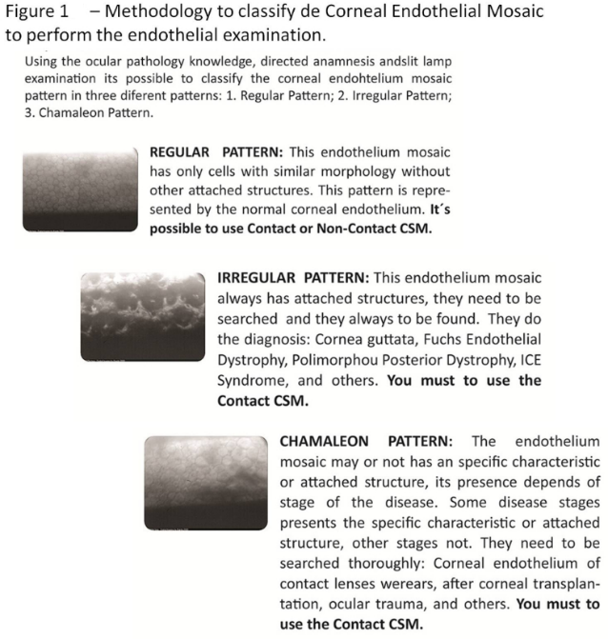
Results: The results used techniques for ECC and EMM are presented at the table.
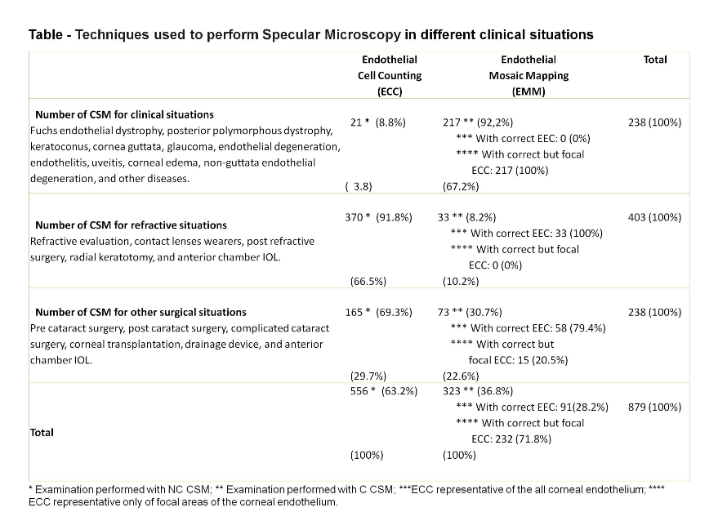
Conclusions: The ECC was the most frequent finality of the CSM (63.2%) and performed with NC CSM. A high number of CSM needed the endothelial mapping (36.8%) to describe the reality of the CEM. We strongly suggest C CSM with endothelial mapping technique to perform CEM examination for Irregular and Chamaleon patterns.
1. LAING, R. L. Specular Microscopy. In: MOSBY (Ed.). Cornea: Fundamentals of Cornea External Diease. St. Luis: Krachmer, J.K., 1997. cap. 19.
2.LAING, R. A.; OAK, S. S.; LEIBOWITZ, H. M. Specialized Microscopy of the Cornea: Specular Microscopy. In: LEIBOWITZ, H. M. e WARRING III, G. O. (Ed.). Corneal Disorders, Clinical diagnosis and management. 2nd. Philadelphia: W.B. Saunders, 1998. cap. 3, p.1172.
3.ABIB, F. C. Corneal Specular Microscopy with Statistical Reliability and Reproducibility. First. Curitiba: Fernando Cesar Abib, 2006. 88.
4.ABIB,F.VC. The endothelial sample size analysis in corneal specular microscopy clinical examinations. Cornea, v. 31, n. 5, p. 546-50, May 2012.
5.ABIB, F. C. et al. The sampling error from specular microscopy examinations and their reliability indexes. Cornea, v. 32, n. 3, p. 377-8, Mar 2013.


Biography
Fernando Cesar Abib from Brazil, graduated in Medicine (1989), residency in ophthalmology (1991), specialization in Occupational Health (1993) and Doctorate in Medicine (1994). Associated Professor of Human Anatomy - Federal University of Paraná. Head Ophthalmologist of Ocular Oncology at Erasto Gaertner Hospital. In addition to general ophthalmology has experience in ocular anatomy and physiology, cornea, and ocular oncology. He is a researcher and developed an unprecedented method to determine the smallest number of endothelial cells for specular microscopy to obtain a sampling error accepted by medical science, customizing it to the reality of the examined cornea. Developed an unprecedented methodology to analyze the results of this examination through age control. Patented in several countries.
Email: drfcabib@mps.com.br

Notes/Comments:

