Different Types of Human Subnormal Corneal Endothelium (SnCE) according to Lifetime Cornea Transparency

Fernando Cesar Abib MD, PhD, Professor of Federal Univsersity of Parana, Brazil; Fernando Abib Eye Clinic, Curitiba, Brazil.
Renata Martins dos Santos MD, Fernando Abib Eye Clinic, Curitiba, Brazil.

Background: Abnormal corneas have a very low endothelial cell density (ECD). Subnormal corneas have progressive endothelial deterioration of its ECD and morphology, characterized by large ECD range with different clinical status. To predict if cornea can decompensate (700-400 cells/mm²) during lifetime, long term endothelial status must be analyzed according to corneal transparency and life expectancy. Purpose: To describe different types of SnCE within average life expectancy of 100 years old. Methods : Cross-sectional study of Specular Microscopy (SM) in a 10-years period. All ECD data was arranged in Statistical-Analytical Ruler, considering it a reliability index software (Cells Analyzer _{China Patent}, Technicall, Brazil), in a way to indetify if data were within the range of corneal decompensation during lifetime. Each SM were classified in one of the 3 proposed nomina for SnCE according to age and ECD: (1)SnCE with Transparent Cornea within Life Expectancy(TCLE); (2)SnCE with No Transparent Cornea within life Expectancy(No TCLE); (3)Decompensation due to Corneal Endothelium Failure (DCEF)(edema and symptoms). SnCE No TCLE subdivides as (a)Imminent Risk of Corneal Decompensation within Life Expectancy(Imminent DRisk)(1000-700 cells/mm²); (b)Immediate Risk of Corneal Decompensation within Life Expectancy(Immediate DRisk)(700-500 cells/mm²). Normal cornea was not used in study. Results: 9,399 eyes: 7,326 normal(77.94%) and 2,073 SnCE(22.05%). 1387 eyes SnCE TCLE(66.92%), 619 SnCE No TCLE(29.85%); 67 DCEF(3.23%). Within SnCE No TCLE, 412 eyes were Imminent DRisk(19.87%); 207 eyes were Immediate DRisk(9.98%) (Figure). Total populational analysis, SNCE LECT 14.76%; Imminent DRisk 4.38%; Immediate No TCLE 2.20%; DCEF 0.71%.Conclusions: 9,399(0 years), the risk for corneal transparency abnormality is approximately 7.29%. SnCE prevalence 22.05%. The presented nomina is useful to describe different patterns of SnCE.
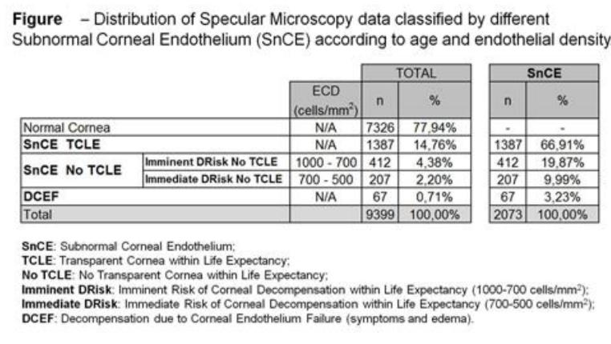
Reference
ABIB, F. C. Predicting Corneal Decompensation. ARVO Imaging in the Eye Conference: ARVO The Association for Research in Vision and Ophthalmology: 142 -143 p. 2015.
ABIB,F.C. Ten years of Specular Microscopy performed in a Cornea Service. Investigative Ophthalmology & Visual Science, v. 58, n. 8, p. 3502-3502, 2017. ISSN 1552-5783. Disponível em: < http://dx.doi.org/ >.
EDELHAUSER, H. F. The balance between corneal transparency and edema: the Proctor Lecture. Invest Ophthalmol Vis Sci, v. 47, n. 5, p. 1754-67, May 2006. ISSN 0146-0404. Disponível em: < http://www.ncbi.nlm.nih.gov/pubmed/16638979 >.
LAING, R. A.; OAK, S. S.; LEIBOWITZ, H. M. Specialized Microscopy of the Cornea: Specular Microscopy. In: LEIBOWITZ, H. M. e WARRING III, G. O. (Ed.). Corneal Disorders, Clinical diagnosis and management. 2nd. Philadelphia: W.B. Saunders, 1998. cap. 3, p.1172.
SAKANO, L. Y. et al. CLASSIFICATION OF DIFFERENT MORPHOMETRIC PROFILES OF HUMAN CORNEAL ENDOTHELIUM. Investigative Ophthalmology & Visual Science, v. 59, n. 9, p. 2906-2906, 2018. ISSN 1552-5783. Disponível em: < http://dx.doi.org/ >.

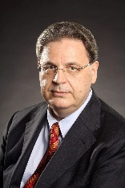
Biography
Fernando Cesar Abib, graduated in Medicine - Federal University of Paraná (1989), residency in ophthalmology at the Hospital of the Federal University of Paraná, Brazil (1991), specialization in Occupational Health, Federal University of Paraná (1993) and Doctorate in Medicine - Ophthalmology, Federal University Minas Gerais (1994). Associated Professor of Human Anatomy - Federal University of Paraná. Head Ophthalmologist of Ocular Oncology at Erasto Gaertner Hospital - Curitiba, Paraná. In addition to general ophthalmology has experience in ocular anatomy and physiology, cornea, and ocular oncology. He is a researcher and developed an unprecedented method to determine the smallest number of endothelial cells for specular microscopy to obtain a sampling error accepted by medical science, customizing it to the reality of the examined cornea. Developed an unprecedented methodology to analyze the results of this examination through age control. Patented processes in several countries: Canada, China, the United States of America, Japan.

Email: drfcabib@mps.com.br

Notes/Comments:

