Plasma rich in growth factors in eye drops for the treatment of ocular surface disease.
Abstract
Plasma rich in growth factors (PRGF) is an autologous 100% platelet-rich plasma as a result of anestablished protocol where platelets are concentrated twofold. This plasma excludes both red and white cells including leukocytes instead of being diluted as usually happens with autologous serum (AS). PRGF differentiates from other platelet-rich plasma products which have high variability in composition, protein content and platelet enrichment because its autologous origin reduces the risk of disease transmission and immunogenic reactions.
In our institution different groups of patients were analyzed: VAS (Visual Analog Scale: Frequency and severity of symptoms), Dry eye Psychometric Survey (OSDI: Ocular Surface Disease Index),BCVA (LogMAR) and Tear breakup time (TBUT) and Schirmer Test.
Measurements were taken before (control) and after (PRGF) starting the treatment with PRGF.
We studied the evolution of the patient throughout one year.
Overall, these results demonstrate that PRGF minimizes scarring and promotes tissue regeneration in patients with moderate to severe dry eye, neurotrophic dry eye and corneal ulcers.

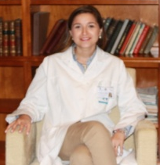
Image
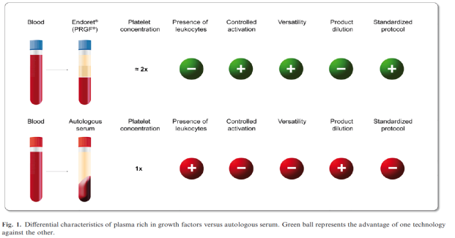
Publications
1 Anitua E, Prado R, Orive G. Closing regulatory gaps: new ground rules for platelet-rich plasma. Trends Biotechnol. 2015;33(9):492–495.
2 Riestra AC, Alonso-Herreros JM, Merayo-Lloves J. [Plasma rico en plaquetas en superficie ocular]. Arch Soc Esp Oftalmol. 2016;91(10):475– 490. Spanish.
3 . Sanchez-Avila RM, Merayo-Lloves J, Riestra AC, et al. Treatment of patients with neurotrophic keratitis stages 2 and 3 with plasma rich in growth factors (PRGF-Endoret) eye-drops. Int Ophthalmol. Epub 2017 Jun 15
4 Ronald M Sánchez-Avila, Jesus Merayo-Lloves, Maria Laura Fernández, Luis Alberto Rodríguez-Gutiérrez, Pedro Pablo Rodríguez-Calvo, Andres Fernández-Vega Cueto, Francisco Muruzabal, Gorka Orive, Eduardo Anitua. Plasma rich in growth factors eye drops to treat secondary ocular surface disorders in patients with glaucoma. International Medical Case Reports Journal 2018:11: 97-103.
5 Ronald M Sánchez-Avila, Jesus Merayo-Lloves, Maria Laura Fernández, Luis Alberto Rodríguez-Gutiérrez, Nancy Jurado ,Francisco Muruzabal, Gorka Orive, Eduardo Anitua. Plasma rich in growth factors for the treatment of dry eye after lasik surgery. Ophthalmic Res 7 DOI: 10.1159/000487951

Email: laura.fernandez.lf@gmail.com
María Laura Fernández from Buenos Aires, Argentina. Ophthalmologist, ocular surface specialist. I performeds my specialty in Argentina(Hospital Santa Lucia de Buenos Aires) and in Spain (Instituto Oftalmológico Fernandez-Vega). Currently I am dedicated to evaluating the treatment with PRGF in patients with long-term ocular surface disease.

