THE IMPORTANCE OF TUMOUR MORPHOLOGY IN PREDICTING
CHEMO-RADIOTHERAPY (C-RT) RESPONSES FOR RECTAL CANCERS
Dr Ratna Parikh, Dr Praful Desai

Background:
Organ preservation has remained the sine qua-non for satisfactory therapeutic outcomes. Neoadjuvant C-RT improves long term survival, prevents local recurrences and can occasionally control and even cure rectal cancers. Our study shows the significance of tumour morphology for predicting C-RT responses and treatment planning.
Material and Methods:
In a prospective study from Jan 2011 to Dec 2015, 50 consecutive patients (45-80yrs) with mid and low rectal adenocarcinomas (3-10cms from the anal verge), were clinically staged as T2,3 N1,2 M0. They were morphologically grouped as proliferative N=40 and stricturous N=10, based on clinical, endoscopic & imaging studies. Treatment consisted of neoadjuvant C-RT (T. Capecitabine 850 - 1000mg/m2 twice daily with concurrent RT 45-56Gy). Therapeutic responses were evaluated at 3 weeks only by a digital rectal examination (DRE) or an endoscopy and at 8 weeks with a DRE, endoscopy with biopsy and imaging studies. On basis of this the outcome of therapy was defined as complete response (CR), partial response (PR) or no response (NR) (Table). Patients with CR were closely followed up every 3-4 months, an endoscopy with biopsy was done twice a year. Those with PR, NR or recurrence underwent an anterior resection or an abdominoperineal resection. All patients were followed up for a mean of 23.8 months (8-55 months).
Results:
In Proliferative lesions CR =17(42.5%)PR= 23(57.5%), NR=0 & in Stricturous lesions CR=0, PR=2(20%), NR=8(80%). In patients with proliferative tumours 4/17 (23.5%) complete responders had local recurrence within 18.2 months (7- 36 months). 13/17(76.4%) have remained disease free till date.
Conclusion:
We believe tumour morphology is important for treatment planning. Proliferative lesions which are vascular usually responded well to C-RT, whereas stricturous lesions which are fibrotic, with reduced vascularity responded poorly. Hence, C-RT in proliferative lesions should be given to shrink the tumour, to facilitate surgery or even as a definitive treatment. Patients with stricturous lesions should be subjected to surgery per primum. We have similar experiences with cancers of the esophagus.

Keywords: Tumour Morphology, Rectal Cancers, Proliferative, Stricturous
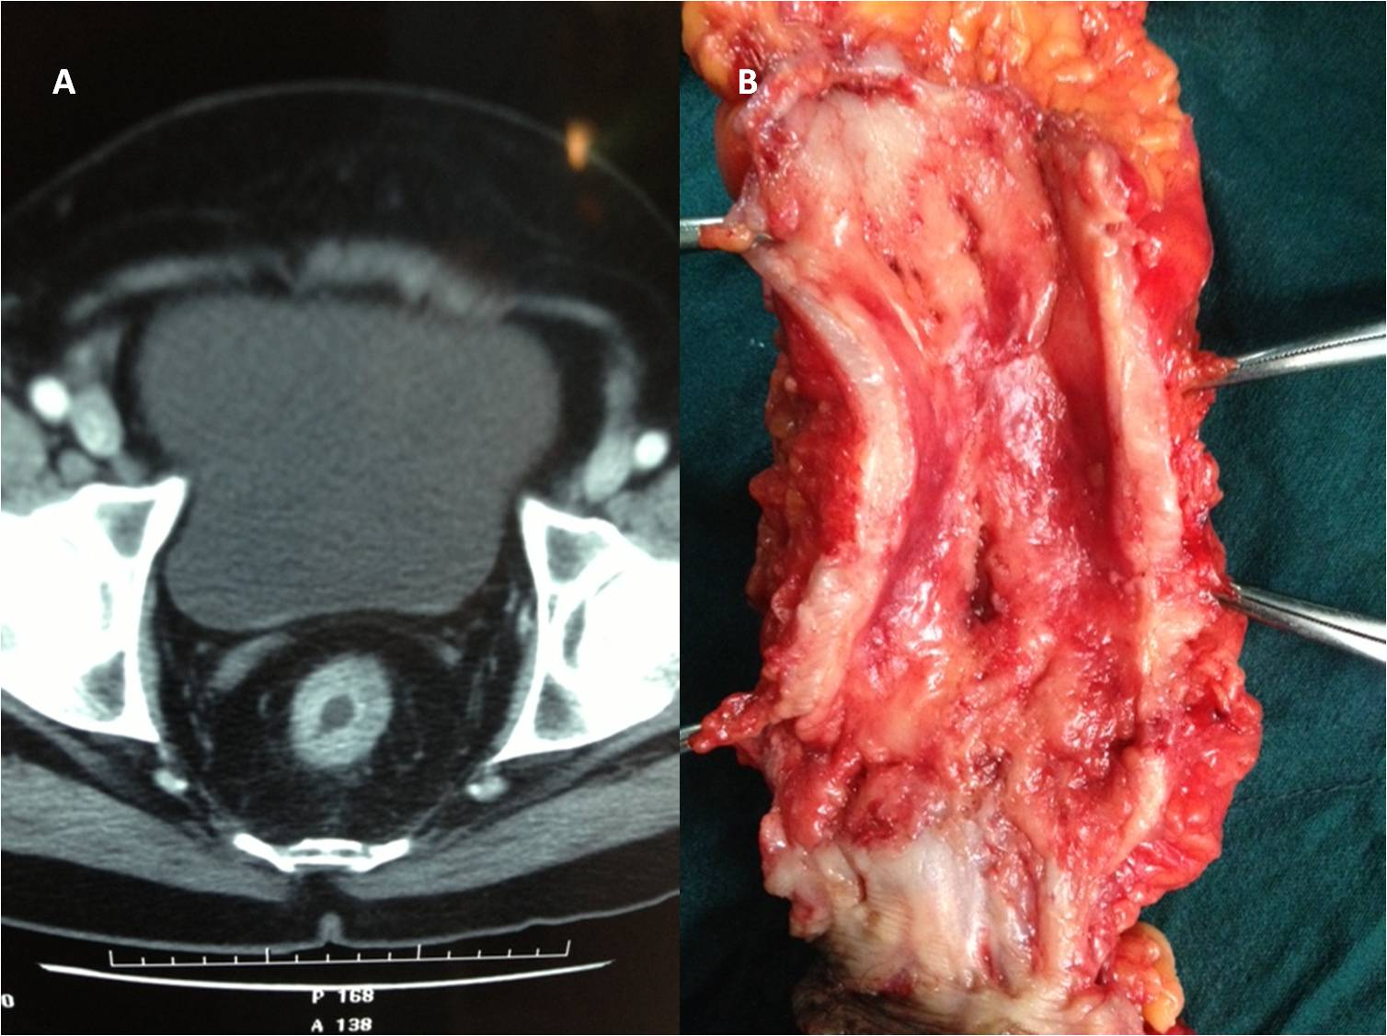
Surgical specimen of a stricturous lesion in the lower rectum with thickened rectal wall
CT scan of a stricturous lesion in the lower rectum with no response to C-RT

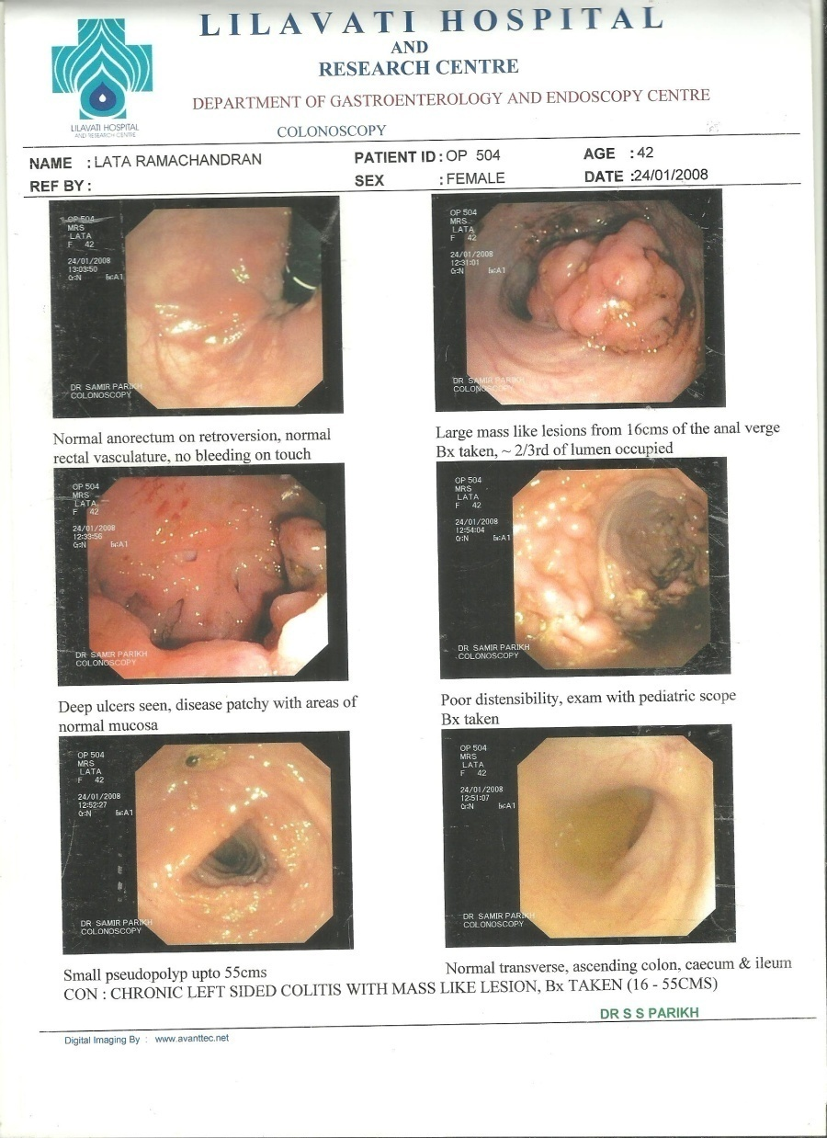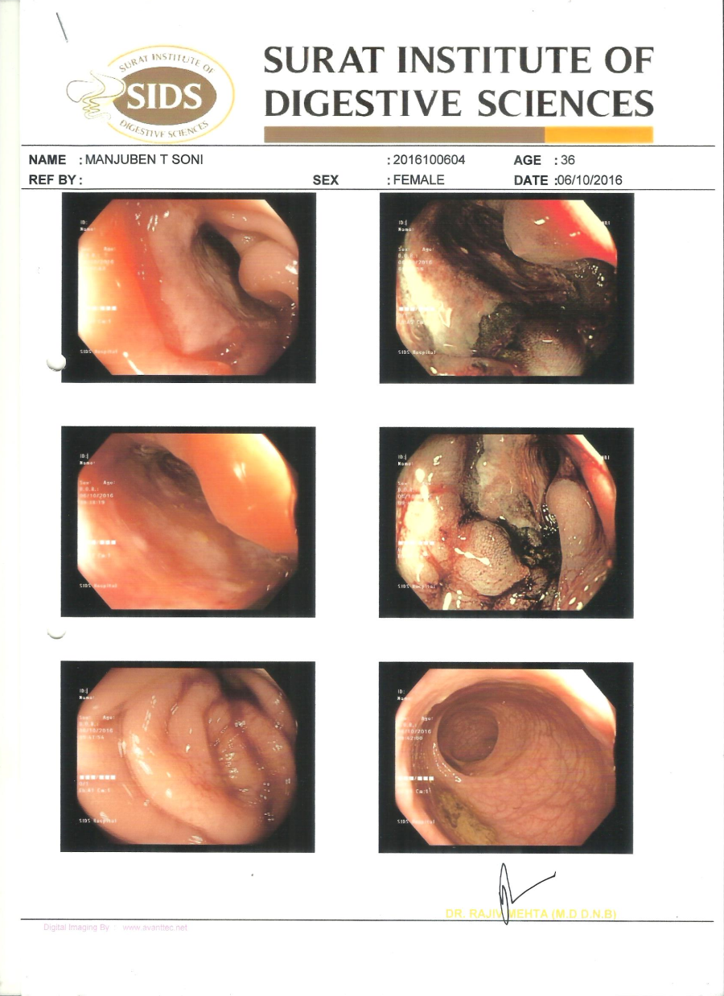
Complete response to C-RT with
residual ulceration & Bx -ve
Proliferative lesion in the mid rectum
mid rectum

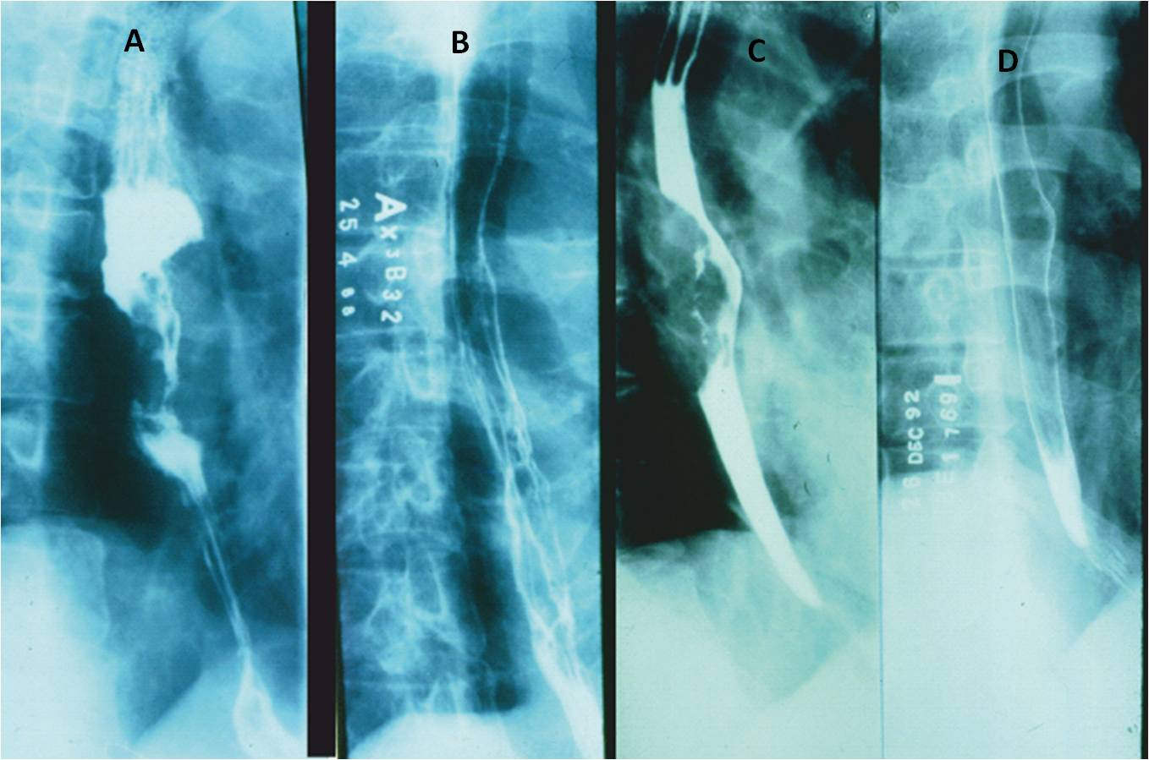
Barium Swallow showing a proliferative growth in the Esophagus.
Complete response after C-RT. Normal Barium Swallow

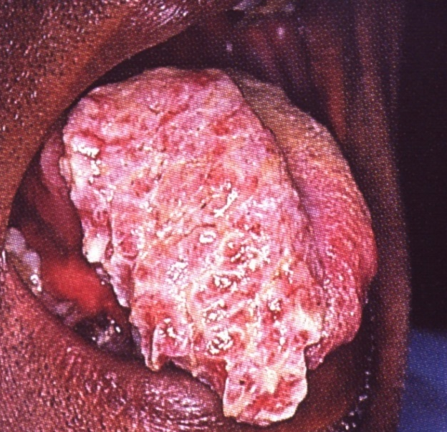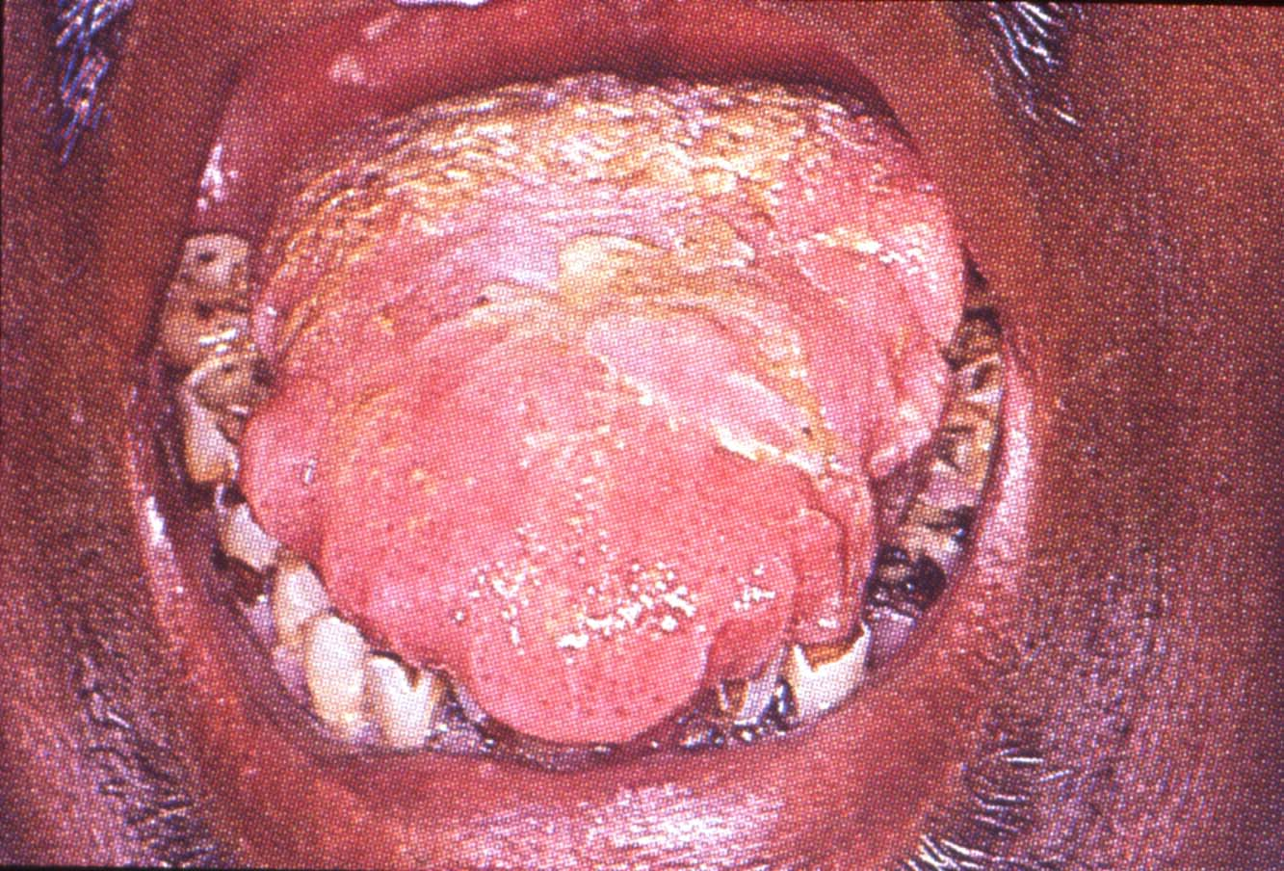
Proliferative lesion of the tongue shows complete response to chemotherapy

1) Dr Ratna Parikh MS FACS FAIS
Surgical Oncology
Breach Candy Hospital
Mumbai - India
Contact No. +91 9820106072
2) Dr Praful Desai MS FRCS FACS
Surgical Oncology
Breach Candy Hospital & Bombay Hospital
Mumbai – India
Contact No. +91 9930318503
BIOGRAPHY
DR MRS RATNA PARIKH- completed my post-graduation in general surgery from Grant Medical College, Mumbai – India in the year 1994. Worked at BY L Nair charitable hospital for 6 yrs. Trained undergraduate as well as postgraduate students. Thereafter worked with Dr Praful B Desai, renowned cancer surgeon and ex director of The Tata Memorial Cancer Centre, Mumbai. I had special training in women’s cancer. Visited MD Anderson and Memorial Sloan Kettering Cancer Centre’s to train in breast cancer. I was bestowed the Fellow of the American College of surgeons in 2012. Presented national and international papers. Published articles and case studies in Indian journals. Co-ordinating editor of the book Practical Clinical Oncology by Dr Desai. Contributed four chapters in the book including on breast cancer. Presently I am attached to Breach Candy Hospital in Mumbai. Visited a rural centre, Barshi in Maharashtra. Recently presented a paper on “Experiences in Organization of Breast Cancer Facilities in Rural India”, at the 7th World Congress on Breast Cancer at Frankfurt in May 2018, which was highly appreciated. The same is published in the International Journal of Cancer Research and Therapy, June 2018.
