Abstracts for Euroscience Conference on Oncology and Oncologists
Paris, France
November 5-6, 2018

David I Smith, Ph.D.
Professor
Mayo Clinic

The DNA Sequencing Revolution and its’ Impact on Clinical Oncology
KeyNote Presentation

Abstract
Advances in DNA sequencing have improved dramatically over the past 10 years. In 2000 the first draft of the human genome was developed using Sanger sequencing technology. This technology required individual DNA molecules to be cloned into E. coli, and then the resulting amplified fragments were sequenced in microliter sized reactions. The cost for the generation of the first draft sequence of the human genome cost almost 3 billion dollars. The advent of next generation sequencing based upon massively parallel sequencing utilized PCR-based methodologies to amplify DNA fragments and also dramatically decreased reaction volumes into the picoliter range. While the first next generation sequencer was capable of 20 million base pairs of sequence per run subsequent sequence technologies were capable of much greater sequence outputs. The Illumina DNA sequencers have now increased sequence output from one billion base pairs to what is now over 6 trillion base pairs of sequence per run. In my presentation I will describe the different next generation sequencing platforms and discuss their strengths and weaknesses. I will further describe the different types of sequencing that can be performed on these platforms and how this will totally transform clinical oncology in just the next few years. These technologies enable true personalized cancer treatment and this will completely change how we can prevent cancers, detect them earlier and also treat each individual patient with cancer.

Recent Publications

- Gao G and Smith DI. Mate-pair sequencing as a powerful clinical tool for the characterization of cancers with a DNA viral etiology. Viruses 20156: 7(8): 4507-4528.
- Gao G and Smith DI. Role of the common fragile sites in cancers with a human papillomavirus etiology. Cytogenet Genome Res 2016: 150(3-4): 217-226.
- Gao G and Smith DI. Human papillomavirus and the development of different cancers. Cytogenet Genome Res 2016: 150(3-4): 185-193.
- Gao G and Smith DI. WWOX, large common fragile site genes, and cancer. Exp Biol Med (Maywood) 2015: 240(3): 285-295.

David I Smith, Ph.D.

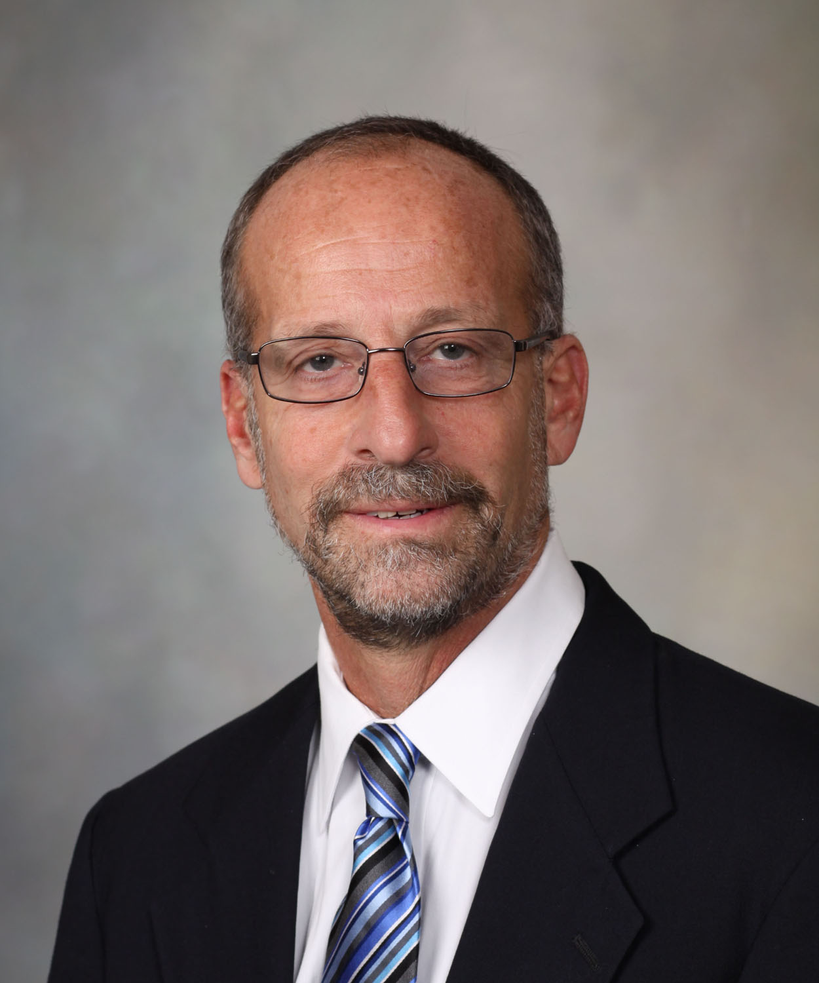

David I Smith received his Ph.D. in Biochemistry from the University of Wisconsin in Madison in 1978. His first academic position was at Wayne State University School of Medicine and in 1996 he moved to the Mayo Clinic as a Professor in the Department of Laboratory Medicine and Pathology. He is also the Chairman of the Technology Assessment Group for the Mayo Clinic Center for Individualized Medicine. His laboratory utilizes next generation sequencing to study the different ways that human papillomavirus can cancer in different tissues. His group also studies the common fragile sites which are regions of profound instability found in all individuals.

Using different next generation sequencing technologies to study the role of human papillomavirus integration in the development of cancer

Absract
Human papillomavirus (HPV) is involved in the development of cervical cancer and a number of other anogenital cancers. It is also increasingly involved in the development of one type of head and neck cancer, namely oropharyngeal squamous cell carcinoma (OPSCC). One key step in the development of many of these cancers is integration of the HPV viral genome somewhere within the human genome, but it is unclear precisely when this occurs, and the precise role that the integration event plays in cancer development. In order to study the different ways that HPV is involved in the development of OPSCC we have been using different genome sequencing technologies to study the physical status of HPV in this cancer. We have used mate-pair next generation sequencing on the Illumina platform and also whole genome sequencing on the BGI Seq500 sequencing platform. This has enabled us to compare these two platforms for their ability to characterize important physical attributes of this cancer including the site of HPV integration, and the resulting dramatic genomic changes of the HPV integration event. We have also been able to determine genome-wide changes in OPSCC separate from the HPV integration event. This work has revealed that HPV integration occurs much less frequently in this cancer than in cervical cancer. Furthermore we have found that the common fragile sites and the extremely large genes contained within these unstable regions are hot-spots for HPV integration in this cancer. We further present evidence that whole genome sequencing technologies provide valuable clinical information about the cancers being sequenced and thus could be used as a clinical tool to characterize each individual cancer to guide clinical treatment strategies.

Recent Publications

- Gao G and Smith DI. Mate-pair sequencing as a powerful clinical tool for the characterization of cancers with a DNA viral etiology. Viruses 20156: 7(8): 4507-4528.
- Gao G and Smith DI. Role of the common fragile sites in cancers with a human papillomavirus etiology. Cytogenet Genome Res 2016: 150(3-4): 217-226.
- Gao G and Smith DI. Human papillomavirus and the development of different cancers. Cytogenet Genome Res 2016: 150(3-4): 185-193.
- Gao G and Smith DI. WWOX, large common fragile site genes, and cancer. Exp Biol Med (Maywood) 2015: 240(3): 285-295.

David I Smith, Ph.D.

David I Smith received his Ph.D. in Biochemistry from the University of Wisconsin in Madison in 1978. His first academic position was at Wayne State University School of Medicine and in 1996 he moved to the Mayo Clinic as a Professor in the Department of Laboratory Medicine and Pathology. He is also the Chairman of the Technology Assessment Group for the Mayo Clinic Center for Individualized Medicine. His laboratory utilizes next generation sequencing to study the different ways that human papillomavirus can cancer in different tissues. His group also studies the common fragile sites which are regions of profound instability found in all individuals.

