HIF‑1α promotes the stemness of oesophageal squamous cell carcinoma by activating the Wnt/β‑catenin pathway
ZHUAN LV，Departments of ¹Hospital Administration，The First Affiliated Hospital of Henan University of Traditional Chinese Medicine;China.
XIAO-QI CHEN，Departments of Gastroenterology , The First Affiliated Hospital of Henan University of Traditional Chinese Medicine;China.

Abstract：Hypoxia-inducible-factor 1α (HIF-1α) is a marker for poor prognosis in the majority of the cancer types, and it has been revealed to be essential for maintaining cancer stem cells (CSCs). In the present study, it was determined that the expression of HIF-1α and CSC-related genes under hypoxic conditions was upregulated. Stable knockdown of HIF-1α significantly inhibited cell proliferation, migra- tion and tumour growth in vivo in oesophageal squamous cell carcinoma (ESCC). A previous study revealed that the Wnt/β-catenin pathway may play a key role in maintenance and progression of CSCs. Therefore, it was also revealed that stable knockdown of HIF-1α reduced the formation of spheroid body cells, the expression of CSC-related genes and Wnt/β-catenin pathway-related target genes, as well as the activity of the Wnt/β-catenin pathway. Collectively, the present results indicated that HIF-1α may regulate the stemness of ESCC by activating the Wnt/β-catenin pathway.

Image：

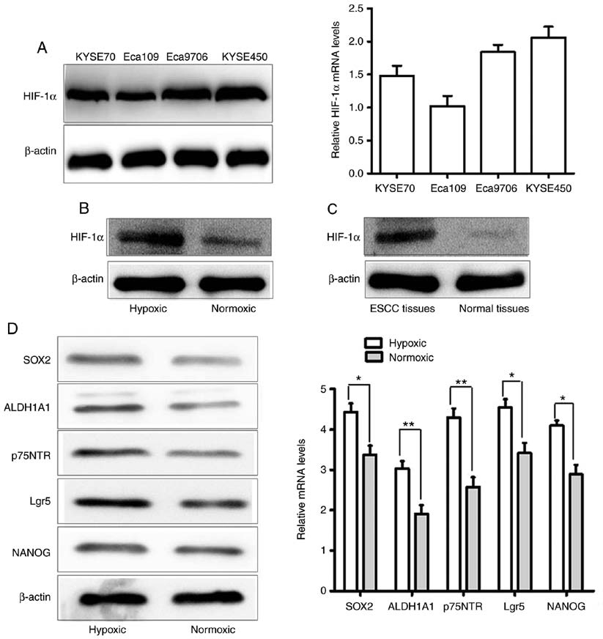
Figure 1. HIF-1α and CSC-related genes are upregulated
in ESCC in hypoxic conditions. (A) mRNA and protein levels of HIF-1α in four ESCC cell lines (KYSE70, KYSE450, Eca109 and Eca9706). (B) The protein expression of HIF-1α in hypoxic conditions (CoCl2 treatment) was higher than in normoxic conditions in ESCC cell line KYSE450. (C) The protein level of HIF-1α was elevated in ESCC tissues, compared with normal esophageal squamous epithelial tissues. (D) qRT-PCR and western blot analysis revealed that the mRNA and protein expression levels of the CSC-related genes Lgr5, ALDH1A1, NANOG, SOX2 and p75NTR in KYSE450 cells was increased under hypoxic conditions, compared with in normoxic conditions (*P<0.05 and **P<0.01). HIF-1α, hypoxia‑inducible factor 1; CSC, cancer stem cell; ESCC, oesophageal squamous cell carcinoma.
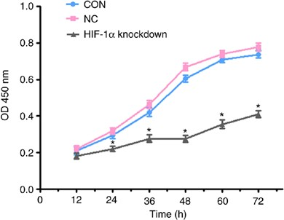
Figure 2. Stable knockdown of HIF-1α decreases ESCC cell proliferation. A cell proliferation assay revealed that the proliferation rate of the HIF-1α-knockdown cell group was inhibited compared to the CON group and the NC group on the third day (*P<0.05). HIF-1α, hypoxia‑inducible factor 1; ESCC, oesophageal squamous cell carcinoma; CON, control cells; NC, negative control cells.

Recent Publications ：
1.Xiaoqi Chen,(2018) LncRNA MIR31HG inhibits The Proliferation of Esophageal Squamous Cell Carcinoma Cells by inducing CellCycle. Progress in Biochemistry and Biophysics ;2018, 45(7): 745~751.
2.Xiaoqi Chen,(2018) Role and mechanism of Dvl3 in the esophageal squamous cell carcinoma.European review for medical and pharmacological sciences;2018; 22: 7716-7725.
3.Xiaoqi Chen,(2017) miR-202 Promotes Cell Apoptosis in Esophageal Squamous Cell Carcinoma by Targeting HSF2,Oncology Research, Vol. 25, pp. 215–223.
4.Xiaoqi Chen,(2016) MicroRNA-202 inhibits tumor progression by targeting LAMA1 in esophageal squamous cell carcinoma,Biochemical and Biophysical Research Communications; 473(2016) 821e827.
5.Xiaoqi Chen,(2016) miR-135a acts as a tumor suppressor in gastric cancer in part by targeting KIFC1,OncoTargets and Therapy;2016:9 3555-3563

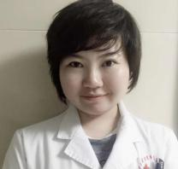 Photograph
Xiaoqi Chen, Ph.D. in clinical oncology combined with Chinese and Western
medicine, is mainly engaged in the clinical, basic and teaching research work of Chinese and Western medicine combined with common diseases of digestive system and digestive system tumors. He presided over the National Natural Science Foundation of China, and participated in the National Science and Technology Major Project as the person in charge of the sub-center. He has published more than 20 academic papers by the first or
correspondent authors, including 7 SCI papers and 2 books.

Email:28050827@qq.com

