Waste bio materials based viscosity reduction and rheological properties of crude
Dr. Salam K. Al‑Dawery, Nizwa, Sultanate of Oman
Mr. Saleh K. Al‑Shereiqi, Nizwa, Sultanate of Oman

Abstract
The effectiveness of using waste bio materials as viscosity reducing agents was investigated on light and heavy crude oils of Oman. The selected materials are fiber of palm tree, date palm kernel and walnut shell. The utilization of waste bio materials is not only considered as a cost effective, but, environmentally friendly and has less effect on crude oil processing as compared to that of chemical additives. In this study, special piping structure was constructed to measure flowabilty time of crude oil. It was observed that use of bio materials reduced oil flowability time by range of 42–50% using particle size 75 μm and by 66% using particle size 150 μm. Moreover, the effect of different additives and various concentrations of bio materials on oil rheological properties, for instance viscosity and yield stress, were also studied. Results showed that the light crude oil exhibits a non-Newtonian viscoplastic behavior following (Bingham plastic model) whereas the heavy crude oil exhibits a non-Newtonian pseudoplastic behavior (shear thinning model). The use of bio materials reduced the limiting viscosities of the light crude oils by 62% using particle size 75 μm and 75% using particle size 150 μm. However, limiting viscosity of heavy crude oil was reduced by 15%. In addition, it was observed that using bio materials lowered yield shear; light crude reduced by average 32% while heavy crude oil reduced by 10%.
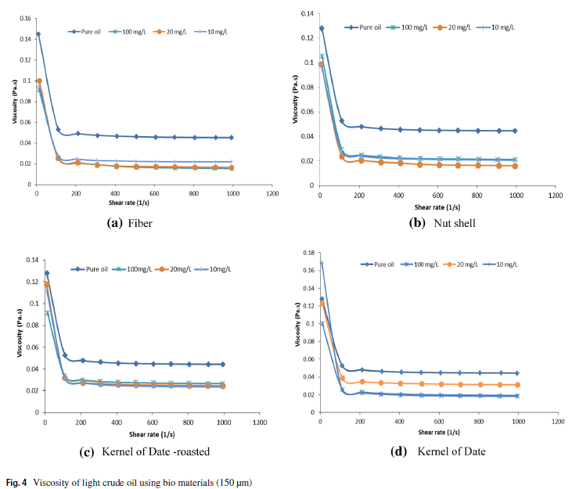

Image

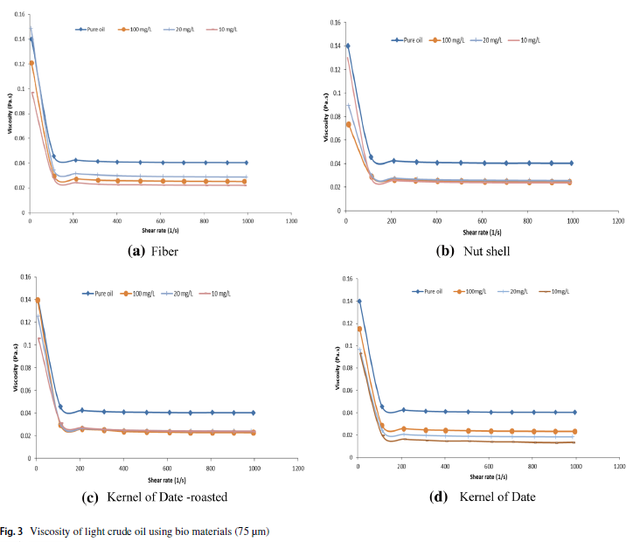
Recent Publications (minimum 5)
- Salam Al-Dawery, Sajjala Sreedhar Reddy, Khamis Al Riyami, and Zainab Said Nasser (2019), Removal of Phenol from Sewage Effluent Using Activated Sludge Coupled with Photo-oxidation Process, Asian Journal of Water, Environment and Pollution, vol 16, issue 1, pp 81-89.
- Salam Al-Dawery and Saleh K. Al‑Shereiqi (2019), Waste bio materials based viscosity reduction and rheological properties of crude oil, Journal of Petroleum Exploration and Production Technology, https://doi.org/10.1007/s13202-019-0612-2
- Salam Al-Dawery and Ashraf Mansour (2018), “Sustainable self-cleaning treatments for architectural facades in developing countries”, Alexandria Engineering Journal, vol.57, pp 867-873.
- Salam Al-Dawery (2017), “Degree of Flocculation and Interparticles Charges of Conditioned Municipal Activated Sludge using Mixed Polymers”, Journal of Macromolecular Science, Part B, VOL. 56, NO. 8, pp 578–594.
- Salam Al-Dawery (2016), “Effects of suspended solid and polyelectrolyte on settling and rheological properties of municipal activated sludge”, Journal of Environmental Chemical Engineering, 4, 4731–4743.

Photograph

Biography
Dr. Salam Al-Dawery received his bachelor degree in chemical engineering at University of Baghdad, Iraq in 1985 and he received master's degree (1988) and PhD degree (1991) in Chemical Engineering at Nottingham University, U.K. He joined Iraqi atomic energy commission, Iraq 1991. Then, he has worked as an associate Prof. of Chemical Engineering at the University of Baghdad (1993 to 2007). Currently, he is working as an associate Prof. of Chemical Engineering and assistant dean for research at the University of Nizwa, Sultanate of Oman. His research interest: process control, rheology and wastewater treatment. He supervised many Master and PhD theses and he has more than 68 publications. He received certificate of Thanks (2017) awarded by the president of Majlis Al Shura in the Sultanate of Oman for his contribution to legislation a law for treatment and re-use of wastewater in the sultanate of Oman. Also, he received best Professor in Chemical Engineering (2014) awarded by the Asian Education Leadership Awards.
Email: salam@unizwa.edu.om
Notes/Comments:

