Advanced Convolutional Deep Neural Networks classify Seismic Features in 3D Images.
Keith R. Holdaway, FGS SAS Institute Inc.

Abstract (300 word limit)

Objectives/Scope: We present a novel seismic image methodology implementing Deep Learning Convolutional Neural Network layers to classify key Direct Hydrocarbon Indicators (DHIs) from high resolution picture files. The soft-computing techniques automate and enhance the process of identifying, extracting and modeling geophysical features such as faults, stratigraphic and structural traps from subsurface seismic volumes.

Methods, Procedures, Process:

We discuss supervised and unsupervised pattern recognition techniques by way of a simple preprocessing technique that creates many small image patches from larger images. These patches encourage the learned patterns to have local scale, which follows well-known statistical properties of natural images. In addition, these patches reduce the number of features that are required to represent an image and can decrease the training time that algorithms need to learn from the images. If a training label is available, a classifier is trained to identify patches of interest. In the unsupervised case, a stacked autoencoder network is used to generate a dictionary of representative patches, which can be used to locate areas of interest in new images.

Results, Observations, Conclusions:

The results demonstrate that we can develop a classification model which is able to distinguish between fracture and non-fracture regions in post-stack seismic data images.

Overall, the proposed approach has potential applications for fast reservoir characterization by identifying DHIs in massive 3D and time-lapse seismic datasets. Additionally, it has the potential to be embedded in coupled workflows for describing near-wellbore characteristics in unconventional reservoirs based on seismic and production data.

Novel/Additive Information: The novelty of this approach is that it adapts a highly efficient pattern detection method to perform fast probabilistic identification of macro-seismic features in post-stack seismic data images. This methodology would therefore help to speed up interpretation of massive 3D seismic datasets in multivariate, heterogeneous reservoirs, to better assist reservoir management and decision-making.

Image

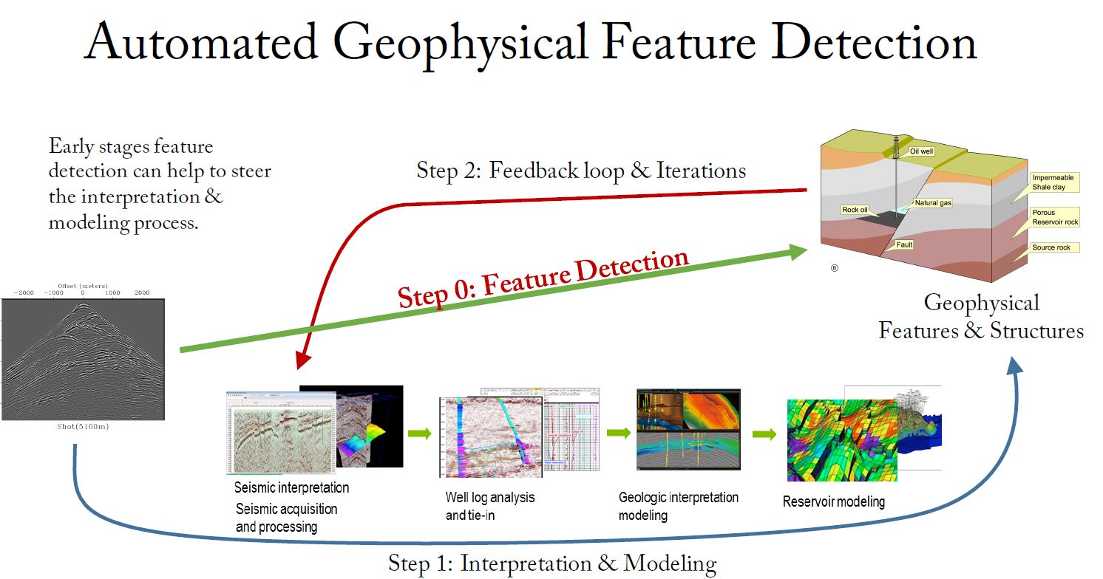

Recent Publications (minimum 5)

- SPE 153454 Predictive Analytics: Development and Deployment Data Driven Models 2012 Latin American and Caribbean Petroleum Engineering Conference Mexico City, Mexico

- SPE 149787 Maximize Placement of Wells and Production in Unconventional Reservoirs: Part2 2012 SPE/EAGE European Unconventional Resources Conference and Exhibition, Vienna, Austria

- SPE 167428 Data Mining Methodologies enhance Probabilistic Well Forecasting 2013 SPE Middle-East Intelligent Energy Conference, Dubai, UAE

- SPE 176820 Drilling and Completion Optimization in Unconventional Reservoirs with Data-Driven Models 2015 SPE Asia Pacific Unconventional Resources Conference and Exhibition, Brisbane, Australia, 9-11 November 2015

- SPE 175606 Derived Seismic Attributes underpin Reservoir Characterization in Data-Driven Methodologies 2015 SPE Reservoir Characterization and Simulation Conference and Exhibition, Abu Dhabi, UAE, 14-16 September 2015

Biography (150 word limit)
Keith R. Holdaway, upstream domain expert across the global oil and gas industry practice, provides SAS customers and prospects with consulting expertise based on 19 years of experience as a geophysicist for BP, Shell and several consultancy companies, living in London, Dubai, Muscat and Houston. He graduated with degrees in geology and geophysics from Durham University in United Kingdom. He has authored two books published by Wiley on data driven analytics in O&G as well as 12 SPE technical papers. He holds 2 patents. An active member of the Society of Exploration Geophysicists, and the Society of Petroleum Engineers, he regularly talks at international conferences. He is also a Fellow of the Geological Society of London.
Email: keith.holdaway@sas.com

