Diversity of diatom (Bacillariophyta) flora from the coastal waters of Pakistan: A review on ecology and taxonomy

Dr Tahira Naz
Center of excellence Karachi University Karachi Pakistan
Current resident at Maputo Mozambique.

Abstract

The paper presented here is a first comprehensive research on diatoms community structure, functioning and its response to the various physicochemical parameters of Manora channel (North Arabian Sea). This research overall objective is to analyze population structure of bacillariophytes and how their abundance and species composition vary seasonally. One of the main aims of studies of diatoms ecology is to be aware of the factors that regulate phytoplankton production and their seasonal succession in marine ecosystem of coastal waters of Karachi, Pakistan. Diatom community was analyzed by using bimonthly collected samples at Manora Channel coastal waters of Karachi, north Arabian Sea bordering Pakistan through the period of May 2002 to July 2003, July, 2007 and November, 2008 from two stations. These studies also discovered toxin producing Pseudo-nitzschia diatom species through light (LM) and scanning microscopy (SEM) for the first time from Pakistan helping the better understanding pollution tolerant and toxic species from regional waters. An important objective of present studies is to evaluate the growth rate of natural diatom communities from Pakistani waters. The growth rate data reflects on the turnover of diatom species and hence primary productivity of the water column.

Methodology
Sampling was done bimonthly from May 2002 to July 2003, July, 2007, November, 2008 at the Manora Channel located on the estuary of Layari River. The study area represents the coastal waters of Karachi from where industrial effluents entering the Channel and causing the coastal pollution in the vicinity of the city. Samples of water were taken at two station established for regular sampling (Figure 1).
Station A, Manora Channel (inside) a polluted area with impact from Layari River and mangrove ecosystem (24˚49.77'N 66˚57.85'E).
Station B, Outside Manora Channel (open waters) a relatively non-polluted station with more oceanic ecosystem influence (24˚47.93'N 66˚58.87'E).
Water parameters like temperature (thermometer), salinity (refrectometer), dissolved oxygen (DO; Wrinkler’s method: Hanna C100), pH (Hanna HI9023, Italy) and chlorophyll a were also measured and correlated with total abundance of diatoms at both stations A and B. For the analysis of chlorophyll a 250mL of sample were passed through GF/F filter papers and extracted with 90% acetone solution, then analyzed spectrophotometrically (Strickland and Parsons, 1972).

Samples for scanning electron microscopy (SEM) were prepared for SEM by KMNO₄ oxidation method (Sournia, 1978).
Estimation of diatom growth rate was done using in situ incubation method (Furnas, 1990). Growth rates of total community and diatom species were calculated from increase and decrease of cell numbers (Smayda, 1973) by following formula
µ (doublings d-^{l}) = (l/T) log (T24/T0)
Where,
T is the incubation period (d) and T0 and T24 are the initial and final cell numbers. For consistency, all growth rates are expressed on a log basis (doublings d^{-l}). No growth rates were calculated when a species was not observed and net loss occurred in the samples.

Findings:
Ecological studies
Ecological studies included the seasonal abundance of diatom, species composition and variations in physico-chemical properties related with it. This variation was due to the influence of monsoon system existing in the region. Primary productivity and hydrographical parameters in the northern Arabian Sea are greatly affected by the monsoon system that prevails from May to October for southwest monsoon and between November and March for northeast monsoon. The total phytoplankton community was dominated by diatoms (personal communications). Seasonal change in chlorophyll a has shown a strong negative correlation with diatom abundance. Highest total average abundance of pennate diatoms was observed at both stations as compared to centric diatoms. Statistical analysis shows overall lower species diversity from 0.1 to 3.6 at both stations (Figure 3). The analysis of chlorophyll during the study period showed highest value in the season of summer in the month of June, 2002. During this time total abundance of diatom population abundance was very low. High values of chlorophyll a and low abundance suggests that picoplanktons were dominating component at that time.
Distribution pattern and seasonal variations in cell abundance of dominant, abundant, frequent and rare species were observed, in which seven dominant species were recorded from station B and six dominant species from station A (plate 1). Among both centric and pennate diatoms, the genera Chaetoceros affinis, Pleurosigma sp, Thalassiosira sp, Navicula directa and Nitzschia longissima, Rhizosolenia setigera, Thalassionema nitzschoides remain dominated all year although seasonal variations in their cell abundance were observed.
Growth rate of diatoms were analyzed by 24 hours in situ incubation technique. Sampling was done at two stations, station A located inside the channel and station B outside the channel. The diatom species dominated in the community were Nitzschia closterium, Nitzschia longissima, Pleurosigma spp and Thalassiosira sp. Total community growth rate was negative -0.11d⁻¹ in summer and -0.7 d⁻¹ in winter but individual species have given positive response of growth even in the presence of grazers.

Statistical analysis

Shannon and weaver diversity index (H΄): Shannon and Weaver, (1949) diversity index (H) was calculated by the equation:
H΄ = -Σ Pi 1n Pi
where,
H΄ = Diversity Index, pi = Relative percentage of specie
Species richness index (d): The equation below was used for calculating species richness.
d = (S – 1)/ Log N
where,
d= Species richness index, S = Number of species in a population, N = Total number of individuals in species.
Species equitability
j = H΄ / Log2 S
J = Equitability index, H΄ = Shannon and weaver index, S
= Number of species in a population.

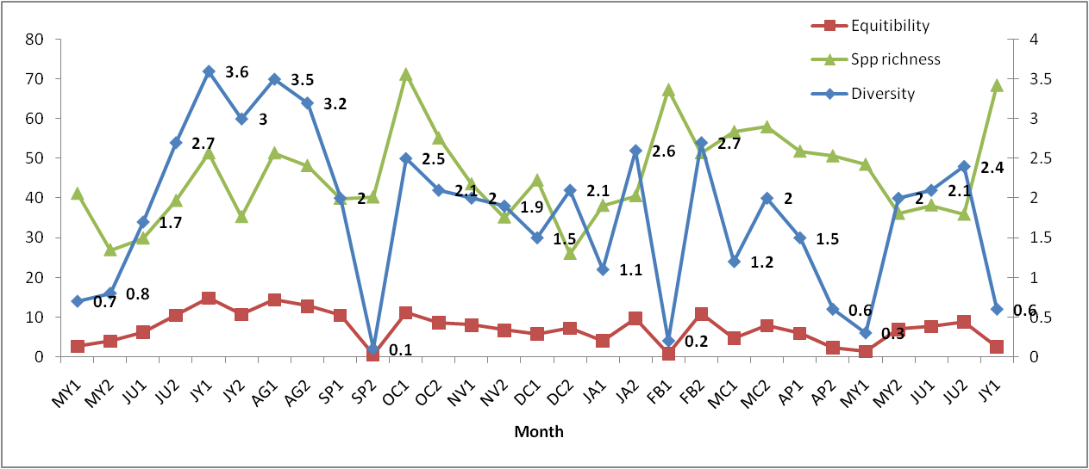
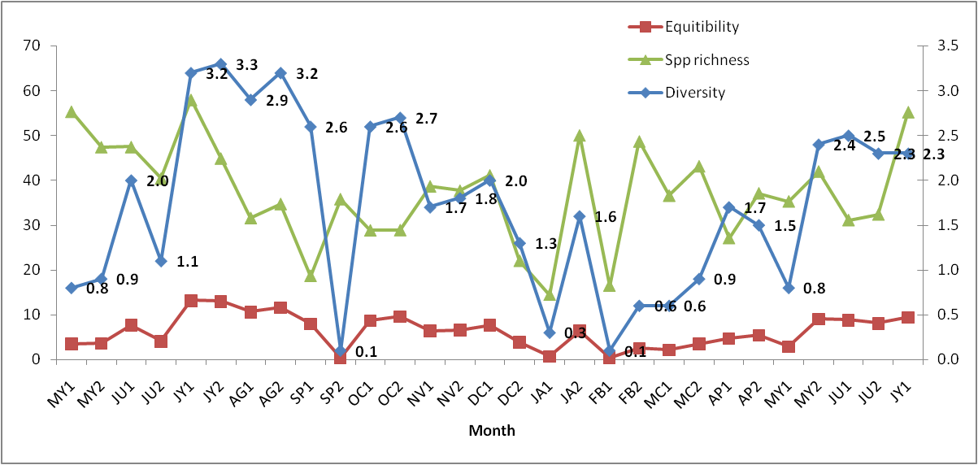

Taxonomical studies
During the taxonomical studies toxic Pseudo-nitzschia species were detected in the samples. The taxonomical differences were observed for Pseudo-nitzschia pungens, P. fraudulenta and P. subfraudulenta. Their seasonal abundance was also calculated. This investigation showed that Pseudo-nitzschia species have comparatively high abundance at station A located inside Manora Channel and this could be attributed generally to the influence of domestic and industrial effluents being regularly pumped in through Layari River. The increasing trend of eutrophication in the region due to these river inputs benefits the harmful species to proliferate and form blooms.

Conclusion and significance
The present study will provide detailed account of diatoms community including their seasonal abundance, species composition, taxonomy and growth of harmful bloom forming and toxin producing diatoms species inhabiting coastal waters of Karachi Arabian Sea (Indian Ocean). Seasonal succession of physicochemical parameters like salinity, temperature, dissolved oxygen and pH were monitored during the study period. Seasonal change in chlorophyll a has shown a marked seasonality and has strong negative correlation with diatom abundance. Overall low species diversity (diversity index) 0.1 to 3.6 at both stations (Fig 2) may be due to the high organic loads which has been shown to reduces the abundance and diversity of diatom communities. The coast of Karachi consistently facing two features, one is the reversal of monsoon systems and the other is increasing pollution. These two features continue to affect the primary productivity. These hydrographical changes are sufficient to change the abundance, biomass and composition of diatom species along the coast. Present study is the first detailed record of bloom forming toxic species namely, Pseudo-nitzschia pungens, Pseudo-nitzschia fraudulenta and Pseudo-nitzschia subfraudulenta including their seasonal abundance and taxonomic identification from coastal waters of Pakistan (Naz et al., 2011). HABs (harmful algal bloom) species are increasing worldwide because of increasing pollution and eutrophication phenomenon. Our study area (Manora Channel) is also facing the problem of eutrophication and the presence of the toxic species showed the possible relation of these species abundance with nutrient enrichment. Present research has contributed in the field of diatoms studies neglected for many years from this region. This work will provide initial information and guideline for future investigations and there is still a need of better understanding regarding the diatom communities and a long-term monitoring program should be initiated.
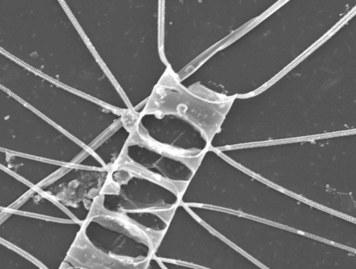
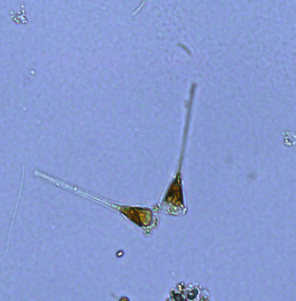
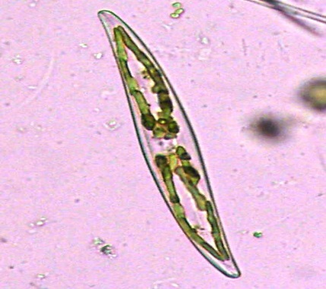

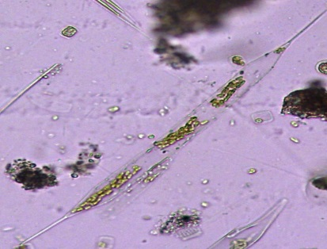
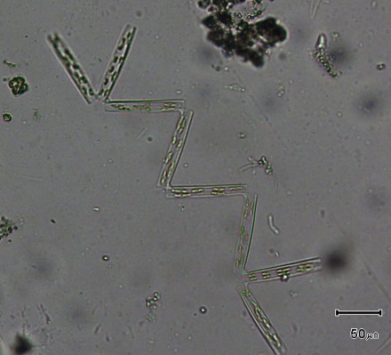
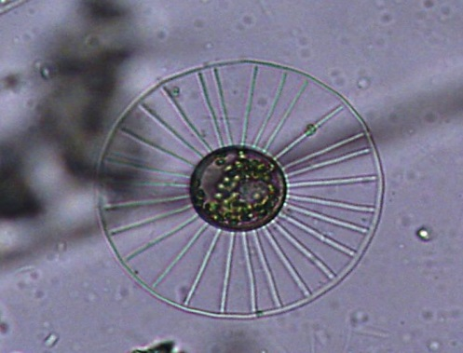

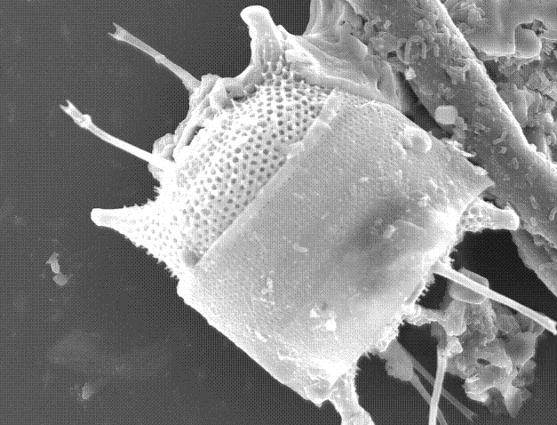

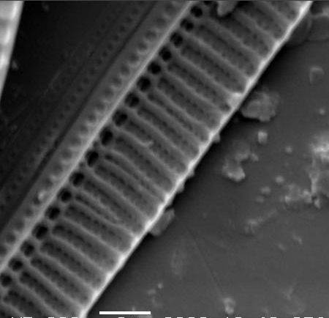
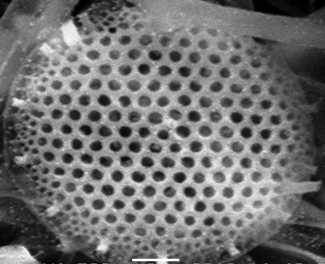
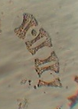

Plate. Micrographs of some diatom species (LM, SEM). Pleurosigma sp, Chaetocerose decipience, Thalassiosira sp, Thalassionema nitzschoides, Pseudonitzschia pungens, Asterionellopsis glacialis, Planktonella sol, Eucampia zodiacus, Guinardia flaccida.

Recent publications
1. Occurrence of HAB and toxic Dinoflagellates species from the coast of Karachi, Pakistan. (2018). Indian journal of Geomarine science.47(01)73-88.
2. Species composition and abundance of dinoflagellates from the coastal waters of Pakistan. (2016). Journal of Coastal Life Medicine. 4 (1) 930-939.
3. Growth rates of dinoflagellates along the Karachi coast assessed by the size fractionation method. (2015). Oceanological and Hydrobiological studies. 44:326-334.
4. Potential harmful dinoflagellates (Dinophyceae) from the coast of Pakistan. (2012). Harmful Algae Proceedings, ISBN:978-87-990827-1-1. 14, 138-140pp.
5. Seasonal abundance of diatoms in correlations with the physicochemical parameters from the coastal waters of Pakistan. (2013). Pakistan j of Botany. 45(4): 1477-1486.


Biography

Dr Tahira Naz (PhD, Post doct) currently resident at Maputo, Mozambique, has expertise and skills in marine ecology, taxonomy of harmful diatom species, Light microscopy and scanning electron microscopy, phytoplankton distribution, Biovolume and biomass of diatom species, Growth rate measurements of diatom species.

nazdrtahira@yahoo.com

Manufacturing of alkene phosphatases from marine organisms with potential functions and industrial applications
XXXX, RN PhD, TLI Foundation, USA
XXXXXX, RN PhD, TLI Foundation, USA

Abstract (300-word limit)
Statement: Over half the population of US is crowded close to the shores, partly because of entertaining and artistic considerations. More and more, however, the near shore ocean is the receiver of a multitude of toxic or aggressive materials. Until recently the oceans with their vast area and volume have seemed safe site for the disposal of wastes. Recent events are causing second thoughts. (ABELSON, 1971).
Methodology and Theoretical Orientation:
Findings:
Conclusion and Significance:
Image:
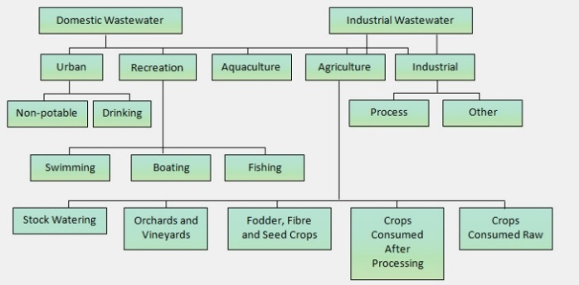
Recent Publications (minimum 5)
- Recent research studies by NOAA scientists have shown that even insignificant amounts of petroleum. (IXTOC I, 1979)
- Heilig M, Eglin M (2006) Pharmacological treatment of alcohol dependence: Target symptoms and target mechanisms. Pharmacology and therapeutics 111:855-876.
- Li X, Schwachman MG, Chaudry IH, Choudhry MA (2008) Acute alcohol intoxication potentiates neutrophil-mediated intestinal tissue damage after burn injury. Shock 29:377.
- Bell PR (1992) Eutrophication and coral reefs – some examples in the Great Barrier Reef lagoon. Wat Res 26:553–568
5. Sullivan EV, Zahra NM (2008) Neuroinflammation as a neurotoxic mechanism in alcoholism: Commentary on “Increased MCP-1 and microglia in various regions of human alcoholic brain”. Experimental neurology 213:10-17.

 Biography (150-word limit)
Smith Walker has his/her expertise in xxxxxxx. His / Her open and contextual evaluation model based on xxxxxxxx. He / She has built this model after years of experience in research, evaluation, teaching and administration in organization. The foundation is based on fourth generation evaluation (Guba& Lincoln, 1989) which is a methodology that utilizes the previous generations of evaluation: measurement, description and judgment. It allows for value-pluralism. This approach is responsive to all stakeholders and has a separate way of focusing.
Email: andrXXX@xxxmail.com

Notes/Comment

