Investigation of Herbivore Marine Populations’ Diversity and Abundance at Bidong and Redang Islands, Kuala Terengganu, Malaysia
Emmanouil Symigdalas, MSc Marine Sciences, Heriot-Watt University

The aim of this project was to investigate the population diversity and abundance of herbivore marine species in Redang and Bidong Island, Kuala Terengganu. Herbivore species include, Fish, Invertebrates, Marine Mammals and Sea Turtles. In this project, the target groups were the Herbivore fish species and the sea urchins from the group of invertebrates. The most significant hypothesis of this project, was to confirm whether there is a difference (in terms diversity and abundance) between the populations found within the Marine Park area of Redang Island and out of its borders. Based on Information supporting that fishing activities are not permitted in the Marine Park area, it was more probable that the herbivore species populations would be more abundant and diverse there than in areas where fishing is allowed.
During the time period of May 2017- July 2017, Underwater surveys were conducted around Redang and Bidong Island. Survey sites were carefully chosen, to make sure that the data which will be collected are reliable, cover a satisfying area of the location and can be used for further analysis. There were two different types of data collection. The first one, was the underwater transect survey and the second one was the quadrat sampling. By using these methods both quantitative and qualitative data were acquired. This project can be described as a monitoring research, which focuses on the healthy state of the coral reefs in terms of species biodiversity and abundance.
The conclusions which were formulated after the data analysis confirmed the main hypothesis of the project. The Marine Park Area of Redang Island was more abundant, both in terms of herbivorous fish species and Sea Urchins. Furthermore, the biodiversity within the marine ecosystems of Redang Island was found to be higher than those in Bidong Island. The fishing regulations and prohibitions of the Marine Park organization have a positive impact towards the local coral reef ecosystems. Moreover, a part of this project focused on whether the herbivorous population affect the algae coverage of the different areas. By the end of the data analysis it was confirmed that herbivorous populations affect the percentage of algae coverage, and that due to the higher herbivorous fish population of Redang Island, algae coverage is lower than in Bidong Island. Further Research, may focus on a wider range of animal groups and ways to control the size of these populations in a sustainable way.

The methodology of the Project consisted of several underwater surveys such as:
- Underwater Belt Transect
- Underwater Invertebrate identification transect
- Underwater quadrant photography
All data collected where then analyzed and illustrated in graphs which will be accordingly presented.

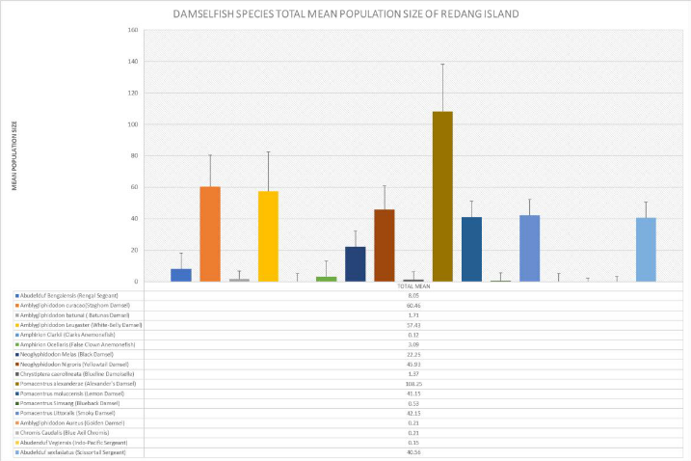
Example of graph from the project illustrating the species of damselfish of Redang Island, Malaysia.

FURTHER PRESENTATION
In addition, the second part of the presentation will be based on technologically advanced ways of surveying and monitoring underwater reef ecosystems. Currently, a team based in Greece is working on designing a machine which will be not only capable of monitoring reef ecosystems autonomously but also contain artificial intelligence which will allow it to draw conclusions and act independently. By being autonomous, robotic and artificially intelligent this machine will be able to create a systematic view of the coral reef condition without the help of underwater survey teams or any other expenses economical or in time around the world. This design and the progress of the project will be presented in the 13th edition of International Conference on Oceanography and Marine Biology in November 2019 in London.

Recent Publication:

Investigation of Herbivore Marine Populations’ Diversity and Abundance at Bidong and Redang Islands, Kuala Terengganu, Malaysia (PENDING)
Emmanouil Symigdalas, MSc Marine Sciences, Heriot-Watt University

Upcoming Project Publications and progress:

Analysis, Research and design of complete artificial intelligent and systematic systems for underwater coral reef surveying.
Emmanouil Symigdalas, MSc Marine Sciences, Heriot- Watt University
Kelyphos, Innovative design solutions

Investigations of Marine Organisms’ Diversity and Abundance in Dryonissi Island, Paros Greece with the potential establishment of Marine Protected Areas around Cyclades Islands and the Aegean Sea.
Emmanoui Symigdalas (Project Leader) MSc Marine Sciences, Heriot- Watt University
Paros Diving Center: Assistant Research and Scientific Diving team



Name: Emmanuel Symigdalas
Date of Birth: 18 April 1995
Email: manolis.symigdalas@gmail.com
Studies: MSc Marine Sciences, Heriot-Watt University 2016-2017
BSc Biology Portsmouth University 2013-2016
Area of expertise: Underwater reef Surveying and Coral reef monitoring

Emmanuel Symigdalas is a marine scientist who has worked for the last 3 years on Marine Research teams around the world. He began his career as an underwater survey and research assistant at Heriot-Watt University and University Malaysia Terrengannu. During his time in Malaysia he had the chance to work on many projects including his own dissertation. All of the projects were focusing on Marine ecosystems monitoring and surveying. Furthermore, in 2018 Emmanuel was part of a research team which teaches volunteers about coral reef and shark conservation in Fiji Islands and also collaborates with Reefcheck Pacific. Nowadays, he is currently working on two projects. The first one is the Analysis, research and design of complete artificial intelligent and systematic systems for underwater coral reef and reef surveying. Finally, the second one is the Underwater surveying of Dryonissi island in Paros Island, Greece. This project focuses on understanding the reasons which cause destruction to the underwater ecosystems and also establish Marine protected areas without affecting local coastal communities which depend on the fisheries and ecosystems of the designated target areas.

