Spatial decision support tools for seaweed aquaculture planning in the Solomon Islands.

Dan Breen, Auckland University of Technology

Antony Vavia, Auckland University of Technology

Clayton Chan, Auckland University of Technology

Wesley Garofe, Solomon Islands Ministry of Fisheries and Marine Resources

Mahuri Robinson, Triland Trading

Sebastian Misiga, Solomon Islands Ministry of Fisheries and Marine Resources

Sylvester Diake, Solomon Islands Ministry of Fisheries and Marine Resources

James Teri, Solomon Islands Ministry of Fisheries and Marine Resources

Rosalie Masu, Solomon Islands Ministry of Fisheries and Marine Resources

Ronnelle Panda, Solomon Islands Ministry of Fisheries and Marine Resources

Ruben Sulu, Solomon Islands Mekem Strong Solomon Island Fisheries (MISSIF)

Anne-Maree Schwartz3, Mekem Strong Solomon Island Fisheries (MISSIF)

Richard Walter, University of Otago

Jillian Fenigolo, Auckland University of Technolog

Armagan Sabetian, Auckland University of Technology

Lindsey White, Auckland University of Technology

Abstract (300-word limit)
Seaweed cultivation can provide important income in remote areas and significant exports for nations like the Solomon Islands. It can also provide a sustainable alternative to more extractive industries like forestry, fishing and terrestrial agriculture. We describe spatial decision support tools developed to help planners and policy makers in the Solomon Islands identify sites suitable for cultivation of the commercially grown seaweed Eucheuma. We identified physical, biological, economic and social factors influencing the suitability of locations for farms and mapped 35 existing, previous or potential locations for seaweed cultivation. An open source Geographic Information System (GIS) was used to map over one hundred variables approximating suitability for seaweed farming in terms of marine habitat, distance to land, rivers, transport, protected areas and possible social and economic constraints. Multivariate patterns among farm sites were analyzed and mapped and a hierarchical multiple criteria model was used to summarize site suitability. Satellite imagery and aerial photo-mosaics from unmanned aerial vehicles (UAV drones) were used investigate sites in more detail. Locations for seaweed farms could be identified from GIS habitat maps but suitability was also affected by depth, substrata, current, wind and wave action and herbivory by fish, dugong and turtles. Economic and social constraints such as the international market price for seaweed and competing sources of employment were important in encouraging community support for farming. The research provides a means to identify locations for seaweed farms in the Solomon Islands and in other regions throughout the Pacific, potentially providing important income for island communities and mitigating increasing global carbon dioxide emissions.
Methodology and Theoretical Orientation:
Physical, biological, social and economic variables likely to affect the suitability of locations for seaweed farming were identified from literature and from discussions with the Solomon Islands Ministry of Fisheries and Marine Resources staff and consultants. These were refined during discussions with managers, consultants and stakeholders, rated according to their importance in general and for specific farm sites, approximated in spatial GIS analyses and incorporated into GIS displays, multivariate analyses and multiple criteria analysis.
Multiple criteria analysis has been widely applied in business management and environmental impact assessment (Edwards 1977, www.infoharvest.com, www.expertchoice.com), with applications also in fisheries (Mardle and Pascoe 1999) and selecting protected areas (Guikema and Milke 1999, Villa et al. 2002, Breen et al. 2002). The techniques incorporate weighting of multiple criteria, calculation of trade-offs, representation of uncertainty, sensitivity analyses of the relative influence of different criteria, and the ability to combine and assess alternative models, data and sources of opinion. The simplest is the Simple Multi Attribute Rating Technique (SMART) which evaluates alternatives according to a hierarchical tree of criteria nested within more general objectives under a single, broad goal. Variables describing the suitability of each site according to each manager or through geospatial analysis were included within a single hierarchical Simple Multi-Attribute Rating Technique (SMART) model using the software Criterion Decision Plus (Infoharvest Inc). Variables rated by seaweed industry managers were weighted in the model according to their perceived importance or influence. Overall scores of site suitability were graphed and mapped, and other scenarios explored using the software interactively.
Findings:
Important findings from the project include that: 1) potentially suitable environments for seaweed farms can be identified from GIS habitat maps (IMaRS-USF 2005); 2) suitability was also affected by depth, substrata, current, wind and wave action and herbivory by fish, dugong and turtles; 3) the market price of seaweed, buying arrangements and competing opportunities for employment in other industries were important economic and social constraints (Hurtardo 2013); 4) surprisingly, distances to the capital city, towns, villages and land appeared less important in an archipelago linked by networks of coastal waterways; 5) while existing databases illustrated broad patterns in factors effecting suitability, there were subtleties in human judgment and interpretation that were not easily captured using GIS data alone and therefore; 6) an interactive exploratory approach combining data and local expertise is likely to be more successful; 7) drone photography and satellite imagery can be used to map farming areas at different spatial and temporal resolutions; 8) GIS can spatially integrate diverse data sources and interactive modeling tools within intuitive visual analyses.
Conclusion and Significance:
The methods can be used to identify locations for seaweed farming throughout the Pacific and in other regions and help plan for sustainable aquaculture and carbon credits to offset greenhouse gas emissions and climate change.
Image:
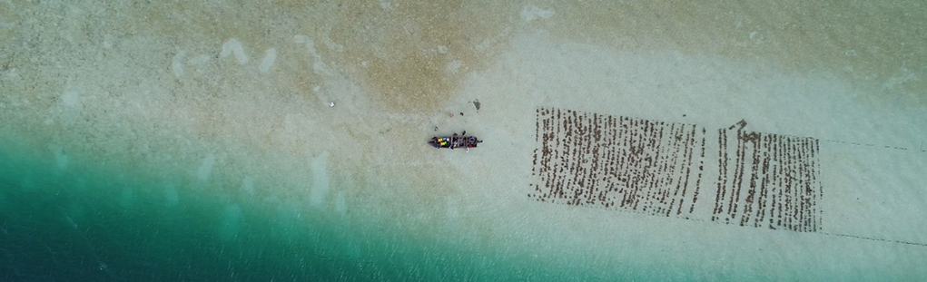
Recent Publications (minimum 5)
- Breen, D. A., Avery, R. P. and Otway, N. M. 2002. Broad scale biodiversity assessments for marine protected areas in New South Wales. In: Beumer. J. P., Grant, A., and Smith, D. C. eds. Proceedings of the World Congress on Aquatic Protected Areas, Cairns, Australia - August 2002. Australia, ASFP Australia..
- Guikema, S., and Milke, M. 1999. Quantitative decision tools for conservation programme planning: practice, theory and potential. Environmental Conservation, 26(3), 179-189.
- Hurtado, A.Q. 2013. Social and economic dimensions of carrageenan seaweed farming in the Philippines. In D. Valderrama, J. Cai, N. Hishamunda and N. Ridler, eds. Social and economic dimensions of carrageenan seaweed farming, pp. 91–113. Fisheries and Aquaculture Technical Paper No. 580. Rome, FAO. 204 pp.
- IMaRS-USF (Institute for Marine Remote Sensing-University of South Florida) 2005). Millennium Coral Reef Mapping Project. Cambridge (UK): UNEP World Conservation Monitoring Centre.
- Villa, F., Tunesi, L. and Agardy, T. 2002. Zoning marine protected areas through spatial multiple-criteria analysis: The case of the Asinara Island National Marine Reserve of Italy. Conservation Biology 16(2) 515- 526.

 Biography (150-word limit)
Dan Breen is a lecturer in environmental science, conservation and Geographic Information Systems (GIS) in the School of Science, Auckland University of Technology, New Zealand. He worked previously with the New Zealand Department of Conservation on marine protected areas and threatened species such as Maui’s dolphin. He also worked at the New South Wales Marine Parks Authority helping to establish marine parks and aquatic reserves and at the Great Barrier Reef Marine Park Authority mapping biophysical data to help protect for over a third of this World Heritage Area within no-take marine reserve zones. Dan's research interests include marine spatial planning, spatial and statistical modelling, and applying GIS based decision support systems.
Email: dbreen@aut.ac.nz

Notes/Comment

