Eelgrass detection from under water videos
Sayantan Sengupta, PhD researcher, DTU Compute, Denmark
Anders Stockmarr, Associate Professor, DTU Compute, Denmark

Abstract (300-word limit)
Benthic vegetation is arguably one of the most important indicators of the state of marine environment. The role of eelgrass is often compared to that of a forest as its presence signifies healthy ecosystem with enough oxygen, sunlight penetration among other important indicators. Assessment of the status of eelgrass (Zostera Marina) is commonly done using various remote sensing methods such as aerial photography or satellite images. These methods often fail to capture the true scenario beneath the surface of the water if the water is turbid or cloud cover masks the satellite image. As a second alternative, researchers have used under water videos (obtained by scuba, snorkel) to assess the ground truth. Lot of person-hours are invested by the domain experts to manually inspect the video transects. In this paper, we propose a method for automatic detection of eelgrass from video transects obtained from Roskilde fjord, Denmark. We use an edge detection algorithm (LSD) to detect number of lines in a video frame (a proxy for amount of eelgrass) and predict presence/absence status for each video frame using a suitable threshold. We also use Gaussian Mixture Model to cluster regions of presence and absence of eelgrass. Extending these methods, we show that it can also be used to estimate percentage coverage of eelgrass in a given area, which matches well with a domain expert’s estimation. We also show that these methods are robust to noisy observations (non-eelgrass objects like scuba gear, hand movement, orientation of the camera, etc.) and detects rare errors from domain expert. These methods also take care of subjectivity from visual inspection by domain experts (expert opinion can vary) by quantifying the bias in the form of threshold. Predictions can be used as a ground truth on satellite images and extrapolated to regions beyond using machine-learning techniques.

Image:
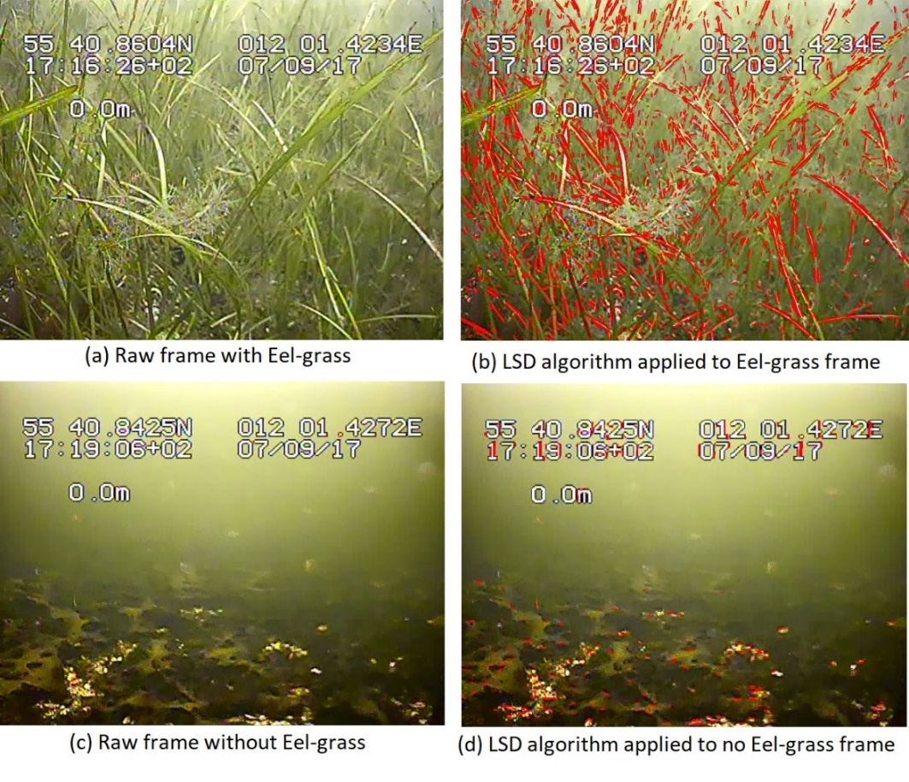
Fig 1: Effect of applying LSD (Line segment detection) algorithm on frames with eelgrass present and absent. It can be seen that there is a clear difference in the number of detected lines in different scenarios.

Recent Publications (minimum 5)
- How a 10-day heatwave impacts barley grain yield when superimposed onto future levels of temperature and CO2 as single and combined factors, Cathrine H Ingvordsen, Michael F Lyngkjær, Pirjo Peltonen-Sainio, Teis N Mikkelsen, Anders Stockmarr, Rikke B Jørgensen(2018), Agriculture, ecosystems & environment, vol 259, 45-52
- Concurrent elevation of CO2, O3 and temperature severely affects oil quality and quantity in rapeseed, Shahla Namazkar, Anders Stockmarr, Georg Frenck, Helge Egsgaard, Thilde Terkelsen, Teis Mikkelsen, Cathrine Heinz Ingvordsen, Rikke Bagger Jørgensen(2016), Journal of experimental botany, vol 67, 4117-4125
- Significant decrease in yield under future climate conditions: Stability and production of 138 spring barley accessions (2015), Cathrine Heinz Ingvordsen, Gunter Backes, Michael Foged Lyngkjær, Pirjo Peltonen-Sainio, Jens Due Jensen, Marja Jalli, Ahmed Jahoor, Morten Rasmussen, Teis Nørgaard Mikkelsen, Anders Stockmarr, Rikke Bagger Jørgensen, European Journal of Agronomy,volume 63, 105-113
- Isokinetic and isometric muscle strength in a healthy population with special reference to age and gender (2009), Bente Danneskiold‐Samsøe, EM Bartels, PM Bülow, H Lund, Anders Stockmarr, CC Holm, I Wätjen, M Appleyard, H Bliddal, Acta physiologica, volume 197,1-68
- Persistence of low-pathogenic H5N7 and H7N1 avian influenza subtypes in filtered natural waters (2013), Anne Ahlmann Nielsen, Trine Hammer Jensen, Anders Stockmarr, Poul Henrik Jørgensen, Veterinary microbiology, volume 166, 412-428

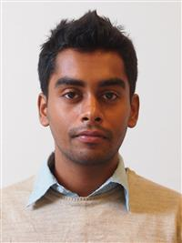
Biography (150-word limit)
Anders Stockmarr (Phd) is an Associate professor of Statistics and Data Analysis in the Department of applied mathematics and computer science, DTU, Denmark. He has authored/co-authored more than 100 published articles in the field of applied statistics. His area of interest is statistical genetics, health care, environment, etc.
Email: anst@dtu.dk

Sayantan Sengupta is a Phd researcher in the Department of applied mathematics and computer science, DTU, Denmark. He has been working in the field of applied machine learning for more than 8 years. His area of interest is applied machine learning, Deep learning, and Bayesian data analysis.
Email: says@dtu.dk

Notes/Comment

