Histological alterations of Microplastic on Digestive Gland of the Mussel Mytilus galloprovincialis L. from Northern Adriatic
Ines Kovačić, PhD, Juraj Dobrila University of Pula, Faculty of Educational Sciences, Croatia, EU
Emina Pustijanac, PhD, Juraj Dobrila University of Pula, Department of Natural and Health Sciences, Croatia, EU

Abstract
The marine environment is polluted by anthropogenic marine debris that consist synthetic polymers – plastic of all shapes, colors and sizes. Researchers have reported that model microplastic particles are ingested and taken up into the marine organism cells and tissues. However, data on microplastic particles and their presence and potential impact on invertebrates from natural environment, especially mussels are very limited. The purpose of this study is to describe the presence and effect of microplastic particles on digestive gland of Mediterranean mussel Mytilus galloprovincialis Lamarck, 1819 from native environments. Mussels were sampled in April 2015, from two sampling sites without anthropogenic impact and one exposed sampling site along Rovinj coastal area, the Northern Adriatic, Croatia. Dissected mussel tissues were cryopreserved, cutted with a cryostat and stained with haematoxylin and eosin. Microplastic uptake into the digestive gland was analyzed by polarized light microscopy. Mussel health status was investigated incorporating histological alterations and semiquantitatively assessment of lipofuscin granule content and digestive gland atrophy. The majority of plastic particles in the mussel digestive gland were fragments between 2 and 80 µm in all mussel samples. Histological observation showed atrophy between digestive gland tubules, abundant content of lipofuscin granules in digestive tubules (cells displayed > 70% of intense lipofuscin) and high number of heterophagosomes (Fig 1). The study provided the evidence that microplastic were uptaked by wild mussels sampled at polluted sampling site and sites without antropogenic activity. Thus, as mussels are filter feeders they are susceptible to uptake of microplastic by direct accumulation in digestive gland and negatively affect the health status. Recommendations are aimed at exploring the mussels health status from nearby aquaculture areas in Northern Adriatic.

Image

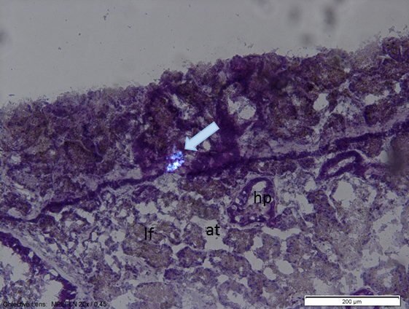
Figure 1: Microplastic particle (arrow) in H&E stained digestive gland section of the Mediterranean mussel in polarized light. Image shows tubule with vacuoles of heterophagosomes (hp), high amount of lipofuscin granules (lf) in digestive gland tubule and tissue atrophy (at).


Ines Kovačić has her expertise in evaluation and observing the health and wellbeing of marine invertebrates. Her research is based on the exploration of the marine mollusks and sea urchin physiology and ecotoxicology. She followed the influence of pollutants by observation of enzymatic changes, lysosomal perturbations and larval deformations. She also investigates the parasites and fungi in tissue cryosections from farmed and native mussels.

Email: ikovacic@unipu.hr

Notes/Comments:

