Divergent Size Phenotype Correspond with Nucleotide Polymorphism and Protein Translate in a Culturable Shellfish in Nigeria
Oyebola, OO (PhD), Department of Aquaculture and Fisheries Management, University of Ibadan, Ibadan, Nigeria
Coker, OM. (PhD), Department of Wildlife and Ecotourism Management, University of Ibadan, Ibadan, Nigeria
Oche, O (Ms), Fisheries Society of Nigeria, Victoria Island, Lagos State, Lagos, Nigeria
Akanmu, OO (PhD), Osun State University, Ejigbo, Osun State, Ejigbo, Nigeria
Alamu, O (Ms), Department of Aquaculture and Fisheries Management, University of Ibadan, Ibadan, Nigeria
Azuh, V (Mr), Department of Botany, University of Ibadan, Ibadan, Nigeria
Idowu, CF (Mrs), National Biotechnology Development Agency, Ogbomoso, Nigeria

Abstract (300-word limit)
Statement: Macrobrachium vollenhovenii are shellfishes inhabiting coastal and freshwater habitats, and are prawns of high protein content. Perceived cryptic genetic and size structure in populations of the species necessitated preliminary biological assessment on divergence in size and DNAsequences of observed morphologic variants of the species for delineation.
Methodology and Theoretical Orientation: 90 samples each of EAAL, SLAL, LLAL (GAALs) and EAOR, SLOR, LLOR (GAORs) being individuals possessing equal left and right side’s chelae/arm (EA-novel), longer left (LL-novel), and shorter left (SL-erstwhile) chelae, obtained from two freshwater habitats (represented as AL and OR) having connection to Lagos Lagoon of the Atlantic ocean in Nigeria, were assessed for size phenotypes: length, L(cm), weight, W(g), and condition factor, K. Subsample’s Partial genome sequences, and the NCBI-reference sequences (NCBIrefseqs) were evaluated for phylogenetic relationship, single nucleotide polymorphism (SNP) and amino acid translates. Phenotypic data were analyzed for differences through ANOVA, and DNAsequences through Mega 6.0 software.
Findings: Respective GAAL had significantly (p<0.05) higher L, W, and K than counterpart GAORs. W and K in EAAL and EAOR were different from respective SLAL and LLAL, and SLOR and LLOR. Sequences formed two main phylogenetic rootings in which three NCBIrefseqs co-rooted with EAAL and EAOR. Other NCBIrefseq co-rooted with SLOR, LLOR, SLAL and LLAL. SNPLocus 91 separated 100%GAAL alongside 100%NCBIrefseqs from 100%GAOR, this translate to Valine. SNPLocus 171 separated EAAL, EAOR, alongside their co-rooted NCBIrefseqs from SLOR, LLOR, SLAL, LLAL and their co-rooted NCBIrefseq, translating to Glycine/Glutamic acid change.
Conclusion and Significance: EA and SL/LL constitute genotypes of divergent sizes having corresponding SNP and amino-acid translates. The genotypes could have habitat strains. NCBIrefseqs were mix of the genotypes probably misconceived as unit. This study provides tools for discriminating intraspecific genotypes of the species in biological studies, and for marker assisted selection for protein diversity in aquaculture.
Image:
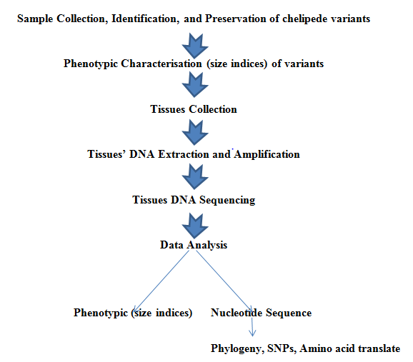 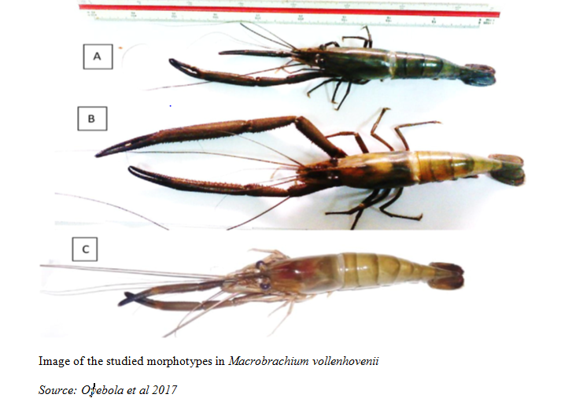Recent Publications (minimum 5)
- Oyebola, O. O, Adelaja, A. S and Adelani, A.S, 2018. Proximate and Amino Acid Profiles of Chelipede Variants of Freshwater Prawn (Macrobrachium vollenhovenii) in Southwestern Nigeria. Tropical Animal Production and investigations, Vol. 20. (in press)
- Oyebola O.O., Efitre J., Falaye A.E., Dada T.M., Idowu F.C. 2018: Agriculture in the Face of Climate-Mediated Flooding in Tropical Africa: Technical Innovations of Fish Farmers in Southwestern Nigeria. In: Leal Filho W. (eds) Handbook of Climate Change Resilience. pp 1-19 Springer, Cham. Online ISBN 978-3-319-71025-9 https://doi.org/10.1007/978-3-319-71025-9_163-1
- Oyebola O.O, Adekunle O.M. and Setufe S.B. 2017: Growth Rate and Disease Resistance of Inbreds and Novel Intra-specific Crossbreds Larva of Clarias gariepinus (Burchell, 1822) in Response to Pseudomonas aeruginosa Challenge. Journal of Experimental Agriculture International 16(6): 1-11. https://doi.org/10.9734/JEAI/2017/32653
- Oyebola, O. O., Jacob, J. M., Omorodion, B. A., Akinsola, Y.Y., Akinade, S., 2017; Molecular marker (allozyme) assisted selection of latent production traits and fingerprints of novel strains of fish (Clarias gariepinus) and shellfish (Macrobrachium vollenhovenii), Aquaculture 472, Supplement 1:66-70 https://doi.org/10.1016/j.aquaculture.2016.07.019
- Oyebola O.O. 2016: Nutritional quality of wastes emanating from processing of genotypes of freshwater Prawn, Macrobrachium vollenhovenii. Cogent Food & Agriculture, Vol., 2, (1). 1268287. https://doi.org/10.1080/23311932.2016.1268287
- Oyebola O.O. 2015. Aquaculture of Freshwater Prawns, Macrobrachium vollenhovenii (Palaemonidae) for Enhanced Food Security: Broodstock Distribution, Genotypes and Larva Production Technology. Oral Presentation, Humboldt International Conference (Humboldt-Kolleg) August 2-7, 2015. Osun State University, Osogbo, Nigeria.


Biography (150-word limit)
Oyediran Olusegun Oyebola (PhD) has his/her expertise in aquaculture and fisheries management. He had Doctoral Degree in Fish genetics and breeding, and a postdoctoral experience developing genomic tools for management of climate mediated invasion in fish. He has built research output and relevance investigating on nutrigenomic and hatchery studies on finfishes and shellfishes, especially Macrobrachium vollenhovenii, while preparing resilience to climate change impacts in aquaculture and capture fisheries sector in Africa. The foundation for his studies is based on the need to establish tools for delineating cryptic populations for sustainable identification and utilization of aquatic resources, based on systematic ideologies (Mayr, 1969).
Email:
olusegun.oyebola@yahoo. com

Notes/Comment

No comment.

