


Title: Role of safe work environment to prevent manganese toxicity in steel and allied factory
Author (S) Name: Dr. Priyanka Roy, Dr. Praveen Kumar

Introduction: Working in a hazard free workplace can prevent health hazards in steel and allied factory, where the heavy metals are widely used in various form mostly as ore. In steel factory manganese ore is widely used for increasing the strength of steel and thus the workers are exposed to manganese in particularly blast furnace area. Continuous exposure to the toxic metal has resulted a long term consequences on health.

Case presentation of patient: A 43 year old male presented with 6 months history of gradual onset and progressive bradykinesia, tremors of upper limbs and walking difficulty in the form of imbalance and short shuffling gait, slurring of speech with hypophonia. Neurological examination revealed slow broken saccades, rigidity with cogwheeling, bradykinesia and short shuffling, festinant gait. He had action and postural tremors of upper limbs. Pull test was positive. Thus a diagnosis of young onset Parkinsonism was considered. But, occupational history revealed that he worked in blast furnace of a steel and allied factory for past 14 years where manganese ore has been using for the strengthening of the stainless steel. He was evaluated with MRI Brain which showed symmetrical hyperintensities involving basal ganglia and subcortical white matter in T2 weighted images. T1 weighted images showed evidence of basal ganglia hyperintensities probably related to mineral deposition. Renal function, thyroid function tests including anti thyroid antibodies, KF Ring, S. Ceruloplasmin, Liver function tests, CSF, ultrasound abdomen- all were normal. Two consecutive serum manganese level tests in six months interval showed initial rise (two times) with the history of exposure and followed by normal level without the exposure. Patient was started on symptomatic medications like levodopa and trihexiphenidyl but after 8 months of medication (March- October, 2018) he had not showed any significant improvement. The written consent was taken from patient for this study.

Conclusion: In view of strong occupational history of manganese exposure, the clinical features and non-responsiveness of treatment with levodopa, a possibility of manganese toxicity was strongly considered for this rare case of secondary parkinsonism. Also non adherence with the legal mandate of periodical medical examination of workers exposed to toxic metals with long term consequence and periodical work environment monitoring are very important factors to prevent occupational health hazards. The strong intervention of statutory body is very much required in country like India.

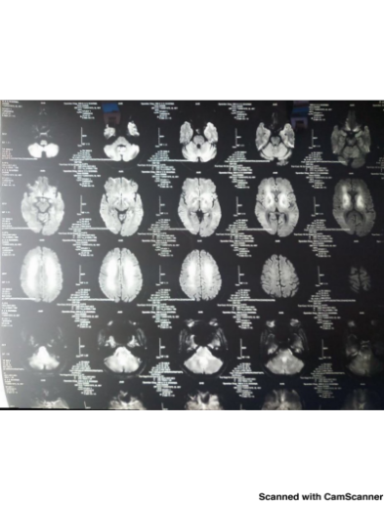 | 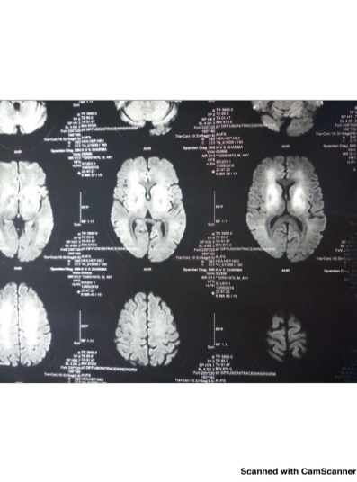
Picture 1 and 2 : MRI Brain scan showed symmetrical hyperintensities involving basal ganglia and subcortical white matter in T2 weighted images and T1 weighted images showed evidence of basal ganglia hyperintensities probably related to mineral deposition

Biography

Occupational Health Professional with more than five years of working experience in both Government and corporate settings. She is a medical graduate with one master in public health from Jawaharlal Nehru University, New Delhi, India and one master in occupational safety and health from International Training Centre of International Labour Organization (ITCILO) and University of Turin, Italy after receiving the prestigious fellowship of ILO. She is the first lady Certifying Surgeon (Medical) and Inspector of Factories (Medical) in the Directorate of Factories, Labour Department, Government of West Bengal and has been working in statutory body for 3 years six months. She has been taking care of the occupational health of around ten lakhs of workers based in seven thousand varied kind of factories. She already has participated in many international, national and regional conferences and workshop. She has been working in both the research and policy level in occupational safety and health domain in Government and presently continuing ongoing survey of prevalence of silicosis and silico tuberculosis among dust exposed workers in rural bengal as principal investigator. She is also doing PhD from Jawaharlal Nehru University, New Delhi with her job. She is active member of International Commission of Occupational Health (ICOH) and life member of Indian Public Health Association (IPHA) and Indian Association of Occupational Health (IAOH).

Presenting author details
Full name: Dr. Priyanka Roy
Contact number: +919433778899
Email id: priyankaroysskm@gmail.com
Category: (Oral presentation)
Session name: Environmental Safety and Occupational Health / Occupational Health and Hazards/

Research interest: occupational safety and health, industrial law, environmental medicine, co morbidity of silicosis and tuberculosis, heavy metal toxicity, accident prevention, chronic disease, accessibility barriers of health service delivery system, urban health and vulnerability, chronic disease, epidemiology and biostatistics, research methodology and experience of conducting research

