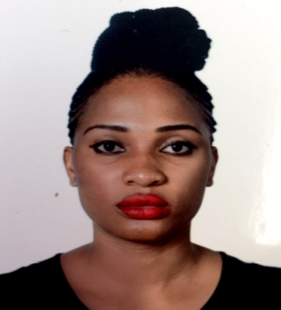

Title: Assessment of Safety Behaviour of Oil and Gas Workers in the Niger Delta Region of Nigeria and its Impact on Personal Safety Response at Work.

Author (s) Name: Efua Ehiaguina and Dr Haruna Moda
Manchester Metropolitan University, Manchester United Kingdom

Interest in the development of appropriate safety culture in the oil and gas industry has taken centre stage among stakeholders in the industry. Human behaviour has been identified as a major contributor to occupational accidents where abnormal activities associated with safety management are taken as normal behaviour. Existing data revealed that the Nigeria oil and gas industry is ranked among the riskiest in terms of health and safety compliance, with workers often exposed to diverse occupational hazard that can result into fatality and mortality in worst scenario. Work-related death rate within the oil and gas sector in Nigeria has been estimated at around 24 fatalities per 100,000 employees, which is one of the highest in the world. To ascertain the impact of employees’ safety and how it impacts health and safety compliance within the local industry, online safety culture survey targeting frontline workers within the industry was administered covering major subjects that include; perception of management commitment and style of leadership; safety communication method and its resultant impact on employee’s behaviour; employee safety commitment and training needs. Preliminary result revealed that 54.4% of the participant feel there is lack of motivation from the management to work safely. In addition, 54.6% perceived employers place more emphasis on work delivery over employee’s safety on the installation. It is expected that the study outcome will provide measures aimed at strengthening and sustaining safety culture in the Nigerian oil and gas industry.

Biography
Efua Ehiaguina hold a BSc degree in Micro-biology and MSc Environment, Safety and Health from Sunderland University and at present a first year PhD student in Manchester Metropolitan University. She is working towards publishing journal articles and other educational impact on this research topic.

Presenting author details
Full name: Efua Ehiaguina
Contact number: +447448385011
Email id: efua.ehiaguina@stu.mmu.ac.uk
Category: (Oral presentation)

Session name: Occupational Health, 2019

Research interest: Occupational public health and safety

