Fourth Edition of International Conference on Occupational Health and Safety
May 28-29, 2018 London, UK
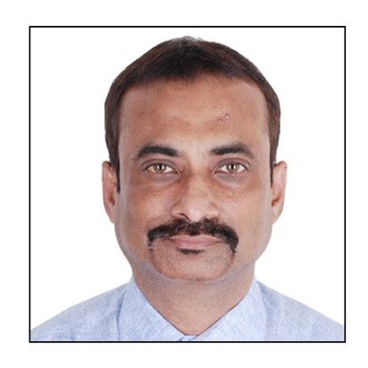
RISK OF ACCIDENTS IN SMALL AND MEDIUM ENTERPRISES (SMEs) IN INDIA
Pranab Kumar Goswami
Dy. Director, Industrial Safety & Health, Labour Department, Delhi, India

Small and medium Enterprises (SME) are considered as the driving force for the economic growth of a developing country like India. Most of the SMEs are located in residential/non-industrial areas to avoid legal obligations of Occupational Safety and Health (OSH) provisions. This study was conducted in Delhi with a view to analyze the accidents that had occurred between the years 2013 to 2016. The objective of the study is to find out the accident prone SMEs in Delhi and major causes of such accidents. Survey and comprehensive data analysis methods, followed by applying simple statistical techniques were used for this study. The accident reports for the study period, collected from the Labour department and Police stations, were analyzed for the study. The study was completed in January 2017. It was found that most of the accidents took place in SMEs located in residential/non- industrial areas in Delhi. The accident-prone machines were found to be power presses (42%) and injection moulding machines (37%). Predominantly unsafe machinery or unsafe working conditions and lack of training of worker were observed to be the major cause of accidents in such industries.
Biography: Mr P K Goswami, Master in OSH from International Labour Organization ( ILO) is presently working as Dy Director (Safety and Health0 in Labour Department , Government of Delhi. He worked n the field of erection and commissioning/ Production/ Safety and Health in various prestigious industries in India. He has a maestro over safety inspections and safety surveys in various industries and construction sites. He has an industrial training and enforcement experience of more than 26 years with international exposure. He has presented various research papers in international forums.
Keywords: Accidents, SME and Safety Culture
Desired presentation : Oral or Poster (either)
Topic : Occupational Health and Risk Management
Corresponding Author Details: P K GOSWAMI
goswamipk@gmail.com
Labour Department, Government of Delhi,
Delhi, India

