Predictive factors for morcellation during total laparoscopic hysterectomy: a cohort study
Catherine Bergeron, MD-MSc, Sarah Labrosse, MD, Philippe Y. Laberge, MD, FRCSC, Madeleine Lemyre, MD, FRCSC, Sarah Maheux-Lacroix, MD-PhD, FRCSC
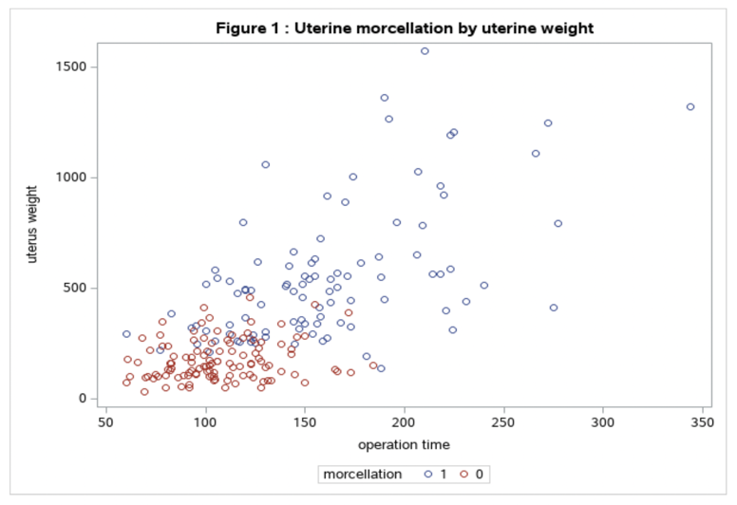
OBJECTIVE: Our objective was to identify predictors of morcellation during total laparoscopic hysterectomy (TLH).
DESIGN: Retrospective cohort study (Canadian Task Force classification II-2)
SETTING: University Hospital Center in Quebec, Canada.
PARTICIPANTS: Women undergoing a TLH for a benign gynecologic pathology form January 1st 2017 to January 31th 2019
INTERVENTION: All women underwent a TLH. If the uterus was to voluminous to be removed vaginally, surgeons favored in-bag morcellation by laparoscopy. Uterine weight and characteristics were assessed prior to surgery by ultrasound or MRI in order to predict morcellation.
MAIN RESULTS: A total of 252 women underwent a TLH and the mean age was 46$±$7 (30–71) years old. The main indications for surgery were abnormal uterine bleeding (77%), chronic pelvic pain (36%) and bulk symptoms (25%). Mean uterine weight was 325 (17-1572)$±$272 grams, with 11/252 (4%) uterus being >1000 grams and 71% of women had at least one leiomyoma. Among women with a uterine weight <250 grams, 120 (95%) did not require morcellation. On the opposite, among women with a uterine weight >500 grams, 49 (100%) required morcellation. In addition to the estimated uterine weight (≥ 250 versus <250 grams; OR 3.7 (CI 1.8-7.7, P<0.01), having ≥ 1 leiomyoma (OR 4.1, CI 1.0-16.0, P=0.01) and a leiomyoma of ≥ 5 cm (OR 8.6, CI 4.1-17.9, P<0.01) Catherine Bergeron, MD-MSc, Sarah Labrosse, MD, Philippe Y. Laberge, MD, FRCSC, Madeleine Lemyre, MD, FRCSC, Sarah Maheux-Lacroix, MD-PhD, FRCSC were other significant predictors morcellation in multivariate logistic regression analysis.
CONCLUSION: Uterine weight estimated by preoperative imaging as well as the size and number of leiomyomas are useful predictors of the need for morcellation.
KEYWRODS: hysterectomy, laparoscopy, morcellation, predictive factors
Recent publication:

- Murji, A., et al., No. 371-Morcellation During Gynaecologic Surgery: Its Uses, Complications, and Risks of Unsuspected Malignancy. J Obstet Gynaecol Can, 2019. 41(1): p. 116-126.
- Tulandi, T., A. Leung, and N. Jan, Nonmalignant Sequelae of Unconfined Morcellation at Laparoscopic Hysterectomy or Myomectomy. J Minim Invasive Gynecol, 2016. 23(3): p. 331-7.
- Gil-Gimeno, A., et al., Morcellation During Total Laparoscopic Hysterectomies: Implications of the Use of a Contained Bag System. J Obstet Gynaecol Can, 2020. 42(7): p. 839-845.
- 7. Harb, T.S. and R.A. Adam, Predicting uterine weight before hysterectomy: ultrasound measurements versus clinical assessment. Am J Obstet Gynecol, 2005. 193(6): p. 2122-5.
- Wolfe, M., et al., Preoperative Factors That Predict the Need to Morcellate in Total Laparoscopic Hysterectomy. J Minim Invasive Gynecol, 2018. 25(1): p. 158-162.
- Asgari, Z., et al., Predictive factors of the need to morcellate in total laparoscopic hysterectomy. Aust N Z J Obstet Gynaecol, 2021.
- Kung, F.T. and S.Y. Chang, The relationship between ultrasonic volume and actual weight of pathologic uterus. Gynecol Obstet Invest, 1996. 42(1): p. 35-8.
- Wasson, M., et al., Prognostic Factors for Morcellation During Vaginal Hysterectomy. Obstet Gynecol, 2016. 127(4): p. 752-757.
- Condous, G., et al., What determines the need to morcellate the uterus during total laparoscopic hysterectomy? J Minim Invasive Gynecol, 2009. 16(1): p. 52-5.


Biography:
Catherine Bergeron
3rd year resident in obstetrics and
gynaecology and master student in
epidemiology in University Laval (Québec City, Canada). She published a systematic review in 2020 comparing endometrial ablation and levonorgestrel intrauterine system in the Human Reproduction Update. She also participated in other publications with her colleagues.

