Stage IV endometriosis, to treat or not to treat before IVF?
Some more considerations besides the Pregnancy Rate: a case of Near Miss for Spontaneous Hemoperitoneum.
Dr G. Gaia, Department of Obstetrics and Gynecology, San Paolo Hospital Medical School, University of Milan; Milan, Italy
Dr M. Afonina, Department of Obstetrics and Gynecology, San Paolo Hospital Medical School, University of Milan; Milan, Italy

Abstract (300 word limit)
Endometriosis represents a well-known cause of infertility. Recently, its association with spontaneous hemoperitoneum in pregnancy (SHIP) was reported. Its occurrence seems to be increased in patients with endometriosis who underwent IVF techniques.
We present a case of near miss at 15 weeks of pregnancy associated with SHIP in a nulliparous patient of 39 years old with chronic endometriosis. Previously, she underwent several IVF cycles and controlled ovarian hyperstimulation plus embryo transfer (COH-ET).
An explorative laparoscopy was performed, then converted in laparotomy. The bleeding endometriotic tissue was removed and an ureteral stent was placed. The patient lost a total of 4 liters of blood and fully recovered. Unfortunately, miscarriage occurred.
The potential link between COH-ET, the number of cycles of ovarian stimulation and SHIP in severe endometriosis must take a part in the balanced decision between preventive surgery of direct hormonal stimulation. In our opinion, this case report emphasizes the importance to make a weighted therapeutic choice between medical and surgical treatment in women with deep endometriosis. Further research is required to establish whether a link between IVF techniques and SHIP occurrence exists. This, to prevent life-threatening complications and to ensure the right of a safer pregnancy to every woman with endometriosis.

Image
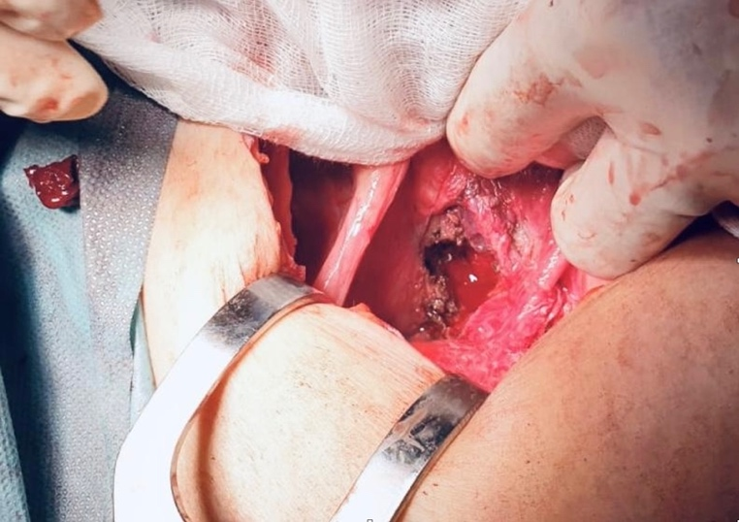
Recent Publications (minimum 5)
- Lier MCI, Malik RF, Ket JCF, Lambalk CB, Brosens IA, Mijatovic V. Spontaneous hemoperitoneum in pregnancy (SHiP) and endometriosis - A systematic review of the recent literature. Eur J Obstet Gynecol Reprod Biol. 2017 Dec;219:57-65. doi: 10.1016/j.ejogrb.2017.10.012. Epub 2017 Oct 12. PMID: 29054042.
- Rafi J. Re: Spontaneous hemoperitoneum in pregnancy (SHiP) and endometriosis - A systematic review of the recent literature. Eur J Obstet Gynecol Reprod Biol. 2018 Apr;223:140-141. doi: 10.1016/j.ejogrb.2017.12.038. Epub 2017 Dec 20. PMID: 29433945.
- Lier M, Malik RF, van Waesberghe J, Maas JW, van Rumpt-van de Geest DA, Coppus SF, Berger JP, van Rijn BB, Janssen PF, de Boer MA, de Vries J, Jansen FW, Brosens IA, Lambalk CB, Mijatovic V. Spontaneous haemoperitoneum in pregnancy and endometriosis: a case series. BJOG. 2017 Jan;124(2):306-312. doi: 10.1111/1471-0528.14371. Epub 2016 Oct 5. PMID: 27704657.
- Huang LY, Hsu PY, Chiang CT, Chen HW, Wu MH. Endometriosis-related spontaneous hemoperitoneum in the early second trimester: A case report. Taiwan J Obstet Gynecol. 2021 Mar;60(2):328-330. doi: 10.1016/j.tjog.2021.01.032. PMID: 33678336.
- Brosens IA, Lier MC, Mijatovic V, Habiba M, Benagiano G. Severe spontaneous hemoperitoneum in pregnancy may be linked to in vitro fertilization in patients with endometriosis: a systematic review. Fertil Steril. 2016 Sep 1;106(3):692-703. doi: 10.1016/j.fertnstert.2016.05.025. Epub 2016 Jun 20. PMID: 27336207.
- Järvelä I.Y., Pelkonen S., Uimari O., Mäkikallio K., Puukka K., Ruokonen A., et. al.: Controlled ovarian hyperstimulation leads to high progesterone and estradiol levels during early pregnancy. Hum Reprod 2014; 29: pp. 2393-2401
- Kim TG, Sudhof LS, Liu FW, Shainker SA. Spontaneous hemoperitoneum in pregnancy due to endometriosis. Journal of Endometriosis and Pelvic Pain Disorders. 2020;12(3-4):124-127. doi:10.1177/2284026520942432

Photograph

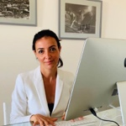
Email: giorgia7gaia@gmail.com; afoninamrgarita@hotmail.com

Biography (150 word limit)

Dr Gaia has graduated in Medicine with top marks at the University of Pavia in 2003. During her studies, she spent two years in Clermont Ferrand (France), where she had the opportunity to learn and to develop both open and mini-invasive, surgical skills. After spending 3 years in Modena improving her robotic surgery knowledge, she moved to Milan. She is currently the director of the pelvic floor unit at San Paolo Hospital, dealing with reconstructive pelvic floor surgery, endometriosis, and benign gynecological diseases. During the past year, she settled robotic training center to educate young surgeons. When she is not in the operatory room she’s dealing with deliveries and obstetrics, fully taking care of women health. Her research is mainly focused on pelvic organ prolapse, deep infiltrating endometriosis and mini-invasive surgery.
Dr Afonina has graduated in Medicine with top marks at the University of Modena and Reggio Emilia in 2018. During her studies she attended Nazareth Hospital in Kenya and Josephine Getirana Neta Hospital in Brazil for voluntary clinical internships. She has been a member of the Italian Red Cross and of an online HIV related Q&A website managed by the Hospital of Modena, from 2013 to 2018. She has also been one of the promoters of MoreMed Congress (2016-2018). In 2019 she started her residency in Obstetrics and Gynecology at the University of Milan, during which she took part to several conferences and teaching courses in the gynecological field. Currently, she is training in the robotic surgery field, working in Dr Gaia's team and she is conducting research in pelvic floor organ prolapses and endometriosis.

Notes/Comments:

