Title: Expression profile of adiponectin in obese pakistani youth.

Farah Ashfaq^{1,}*, Tasnim Farasat¹, Shagufta Naz¹ and Shahjahan².
¹Department of Zoology, Lahore College for Women University, Lahore, Pakistan
²Department of Immunology, University of Health Sciences, Lahore, Pakistan
Obesity in adolescents and young adults has increased significantly in recent years resulting in the development of chronic diseases. Obesity induces adipocyte dysfunction, secretion of adipokines and activation of macrophages leading to inflammatory cytokine production.
The aim of the present study was to investigate the Adiponectin gene expression in young subjects of different BMI groups. Study subjects included 300 over weight, obese males and females with an age ranging from 17 to 30 years. 100 Comparable control subjects with normal BMI were included. The data was stratified into normal-weight, overweight, Obese I and obese II groups. Anthropometric parameters including age, BMI, waist circumference, WHR, systolic and diastolic blood pressure were assessed. The metabolic and inflammatory parameters including glucose, Insulin, Lipid profile, Leptin, Adiponectin, Resistin, C-reactive protein and interleukin-6 in serum were measured by chemistry analyzer and ELISA. RNA extraction was done by TRIZOL method and cDNA synthesis was done by using cDNA synthesis kit. The expression of target gene was compared with GAPDH on Real time PCR using gene specific primers. Serum levels of insulin, leptin, resistin, CRP, IL-6 were significantly higher in overweight and obese subjects as compared to control subjects (p<0.01). Adiponectin was significantly low in obese groups (p<0.01). In correlation analysis, Adiponectin showed a significant inverse relationship with BMI, WC (r = - .262 , p<.008),(r = -.310,p<.002 )p<0.01 and with WHR (r=-.199,p=.046) p<0.05 respectively. Adiponectin was significantly correlated with fasting insulin(r= -.282, p=.004) p<0.01 in obese group. The expression of adiponectin gene was significantly influenced by obesity.
Key words: Adiponectin, Adiponectin expression, obesity, inflammatory markers.
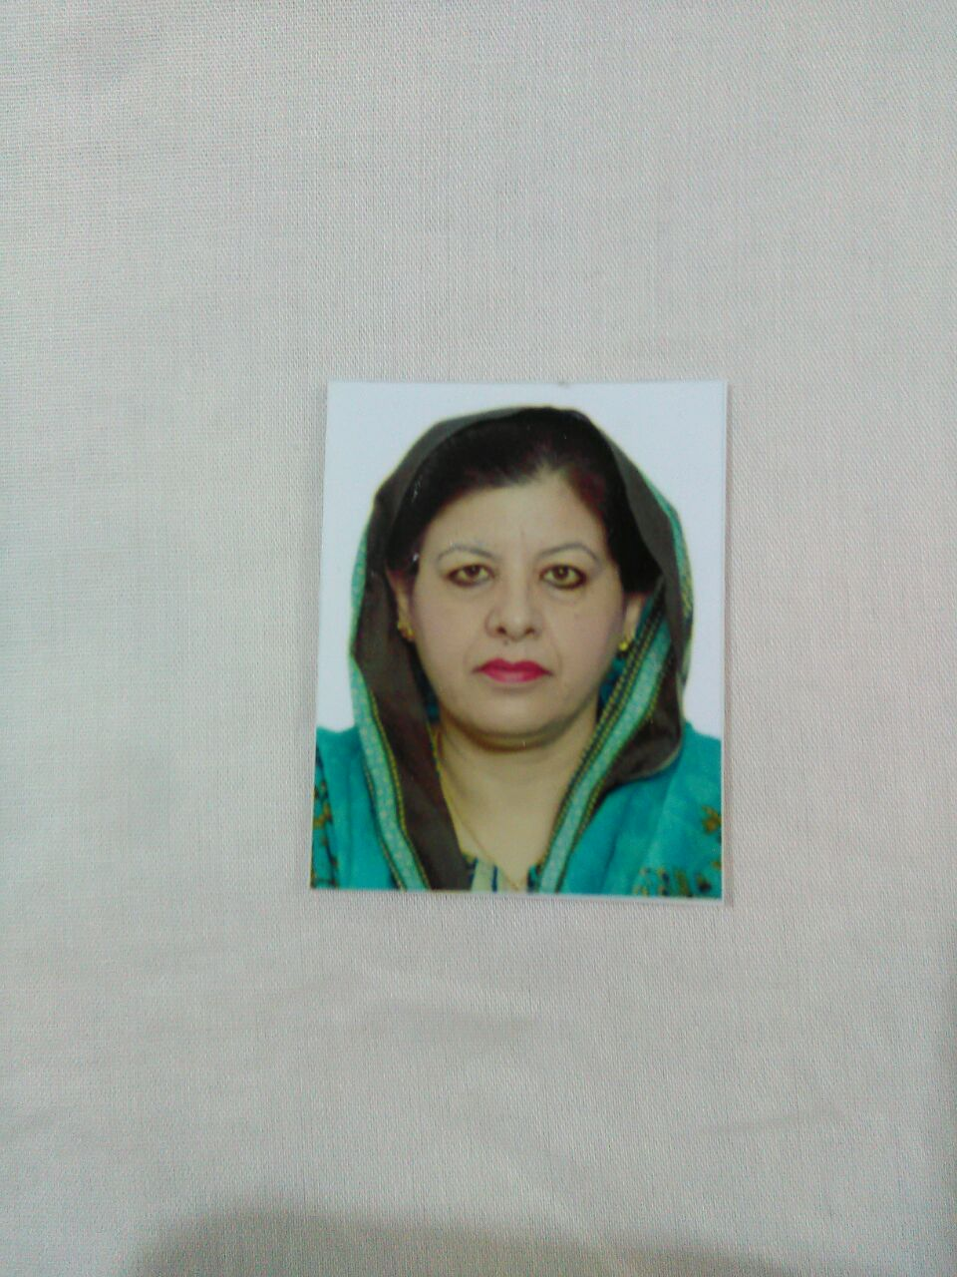

Email: farah_ashfaq@yahoo.com, +92-03214011680

Professional Biography:
Dr Farah Ashfaq completed her Ph.D from Lahore College For Women University, Lahore in 2017. She got gold medal for highest CGPA in Ph.D. She is an assistant professor in Department of Zoology, Lahore College For Women University, Lahore. She has published papers in reputed journals. She has presented papers in national and international conferences. She has wide experience of teaching and research and supervised research work of BS and MS students.

