Abstract Template
Abstract Title: The Consequences of Unbalanced Diabetes Management
First A. Author, Second B. Author, Jr., Third C. Author

Mohammad Y. Al-Bahar (College of Business Administration - Kuwait University, KU, Chartered Insurance Institute (CII), UK)

Abstract (not more than 300 words)

This abstract will be discussing both diabetes type 1 and type 2, general information about diabetes Type 1 and Type 2, living with type 1 diabetes, how the frequent occurrence of a hypoglycaemia can lead to weight gain in T1D, and the importance of carb counting to manage diabetes and to reduce the exposure to hypos. Stories of people living with type 2 diabetes, how diabetes have changed their lives, to take an action towards their lifestyle and eating habits. The impact of weight loss on the lives of people living with Type 2 Diabetes.

Professional Biography (100-150 words)

Mohammad is a global advocate for people living with diabetes, mainly focused on discrimination towards people living with this condition as well as an adventure activist to raise awareness about diabetes.

In January 2014, Mohammad in order to empower people living with diabetes and help them live a healthy and a productive life with Diabetes. The main six components of the program are: Education and awareness, insulin access, advocacy, People living with diabetes Laws & Regulations, Group Sessions and Self-Management, with the fulfilment of the six components we will be able to empower people living with diabetes. Throughout this program, they have reached 24 schools, public and private sector as well as non-profit organizations.

he created the diabetic traveller account on Instagram in 2014, to share his life with diabetes, travels as well as general information about health and awareness about diabetes, in order to help others living with diabetes, by showing them by proof that living with diabetes is challenging yet is rewarding and can shape us up to be better individuals in the community, that it can be a hassle living with the condition yet it can be rewarding if we were able to manage it and keep track of our health.

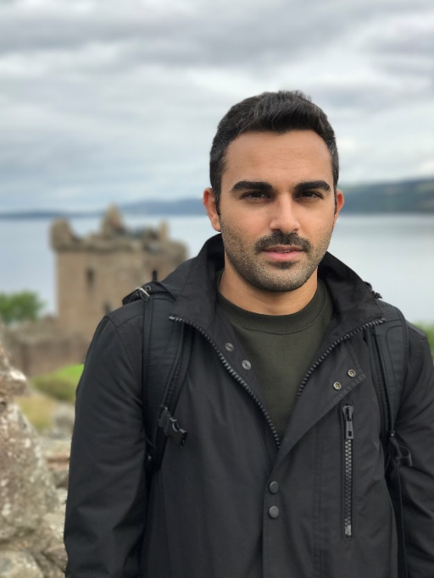

Email Id: moh.albahar@gmail.com

Any Comments: The Abstract title may change

