Title: “Assessment of nutrient intake, anthropometric measurements and body composition of soliga primitive tribe in Karnataka.., India.”
Name: Dr. Krishnaraj V
Affiliation: University of Bangalore Karnataka., India
Co- authors: Dr. R P Lalitha Reddy
Abstract (up to 300 words)
Tribal people are the most conservative, orthodox and superstitious, which obstructs their growth and development in all walks of life. Most of the tribes are poor, backward and generally lead a hard and miserable life. A study was conducted among Soliga, a primitive tribe settled in and around the hilly regions of Chamarajanagar district of Karnataka, India, with an objective to “Assessment of nutrient intake, anthropometric measurements and body composition of soliga primitive tribe in Karnataka, India”. A total of 1000 adult Soliga tribals in the age group of 18-40 years were selected from all four taluks of Chamarajanagar district using simple and stratified random sampling methods. The sample included both male and female genders. The validated questionnaire was used to collect data on nutrient intake, anthropometry, 24 hours 3 days dietary recall method and food frequency questionnaire and Body composition analysis was done by using, Electric Bio-Impedance Body Stat^{R} -1500MDD analyser for the selected samples. The finding of the study revealed that the prevalence of CED was higher among females compared to males. Incidentally the percentage of pre-obesity was also found to be higher among female respondents. Females had higher waist by hip ratio exposing them to the risk of non-communicable disease as against males. The intake of the various nutrients by the respondents namely protein and fat was lower than the RDA while the energy, carbohydrate and micronutrient namely, calcium and vitamin C was more than the RDA. The extent of deficit was highest with respect to protein and fat in irrespective of the genders. The males had their fat percentage in normal range as compared to the females. Body fat mass index (BFMI) was higher in females as against to the males. The low FFMI values were observed more in females as against the males. The finding reveals precautionary actions are desirable to progress the health and nutrition condition, nutritional status of the tribals was unsatisfactory and they need in-depth nutrition education and intervention programmes for their holistic development.
Keywords: Soliga, primitive tribe, body composition, and recommended dietary allowance (RDA).
Biography (up to 150 words)

I Dr. Krishnaraj V is successfully completed my PhD research work entitled with “Nutritional status, lifestyle and body composition of tribal adults in Chamarajanagar district of Karnataka, India”. In the Department of Food and Nutrition and Research Centre, Smt. VHD Central Institute of Home Science, University of Bangalore, Karnataka.., India. Waiting for PhD degree and presently working as lecturer in food science and nutrition at government home science college, university of Mysore Karnataka, India. I had eleven (11) years teaching experience. I have cleared Karnataka state level eligibility exam for assistant professor (K-SET). Two research papers published in reputed international journals one in (International Journals of Trends in Bio-science) and another one in (International Journals of current research). Two oral presentations were done one in International conferences on “Roll of technologies in redefying health” conducted at MCC Bangalore. Karnataka, India. Another one in national conference on “Family and Community Science- Catalyst for Sustainable Development Goals “February 1-3, 2018 College of home science at MPUAT Udaipur, (Rajasthan).., India. I have delivered Guest Lecture and training programmes to agricultural formers and women’s self-help groups in relation to mushroom cultivation, candle making, bakery products and preservative products through Krushi Vijnana Kendra (UAS, Bangalore ), and Canara Bank RUDSET, Hassan. .

Email ID: kitty_fsn@yahoo.co.in
Presenter Name: Dr. Krishnaraj V.
Type of Presentation: Eminent Speaker
Contact Number: +918722221499
Right click on the image to change 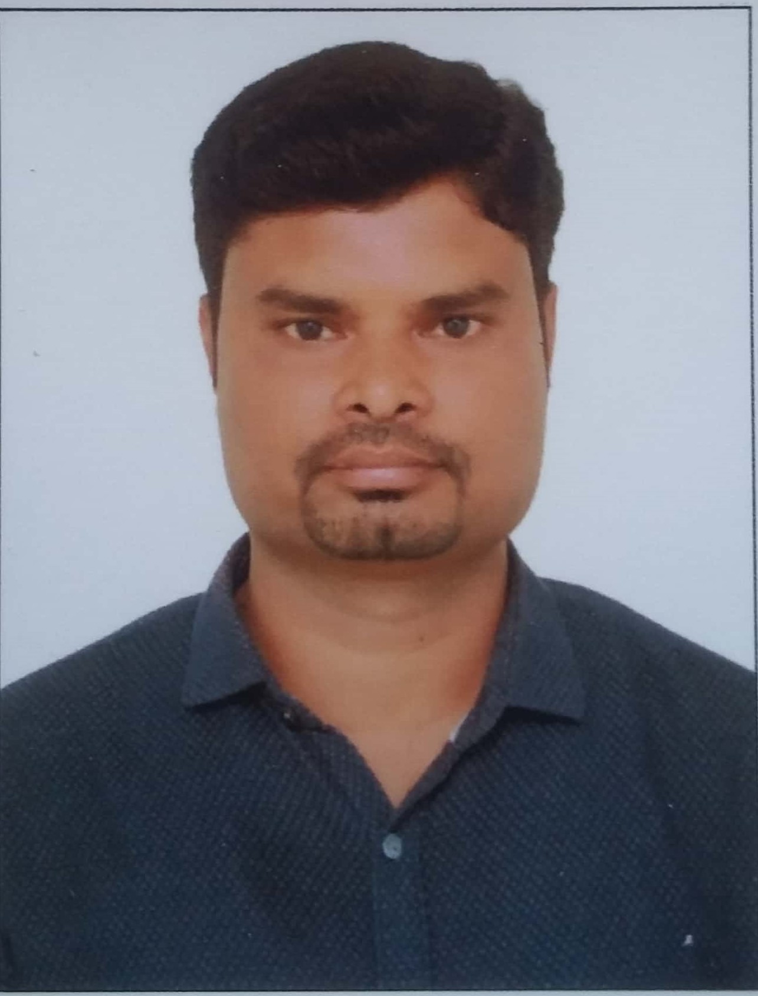picture

kitty_fsn@yahoo.co.in

