To Assess the Food Concepts, Lifestyle and Dietary Patterns among the adults with Diabetes Mellitus: A cross-sectional study
Faran Khan, M.Phil., UVAS, PAK
Dr Zahra Khan, PhD, UVAS, PAK
Marriam Ahmed, M.Phil., UVAS, PAK

Abstract (300-word limit)
Statement: Diabetes mellitus needs special implementation and maintenance of dietary habits, lifestyle practices, and food concepts for its management. Diabetes mellitus affects approximately 422 million people around the globe. Diabetes prevalence has been rising more rapidly in middle and low-income countries. It is estimated that 1.5 million deaths were directly caused by diabetes and 2.2 million deaths caused by high blood glucose This study was designed to assessed the relationship of food concepts, lifestyle practices and dietary patterns among adults with diabetes mellitus.
Methodology and Theoretical Orientation: The people with diabetes mellitus were selected from the OPD’s (Outpatient department) and diabetic wards from different private and government hospitals of Lahore. The questionnaire was developed to assess lifestyle applies, eating patterns and food perceptions among adults with diabetes. The questionnaire contains mixed questions both open and closed ended.
Findings: Study showed that 55.8% adults have family history of diabetes mellitus. Approximately 41.8% people were physically inactive and have a sedentary lifestyle. And 47.8% people were not dining out at all. Participants having no or less education have more uncontrolled HbA1C as compared to educated participants. 6% uneducated participants and 1.8% educated participants had uncontrolled HbA1C level.
Conclusion and Significance: The food concepts of diabetic patients vary from each other people have less knowledge regarding food concepts. There is lack of physical activity among individuals and Consumption of major meals was adequate. Uneducated people were having uncontrolled HbA1c level as compared to educated participants.
Image:
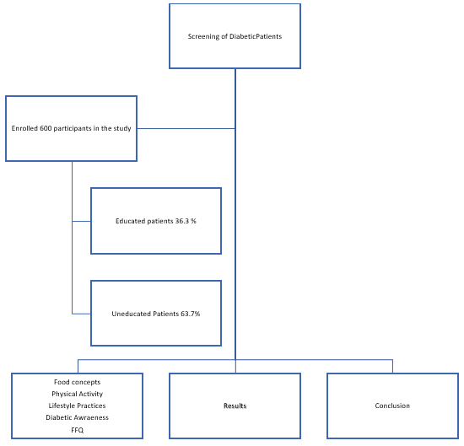

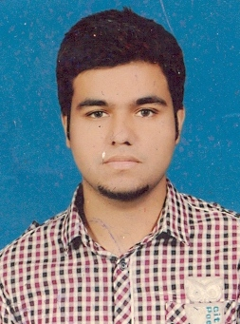 Biography
Faran Khan has his expertise in “Clinical Nutrition”. He has built his experience is the field of nutrition and dietetics. His interest in reducing the rate of mortality and morbidity in malnourished children. During his education he focus on different community work voluntary. He worked in Sir Ganga Ram Hospital, Lahore as clinical nutritionist. His focus is to sever “Humanity”.

Email id: faran.hocane@gmail.com

