Evaluating the effects of low molecular weight sodium alginate as an immunostimulator, also as a novel prebiotic combined with Bactocell® (a probiotic) on humoral and mucosal immune responses of Asian seabass (Lates calcalifer) juveniles
Ghasem Ashouri *, PhD student, Department of Natural Resources (Fisheries Division), Isfahan University of Technology, Isfahan 84156-83111, Iran
Nasrollah Mahboobi Soofiani, Professor, Department of Natural Resources (Fisheries Division), Isfahan University of Technology, Isfahan 84156-83111, Iran
Seyed Hossein Hoseinifar, Professor, Department of Fisheries, Faculty of Fisheries and Environmental Sciences, Gorgan University of Agricultural Sciences and Natural Resources, Gorgan, Iran.
Amir Mani, PhD student, Department of Natural Resources (Fisheries Division), Isfahan University of Technology, Isfahan 84156-83111, Iran

Abstract (300-word limit)
During the past decade, aquaculture has been considered as one of the fastest-growing industries of food production. The elevation of aquatic animal production has been obtained by increasing the production per unit of area which per se results from intensification. However, the elevation of stocking density in aquaculture practices increases the stress level in the cultured organism and the risk of diseases. Following the 2006 EU ban on antimicrobial growth promoters, to reduce use of antibiotics chemical compounds in agri-business products have arisen. Therefore, application of bioactive substances, such as probiotics and prebiotics as an alternative to antibiotics has been considered as environmentally friendly tool for aquaculture. Interest in the use of prebiotics and probiotics in aquaculture increased considerably over the past several years due to the beneficial effects reported for these diet additives in humans and terrestrial animals, including enhanced production efficiency, increased nutrient utilization, .and improved disease resistance. Using immunostimulants as bio-friendly and environmentally safe agents is an alternative approach to combat diseases in aquaculture. Therefore, present study performed to evaluate the potential effect of individual or combined administration of dietary low molecular weight sodium alginate (LMWSA) and Bactocell® on haematological, humoral and skin mucosal immune responses of L. calcarifer juveniles.
Methodology and Theoretical Orientation:
In this study six weeks of feeding trial was conducted to examine the effect of dietary administration of low molecular weight sodium alginate (LMWSA) and Pediococcus acidilactici MA 18/5M (PA) on growth performance, digestive enzymes, and intestinal histology of Lates calcarifer juveniles. Fish (12.0 ± 0.2 g ) were fed experimental diets as follows: Control (diet 1, basal diet), 5 g kg⁻¹ LMWSA (diet 2), 10 g kg⁻¹ LMWSA (diet 3), 0.9 × 10⁷ CFU g⁻¹ PA (diet 4), 5 g kg⁻¹ LMWSA + 0.9 × 10⁷ CFU g⁻¹ PA (Diet 5), and 10 g kg⁻¹ LMWSA + 0.9 × 10⁷ CFU g⁻¹ PA (Diet 6). At the end of the trial, blood samples from the caudal vein and skin mucus were collected for evaluation of immunological parameters.
Findings:
Results indicated a significant (P < 0.05) increase in innate immune parameters including serum lysozyme, bactericidal, hemolytic and respiratory burst activities as well as mucosal immune responses including lysozyme and bactericidal activities when diet was supplemented with immunostimulants. Moreover, the combined effects of LMWSA with Bactocell® resulted in more pronounced immunological responses compared to the control and singular administration. Red and white blood cell counts significantly increased with either singular or combined administration of LMWSA and Bactocell® compared with the control group (P < 0.05).
Conclusion and Significance:
These results indicated that combined administration of LMWSA and Bactocell® can be considered as a beneficial feed additive and immunostimulant in L. calcarifer juveniles.

Image:
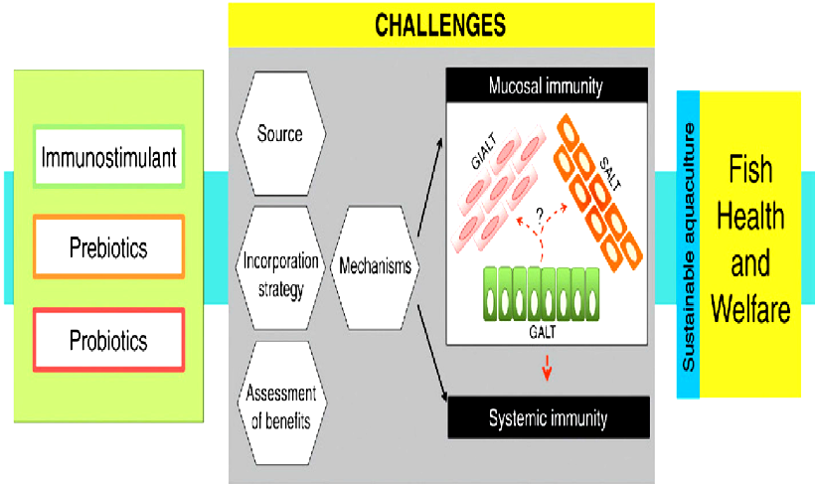
Figure 1. Paradigm of present status and future perspective in the application of immunostimulants, prebiotics, and probiotics in fish (adopted from Caipang & Lazado 2015)
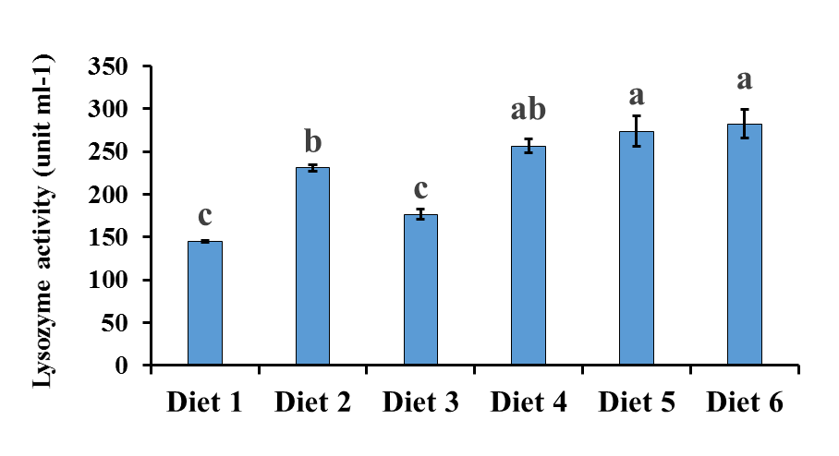
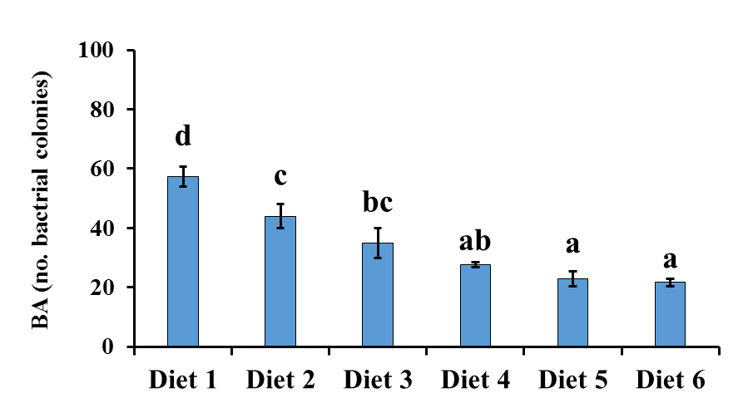

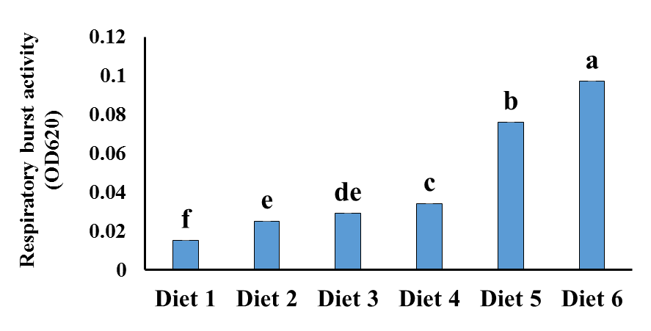
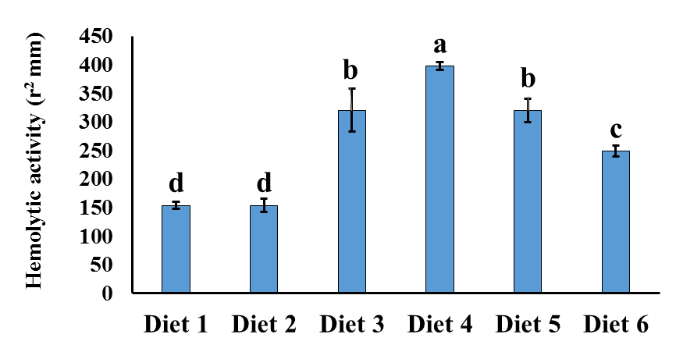

Figure 2. Effect of various dietary treatments on humoral immune parameters including, Values are presented as the mean ± S.E., n = 15. Different superscripts on the bars denotes statistically significant differences (P < 0.05) (by Duncan’s Multiple Range Test) .

Table 1. Mucosal immunological parameters (mean ± S.E., n = 9) of the L. calcarifer fed different levels of dietary LMWSA and P. acidilactici.
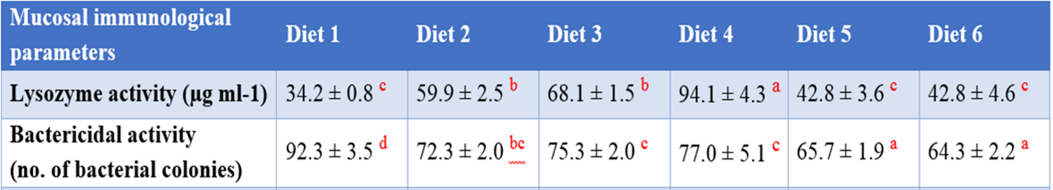
Values in a row assigned with different letter denote significant difference (P < 0.05) (by Duncan’s Multiple Range Test).

Table 2. Hematological parameters (mean ± S.E., n = 9) of the L. carcalifer fed different levels of dietary LMWSA and P. acidilactici
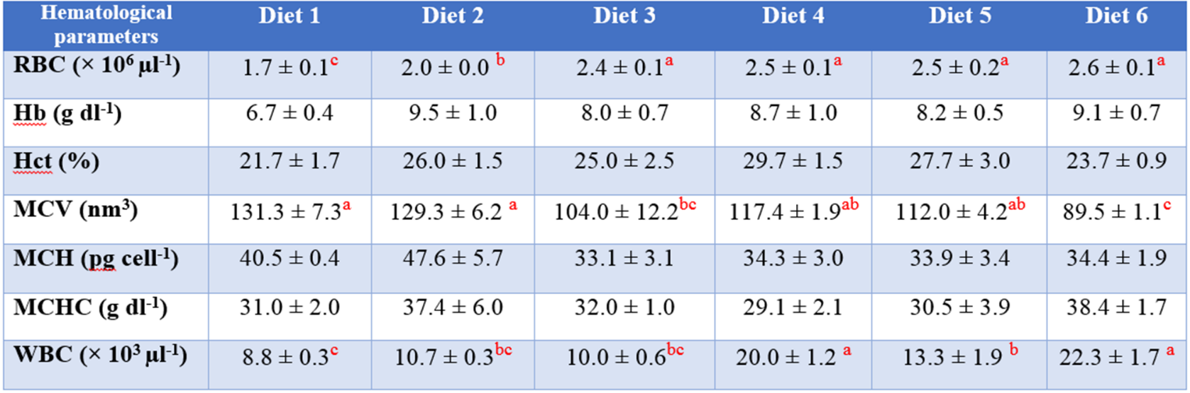
Values in a row assigned with different letter denote significant difference (P < 0.05) (by Duncan’s Multiple Range Test).

Recent Publications (minimum 5)
- Ashouri Gh, Mahboobi Soofiani N, Hoseinifar SH, Jalali SAH, Morshedi V, Van Doan H, Torfi MozanzadehHeilig M (2018) Combined effects of dietary low molecular weight sodium alginate and Pediococcus acidilactici MA18/5M on growth performance, haematological and innate immune responses of Asian sea bass (Lates calcalifer) juveniles. Fish and shellfish immunology 79: 34-41. M, Egli M (2006) Pharmacological treatment of alcohol dependence: Target symptoms and target mechanisms. Pharmacology and therapeutics 111:855-876.
- Hoseinifar SH, Dadar M, Ringø E, (2017) Modulation of nutrient digestibility and digestive enzyme activities in aquatic animals: The functional feed additives scenario. Aquaculture Research 48 (8): 3987-4000..
- Hoseinifar SH, Ringø E, Shenavar Masouleh A, Esteban MÁ, (2014) Probiotic, prebiotic, and synbiotic supplements in sturgeon aquaculture: A review. Review in Aquaculture 6: 1–14.
- Ringø, E, Song SK, (2016). Application of dietary supplements (synbiotics and probiotics in combination with plant products and ß-glucans) in aquaculture. Aquaculture Nutrition 22: 4–24.
- Ringø E, Olsen R, Gifstad T, Dalmo R, Amlund H, Hemre GI, Bakke AM, (2010). Prebiotics in aquaculture: a review. Aquaculture Nutrition 16: 117–136.

 Biography (150-word limit)
I am Ghasem Ashouri, a PhD student in Isfahan University of Technology. I am doing my thesis on the effect of additive supplements on growth performance, digestive enzyme activity and intestinal morphology in fish under supervision of Dr. Mahboobi Soofiani and Dr. Hoseinifar. I am deeply interested to take part in your symposium. I have expert in this field. I am a motivated researcher in food biotechnology and diet supplementation sciences. My scientific life officially began on 2004; since then I realized that academic work is my dream job. Immune stimulation sciences is an interesting and extensive field. My study and research interests are gut microbiota, immunology, hypocholesterolemia effect and anti-hypertensive properties of probiotics and prebiotics.

Email: g.ashouri@na.iut.ac.ir

Notes/Comment

