Evaluation of Native Probiotic Bacillus tequilensis Strain Based on Enzyme Production and its Protective Activity against foodborne disease
Nazila Ghorban Hosseini*, Fatemeh Zarei, Meisam Saeedi, Maryam Tajabadi Ebrahimi
*Department of Biology, Science and Research Branch, Islamic Azad University, Tehran, Iran, nazilagh1360@gmail.com

Abstract
Probiotic strains of Bacillus Species are used in industrial poultry production because of their ability to produce enzymes enhancing the absorption of nutrients, and reducing foodborne disease. The aim of this study was to isolate native probiotic with above abilities. Twenty-five samples of feces from seven chicken’s farms were collected in Golestan province located in northern Iran. After isolation of Bacillus spp. on nutrient agar, the ability of producing amylase and phytase and their probiotic characteristics such as bile salt, acid and antibiotic resistance, the ability to attach to intestinal epithelial cells and inhibit Salmonella Typhimurium invasion were evaluated. The selected strains were identified by PCR and 16S rDNA sequence. From 86 isolates, K03, K02, and K20 were identified as Bacillus tequilensis and K10 as Bacillus subtilis that had desirable characteristics. The Bacillus tequilensis K03 showed production ability of amylase and phytase and the highest attachment to intestinal epithelial cells and could inhibited Salmonella Typhimurium attachment. Therefore, it can be used as a probiotic in chicken diet in order to improve the production quality and lowering the incidence of salmonellosis in chickens and human.

Methodology and Theoretical Orientation:
Findings:
Conclusion and Significance:
Image:
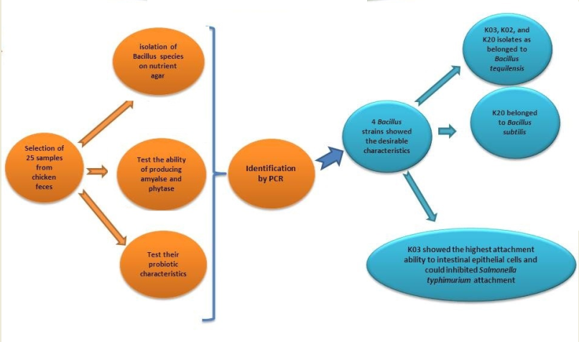
Recent Publications
- Evaluation of Bacillus strains as probiotic based on enzyme production and protective activity against Salmonellosis, Journal of Hellenic Veterinary Medical Society. (2018) (Accepted, In press)
- Akhavan Sepahi, Abas; Amini, Javid; Ghorban Hosseini, Nazila. (2018). BioLeaching. Iran. Published by Vice Presidency For Research and Technology Islamic Azad University.
- In Silico Analysis of L1/L2 Sequences of Human Papillomaviruses: Implication for Universal Vaccine Design, Nazila Ghorban Hosseini, Majid Tebianian, Ayoub Farhadi, Ali Hossein khani, Arian Rahimi, Mojtaba Mortazavi, Seyed Younes Hosseini, Morteza Taghizadeh, Mahsa Rezaei, Mehdi Mahdavi, Viral Immunology. (2017). 30 (3); 1-14.
- Aminzadeh, Massoud; Ghorban Hosseini, Nazila. (2015). Basic Classification, Taxonomy, Nomenclature & Replication of Vertebrate Viruses. Iran. Published by Vice Presidency For Research and Technology Islamic Azad University.


Biography
Nazila Ghorban Hosseini has completed her PhD at the age of 37 years from Science and Research Branch, Islamic Azad University, Tehran, Iran and she is the expert of probiotics in Takgene zist Company. She has published more than 4 papers in different journals and books.
Email:
Nazilagh1360@gmail.com

Notes/Comments
Full name: Nazila Ghorban Hosseini
Contact number:+989121597391
Category: (Poster presentation)

