Production of γ-aminobutyric acid in whey protein juice during fermentation by Lactobacillus plantarum

Fatemeh Zarei*, Leila Nateghi, Mohamad Reza Eshaghi, Maryam Ebrahimi Taj Abadi, Nazila Ghorban Hosseini, Maryam Zarei
Ph.D. Student, Department of Food Science and Technology, Faculty of Agriculture, Varamin-Pishva Branch, Islamic Azad University, Varamin, Iran, Email: zarei.fatemeh@gmail.com

Background: Today, demand for functional foods has increased. GABA, as a bioactive agent, has many potential applications in the functional food industry. The general objective of this study was to evaluate the potential of probiotic bacteria and lactobacillus plantarum in the whey drink containing strawberry and banana concentrates and to evaluate the sensory properties of this beverage during storage.
Materials and Methods: Lactobacillus plantarum was injected with 10⁸ to whey protein juice containing concentrate of banana and strawberry adding 250 mM glutamic acid. Viability, pH, GABA production and sensory evaluation of the treatments were evaluated for 30 days at 4 and 25 ° C.
Findings: Lactobacillus plantarum has the potential for producing GABA in all treatment beverages. The highest amount of GABA production (195.5 ppm), the probiotic bacterial viability (8.01 log10 cfu / ml) and pH (3.81) after 30 days of storage in whey drink containing banana concentrate kept at 25 ° C. It turned out Sensory evaluation results showed that the overall acceptance scores of all treatments were not significantly different (p>0.05).
Conclusion and Significance: L. plantarum can have a viable function and produce GABA in a whey drink containing concentrate of banana and strawberries, without undesirable effects on the sensory properties of the beverage. Probiotic-based GABA-in beverages can be taken as a positive step in the development of functional products and the promotion of consumer health.

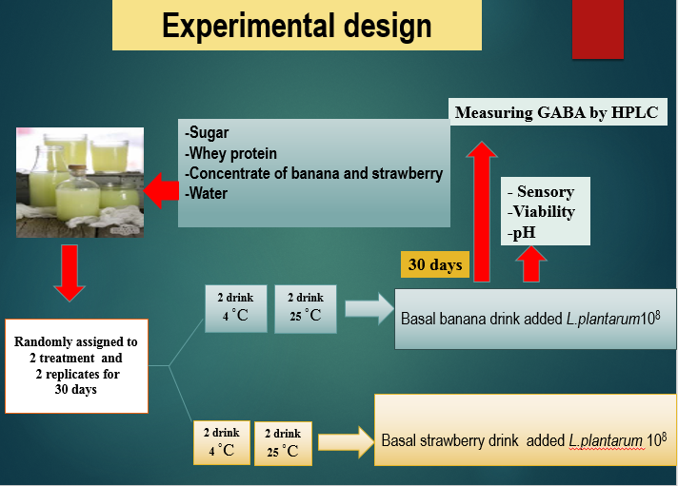

Publications:
Fatemeh Zarei, Leila Nateghi, Mohamad Reza Eshaghi, Maryam Ebrahimi Taj Abadi. Optimization of Gamma-Aminobutyric Acid Production in Probiotics Extracted from Local Dairy Products in West Region of Iran using MRS broth and Whey Protein Media. Appl Food Biotechnol. 2018; 5- 4.
-Zarei,F., Nateghi, L., Eshaghi, M.R. Evaluation of probiotic properties of Lactic Acid Bacteria isolated from native dairy products of western Iran. Applied Microbiology in Food Industries.2018; 3;4,55-65. Author. Persian Journal.
-Factors associated with body weight status of Iranian postgraduate students in University Putra Malaysia. Corresponding Author. Nursing and midwifery studies Journal. Nursing Midwifery Studies. 2013; 2 (2): 97-102.
- Lifestyle factors and dietary intake of Iranian postgraduate students in Universiti Putra Malaysia (UPM), Corresponding Author: Electronic Physician, 2013; 5 (3):679-684.


Biography
Fatemeh Zarei has completed her Bachelor in Nutrition science in Shaheed Beheshti University, Tehran, Iran, and for master she continued Nutrition community in University Putra Malaysia (UPM), Malaysia. After while started her PhD at Azad Varamin University, Tehran, Iran. Title of her thesis was Optimization and identification of culture conditions and the possibility of producing probiotic microorganisms producing GABA (gamma-aminobutyric acid) isolated from native dairy products of western Iran and using it in whey drink. Now She is working as an expert of Supplements food in Food and Drug Administration, Tehran, Iran. She has published more than 6 papers in different journals during her education and participated in many international congress.

Presenting author details
Full name: Fatemeh Zarei
Contact number:+989129569137
Twitter account: fatima47036842
Linked In account: Fatemeh Zarei
Category: (Poster presentation)

