Effect of Vitamin D Supplementation for Obese Pregnant Women on Gestational Diabetes and Diabetes Biomarkers

Dr Faten Tamim, RN, PhD, University of Jordan
Dr Hamed Takruri, Prof. University of Jordan

Abstract
Background: High rates of vitamin D deficiency in Jordan are alarming especially when they are associated with obesity during pregnancy. Objectives: To investigate the effect of vitamin D supplementation for obese pregnant women on gestational diabetes and diabetes biomarkers. Methods: 118 women were investigated and were divided into three groups. Each group was divided into two treatment subgroups. (1) Women (n=23) with normal 25(OH)D levels were given either no supplementation (1A=12) or given vitamin D supplementation of 10000 IU/wk (1B=11), (2) women (n=43) with insufficient 25(OH)D levels were given either 10000 IU/wk (2A= 22) or 20000 IU/wk of vitamin D supplementation (2B=21), (3) women of group 3 (n=52) with deficient 25(OH)D levels were given either 20000 IU/wk (3A=26) or 50000 IU/wk (3B=26) of vitamin D supplementation. Results: Fasting blood sugar showed decreased levels among B treatment subgroups in both group 1 and 3, while no significant difference was found between A and B treatment subgroups in group 2. Insulin resistance showed a significant difference between A and B treatment subgroups among group 2 and 3 but not group 1. Conclusion: Screening for 25(OH)D during pregnancy and appropriate replacement, especially in patients with severe deficiency, may contribute to the prevention of gestational diabetes mellitus.

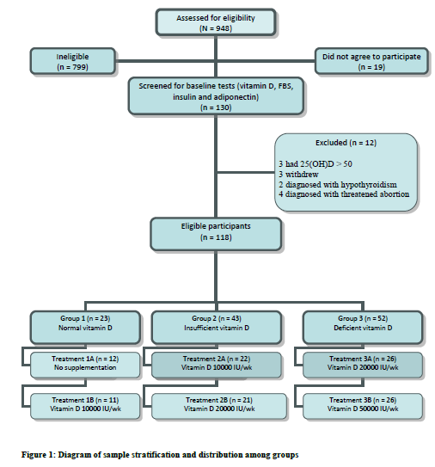
Recent Publications (minimum 5)
- Abdul-Razzak, K. Ajlony, M. Khoursheed, A. and Obeidat, B. (2011), Vitamin D deficiency among healthy infants and toddlers: A prospective study from Irbid, Jordan. Pediatrics International, 53 (6), 839-845.
- Batieha, A. Khader, Y. Jaddou, H. Hyassat, D. Batieha, Z. Khateeb, M. Belbisi, A. and Ajlouni, K. (2010), Vitamin D status in Jordan: dress style and gender discrepancies. Ann Nutr Metab, doi: 10. 1159/ 000323097.
- Bondar, L. Catov, J. Robrts, J. and Simhan, H. (2008), Prepregnancy obesity predicts poor vitamin D status in mothers and their neonates. J Nutr, 137(11), 2437-2442.
- Datta, S. Alfaham, M. Davies, D. Dunstan, F. Woodhead, S. Evans, J. and Richards, B. (2002), Vitamin D deficiency in pregnant women from a non European ethnic minority population-an interventional study. BJOG, 109, 905-908.
- Josefson, J. Feinglass, J. Rademaker, A. Metzger, B. Zeiss, D. Price, H. and Langman, C. (2013), Maternal obesity and vitamin D sufficiency are associated with cord blood vitamin D insufficiency. J Clin Endocrinol Metab, 98(1), 114-119.
- Khader, Y. Batieha, A. Ajlouni, H. El-Khateeb, M. and Ajlouni K. (2008), Obesity in Jordan: prevalence, associated factors, comorbidities, andchange in prevalence over ten years. Metab Syndr Relat Disord, 6 (2), 113-120. Abstract.


Dr. Faten Tamim has got her PhD in Human Nutrition & Dietetic, specialized in Maternal & Child Nutrition, University of Jordan, 2017. She got her MSc in Public Health, specialized in Maternal & Child Health in 2008. She has one published book titled by "Effect of Vitamin D Supplementation For Obese Pregnant Women: Maternal and Neonatal Outcomes". In addition, she has one accepted article for publication at "Journal of Clinical Nutrition and Metabolism". She worked as a midwife for 20 years in Jordan Ministry of Health facilities. She founded the first lactation support clinic in Jordan in 2014. As well, she is the founder and chairperson of The Breastfeeding Support Association since 2016, so she is considered as a breastfeeding advocate in her country. Last and not the least she got the chance to join the family of Abt. Associates as Nutrition Specialist in March 2018 up to date.

Email:fatintamim@yahoo.com

Notes/Comments:

