Social Determinants of Health among Syrian Refugees Residing Inside and Outside Camps in Jordan
Hamza Alduraidi, RN, MPH, PhD, University of Jordan, Amman, Jordan

Abstract
Introduction: Social Determinants of Health (SDOH), such as age, gender, income, and educational level, are considered an important indicator of health characteristics and outcomes of individuals, families and communities, regardless of the ethnic, racial or socio-economic backgrounds. The Hashemite Kingdom of Jordan has received waves of refugees and asylum seekers all over its relatively-short history. The latest wave of refugees and displaced persons who fled to Jordan is that of several hundreds of thousands of Syrians who fled the devastating and life-threatening consequences of the Syrian crisis since winter, 2011. These Syrian refugees currently reside either inside of designated refugee camps, or outside camps among the host Jordanian urban communities.
Purpose: This research project aims to investigate the association between adult Syrian refugees’ health characteristics and health outcomes, and the socio-demographic characteristics of these refugees. It also aims to assess for correlation between living in a camp and the consequent health outcomes. Ultimately, this research project aims to explore SDH’s of Syrian refugees inside and outside Jordan’s camps.
Methodology: This is a descriptive, comparative cross-sectional research study, where data will be collected from two sample of adult Syrian refugees in Jordan; one inside camps, and the other within Jordan’s urban communities outside camps. Health characteristics and outcomes will then be found for each sample and compared between the two samples in order to find statistically significant SDH’s inside and outside camps. The questionnaire is a combination of socio-demographic part and several instruments including General Health Assessment, Hopefulness, Psychological 9-item index, World Health Organization’s brief 26-item Quality of Life tool. All instruments have been studied for psychometric characteristics and were found valid and reliable. All instruments were checked for cultural appropriateness for Arabic-speaking, Syrian refugee population.

Image

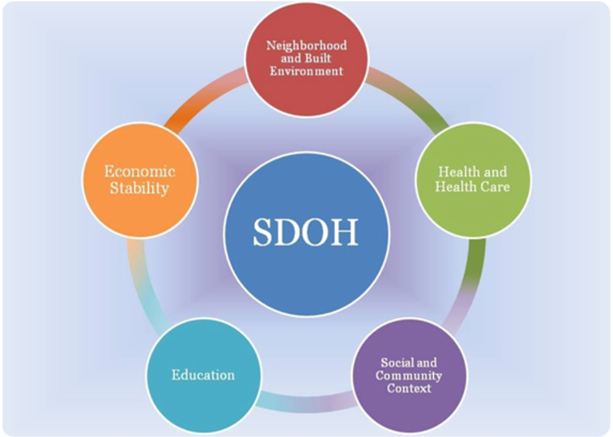

Recent publications

- Alduraidi, H. et al (2017). Depression, Perceived Health and Right-of-Return Hopefulness of Palestinian Refugees, Journal of Nursing Scholarship In Press; DOI: 10.1111/jnu.12363
- Alduraidi, H. et al (2017). Health-related quality of life of Palestinian refugees inside and outside camps in Jordan. Nursing Outlook, Volume 65, Issue 4, , Pages 436-443
- Alduraidi H. (2017). Social determinants of health-related quality of life in Palestinian refugees in Jordan. ProQuest Dissertations Publishing, 2016. 10133407.

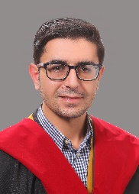
Biography
I completed Ph.D. program in June, 2016 at the School of Nursing at University of California, San Francisco. The title of my dissertation was “Social Determinants of Health-related Quality of Life in Palestinian Refugees Living Inside and Outside Camps in Jordan”. Two relevant research papers were submitted for publication since my doctoral graduation. The first was published online in May, 2017 and was entitled: “Health-related quality of life of Palestinian refugees inside and outside camps in Jordan”. The second one is still under review and it is entitled: “Depression, Perceived Health and Right-of-Return Hopefulness of Palestinian Refugees”. I plan to continue working with refugees in Jordan and contributing to the understanding of their health and quality of life in the physical, psychological, social, as well as environmental domains over the course of my academic career.

Email: h.alduraidi@ju.edu.jo

