Executive functions and memory in Parkinson’s disease patients with and without Deep Brain Stimulation
MSc. Thayná Laís de Souza Arten, Universidade Federal do Paraná (UFPR), Brazil

Abstract
The cognitive effects of Deep Brain Stimulation (DBS) in patients with Parkinson’s Disease (PD) have been investigated in several researches. Studies on the influence of individual variables on cognitive performance in DBS, however, are scarce. This study aimed to identify the association between demographic characteristics, executive functions, and memory performance in a group of PD patients with and without DBS before COVID-19 pandemic. Methods: 76 participants were subdivided into three groups: 30 healthy people (control group), 30 diagnosed with PD treated only with drugs (drug group), and 16 with PD treated with DBS (DBS group). Executive functions and memory were assessed using the following instruments: Montreal Cognitive Assessment, Rey Auditory Verbal Learning Test, Trail Making Test A and B, Digits Span, and Stroop Test. Analysis of Variance (ANOVA) and exploratory linear regression were used for data analysis. Results: ANOVA showed significant differences between the control, drug, and DBS groups. However, the exploratory regression analysis identified a significant association of the variables including age, schooling, and activity of daily living with the performance of executive functions and memory only in the DBS group. This study showed significant associations of some demographic variables (age, schooling, and activities of daily living) in the performance of various measures of executive functions and memory in patients with DBS, but not in patients with drug treatment. The demo- graphic characteristics of the patients were identified as being associated with behavioral changes, such as impulsivity, and as risk factors for post-surgical complications. The result of this study, on the association between demographic characteristics and cognitive performance, can be explained by the pre-clinical characteristics of patients subjected to surgical treatment. Conclusion: The results showed that the performance of memory and executive functions was associated with demographic characteristics only in patients treated with DBS.

Image
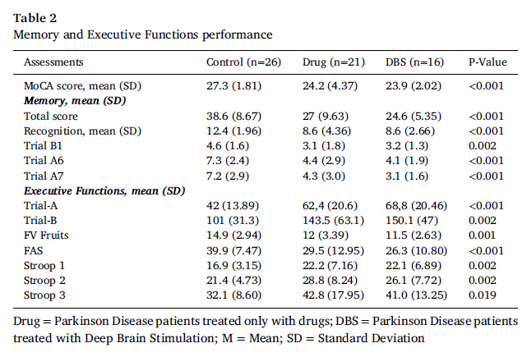
Recent Publications
- Merola A, Romagnolo A, Rizzi L, et al. Impulse control behaviors and subtha- lamic deep brain stimulation in Parkinson disease. J Neurol 2017;264(1):40–8. doi: 10.1007/s00415-016-8314-x
- Farrokhi F, Buchlak QD, Sikora M, et al. Investigating Risk Factors and Predict- ing Complications in Deep Brain Stimulation Surgery with. Machine Learning Algo- rithms.World Neurosurg 2020;134:325–38. doi: 10.1016/j.wneu.2019.10.063
- Mills KA, Donohue K, Swaminathan A, Leoutsakos JM, Smith G, Brandt J. Neu- ropsychological predictors of patient-reported cognitive decline after deep brain stimulation in Parkinson’s disease. J Clin Exp Neuropsychol 2019;41(3):219–28. doi: 10.1080/13803395.2018.1526889.
- Mulders AEP, Temel Y, Tonge M, et al. The association between surgical char- acteristics and cognitive decline following deep brain stimulation of the subtha- lamic nucleus in Parkinson’s disease. Clin Neurol Neurosurg 2021;134:98–103. doi: 10.1016/j.clineuro.2020.106341
- Combs HL, Folley BS, Berry DT, et al. Cognition and Depression Following Deep Brain Stimulation of the Subthalamic Nucleus and Globus Pallidus Pars Internus in Parkinson’s Disease: A Meta-Analysis. Neuropsychol Rev 2015;25(4):439–54. doi: 10.1007/s11065-015-9302-0 .

Photograph
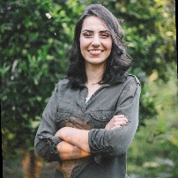
Biography
Currently part of the postgraduate program – Doctorate (PhD) at the Universidade Federal do Paraná (UFPR). Doctoral project in personality, executive functions, and post covid cognitive sequelae in Parkinson’s Disease. Master in Psychology, focused in the research line of Neuropsychological Assessment and Rehabilitation. Psychologist specialist in Psychological Assessment and in Cognitive Behavioral Therapy. Research interest in Neuropsychology, Bilingualism, Behavior/Cognition, Parkinson's Disease, Neurosurgery, Cognitive Behavioral Therapy.
E-mail: thayarten2@gmail.com

