An Exploration of Family Caregiver Experiences of Burden and Coping While Caring for People with Mental Disorders in Saudi Arabia—A Qualitative Study

Loujain Sharif 1,*, Shimaa Basri 2, Fidaa Alsahafi 2, Mashael Altaylouni 2, Shihanah Albugumi 2, Maram Banakhar 3, Alaa Mahsoon 3, Nofaa Alasmee 1 and Rebecca J. Wright 4
1 Department of Psychiatric and Mental Health Nursing, Faculty of Nursing, King Abdulaziz University, Jeddah 21551, Saudi Arabia; nalasmee@kau.edu.sa
2 Faculty of Nursing, King Abdulaziz University, Jeddah 21589, Saudi Arabia; Shimaa.basri98@gmail.com (S.B.); Fidaaalsahafi1998@gmail.com (F.A.); Mashaelrt@hotmail.com (M.A.); Shehanh1998.911@gmail.com (S.A.)
3 Department of Public Health Nursing, Faculty of Nursing, King Abdulaziz University, Jeddah 21551, Saudi Arabia; ahbbanakher3@kau.edu.sa (M.B.); mahsoon@kau.edu.sa (A.M.)
4 Johns Hopkins School of Nursing, Baltimore, MD 21205, USA; Rebecca.wright@jhu.edu
* Correspondence: Lsharif@kau.edu.sa

Abstract
Family caregivers of people with mental disorders face a number of burdens and stressors, such as associative stigma and burnout. These burdens are often a result of their caring role coupled with insufficient support or ineffective coping strategies, which can affect their quality of life and biopsychosocial integrity that, in turn, may affect the care they provide. This study aimed to explore the experiences of family caregivers of people with mental disorders, through examining the burdens that they face and the coping strategies that they use. Using a descriptive qualitative approach, 13 semi-structured interviews were conducted with members of the Saudi public, recruited through popular social media platforms and analysed using thematic analysis. Five main themes were constructed from the data: Type of care, Challenges, Coping and support, Perceptions of public awareness, and Messages to others. The findings emphasize the different types of burdens that caregivers experience, and their needs that require a range of responses such as educational training on effective coping strategies, and psychological support in the form of counselling or group therapy. This study highlights the voice of caregivers and their message to the public, in order to correct the misconceptions surrounding mental disorders and those associated with them.

Image
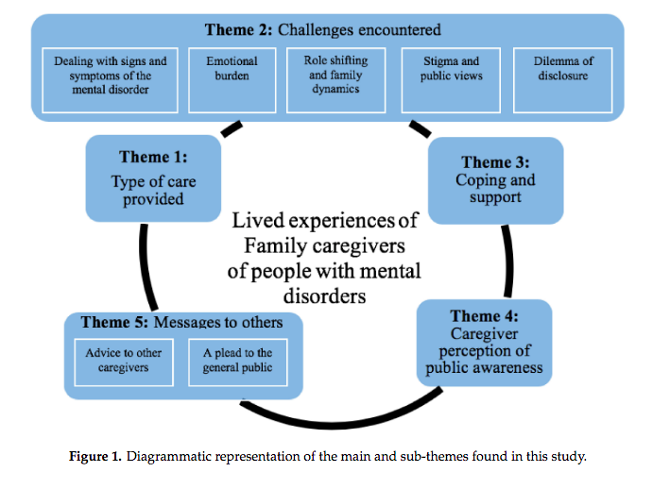
Recent Publications
- Noorwali, R., Almotairy, S., Akhder, R., Mahmoud, G., Sharif, L., Alasmee, N., ... & Hafez, D. (2022). Barriers and Facilitators to Mental Health Help-Seeking among Young Adults in Saudi Arabia: A Qualitative Study. International Journal of Environmental Research and Public Health, 19(5), 2848.
- Aljohani, W., Banakhar, M., Sharif, L., Alsaggaf, F., Felemban, O. and Wright, R. (2021). Sources of Stress among Saudi Arabian Nursing Students: A Cross-Sectional Study. International journal of environmental research and public health., 18(22), 11958; https://doi.org/10.3390/ijerph182211958
- Alreshidi, N. M., Alghamdi, S., Shibily, F., Mahsoon, A., Alasmee, N., Sharif, L., ... & Siddiq, N. (2021). The Association between Using Personal Protective Equipment and Headache among Healthcare Workers in Saudi Arabia Hospitals during the COVID-19 Pandemic. Nursing Reports, 11(3), 568-583.
- Almutairi, W. M., Alsharif, F., Khamis, F., Sallam, L. A., Sharif, L., Alsufyani, A., ... & Alqasimi, R. (2021). Assessment of Mothers’ Knowledge, Attitudes, and Practices Regarding Childhood Vaccination during the First Five Years of Life in Saudi Arabia.Nursing Reports, 11(3), 506-516.
- Niall, M., Sharif, L. and Norman, I. (2019) Media portrayals of mental disorder in Saudi Arabia: a review of popular newspapers. Transcultural Psychiatry. DOI:10.1177/1363461518819117

Photograph

Biography

Dr. Loujain Sharif, completed her doctoral degree in Nursing Research at King’s College London which entailed devising and testing an educational intervention to reduce mental health-related stigma in a sample of nurses in Saudi Arabia. She also has a Master of Science in Mental Health Studies from the Institute of Psychiatry and Psychology and Neuroscience (IoPPN), King’s College London. She is currently an assistant professor and the head of the Psychiatric and Mental health nursing department at the Faculty of Nursing at King Abdulaziz University , Jeddah, Saudi Arabia.

Email: Lsharif@kau.edu.sa

Notes/Comments:

My research paper would benefit nurses with an area of interest In mental health research and staff improvement of vulnerable caregiver/ patient care

