The Meaning Of Life Client With Systemic Lupus
With The Perspective Of Maslow And Henderson
Mohamad Judha, Respati Univ Yogyakarta, Indonesia.

Abstract
Statement of the Problem: Sufferers of Lupus not only suffer from disrupting physical abilities but also physiologically the body is in a weak state and cause uncomfortable effects, also will reduce the quality of life. Several instruments have been approved to assess the ability of quality of life including those caused by lupus. The purpose of this study is to know quality of life who had been treated after Lupus treatment and what support was needed. Methodology & Theoretical Orientation: Data obtained by in-depth interview questions and can also use focus group discussions (FGD). Samples selected for the qualitative research stage were obtained from patients who were able to communicate well, were diagnosed with lupus and had received treatment, for the initial stage in qualitative research the number of samples obtained to obtain data saturation was around 8-12 respondents. Findings: The attention from the environment associated with the concept of Maslow's hierarchy means providing a sense of security and comfort associated with a sense of appreciation and feel loved by the environment around sufferers. The support function carried out by people around the sufferer will influence higher positive feelings by validating existing beliefs, encouraging to provide information and advice as well as material assistance. Conclusion & Significance: The coping mechanism used by the patient depends on internal and external factors, this factor makes the patient adaptive or if each factor does not support will be mal-adaptive. Type of support experienced by sufferers comes from people around, adequate support will improve patient coping and self-esteem. Recommendations information in accordance with the patient's condition will be provided the basis for taking action, this process requires time so that the patient is able to adapt. The result of adaptation is the patient's effort to improve the quality of life and find meaning of life.
Image
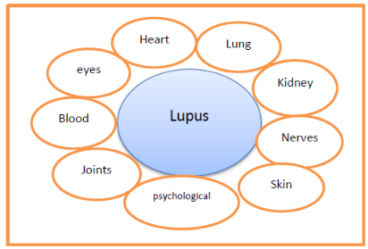

The flowchart of searching for the meaning of life for Lupus sufferers :

1 2 3 4 5 6 7 8
- Search Information :
- The initial stage is exposed to stressors.
- Response phase.
- The information search stage.
- The stage of filtering information.
- Contemplation stage.
- Adaptation stage.
- The stage of gaining meaning in life.
Recent Publications
- Creswell, J.W. (1998). Qualitative inquiry and research design: choosin among five traditions. Thousands Oaks: Sage Publications, Inc.
- ____________. (2002). Research design:qualitative and quantitative Approaches : pendekatan kualitatif dan kuantitatif . alih bahasa :Angkatan III & IV KIK-UI . Jakarta. KIK Press.
- Das, Puspa M. (2005). The effects of optimism and coping strategies on quality of life for women with systemic Lupus erythematosus. Ph.D. dissertation, State University of New York at Albany, United States -- New York. Retrieved June 18, 2010, from ProQuest Psychology Journals.(Publication No. AAT 3177047)
- Judha mohamad dan Deden Iwan S (2015). Apa dan Bagaimana Penyakit Lupus (Sistemik lupus eritematosus) . Yogyakarta Penerbit : Gosyen Publishing ISBN : 978-602-1107-21-8 .pp 14 -29
- Maryam, Siti (2007). Kebutuhan dasar manusia: Berdasarkan hierarki Maslow dan penerapannya dalam keperawatan. Jakarta; Semesta Media



Biography
researchers as instructors in the field of health in Indonesia and clinical practitioners who have expertise in the context of surgical medical nursing and are active in research activities especially in nursing in response to an illness. besides being active in the social organization of the lupus foundation in Indonesia and contributing to research related to lupus.
Email: judha.fikes@gmail.com

