Nurses, here’s why (and how!) you should be using social media—
A workshop
Sydnee Logan, MA, Johns Hopkins University School of Nursing

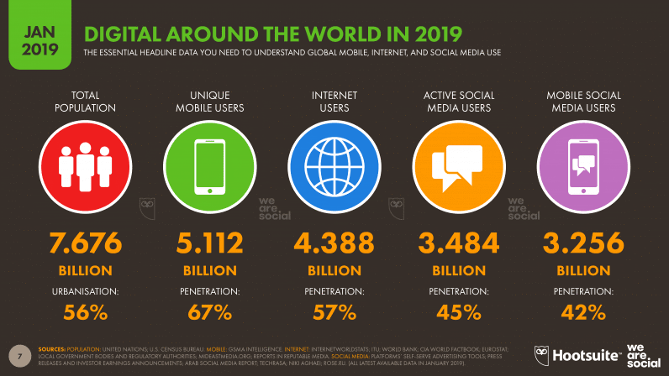
Abstract (300 word limit)

Of the 7.676 billion people on the planet, nearly half of them are on social media. This is the space to make yourself known to healthcare leaders, build relationships that further your research, and raise awareness of evidence-based practice.

In this workshop nurses will create a professional social media presence and learn to navigate the industry’s digital landscape. Participants will set up their social media profiles on Twitter and LinkedIn, learn how different sites are used, participate in a Twitter chat, and learn to navigate tricky online situations -- like promoting your work, managing public and private on social media, and dealing with online bullies.

Participants should bring a smartphone (mandatory) and a laptop (optional). They should have a digital headshot to use for their social media profiles and general work history on hand to fill out their LinkedIN profile. Participants should already have a Twitter and a LinkedIN account established, but if they do not we can set them up in the workshop.

Harness the power of social media to:

Earn funding

Find professional opportunities

Promote the professionalization of nursing

Promote yourself and the institutions you represent
Image

Hootsuite, 2019
Recent Publications (minimum 5)
- Logan, S. 2019. Using social media to further palliative and hospice care. Webinar presented to the Hospice and Palliative Nurses Association Cambia Leadership Program, Baltimore, MD.
- Logan, S. 2019. Social media lunch & learn. Presentation to Johns Hopkins School of Nursing faculty & staff, Baltimore, MD.
- Logan, S. 2019. Social Media with Sydnee Logan. Video blog to the Global Alliance for Nursing & Midwifery, Baltimore, MD.
- National Academies of Sciences, Engineering, and Medicine, Institute of Medicine, Board on Population Health and Public Health Practice, Roundtable on Health Literacy (2015). Health Literacy and Consumer-Facing Technology: Workshop Summary, Washington, DC.
- Spinner, J., Logan, S., Bravo, K. et al. (2015) Reducing health disparities through tailored communication: An overview of the Food and Drug Administration’s Office of Minority Health Outreach and Communication Program. Poster session presented at the National Conference on Health Communication, Marketing, and Media, Atlanta, GA.
Sydnee Logan, reviewer

Photograph

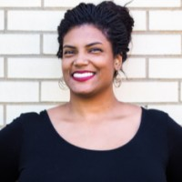
Sydnee Logan is an award-winning communicator. She gets the word out on social media and online, and is particularly familiar with the health industry. Sydnee manages social media and digital content for the Johns Hopkins School of Nursing, and is currently editor of the #1 school of nursing blog in the world.
​
Sydnee earned her BA in Communication from Tulane University in 2010 and her MA in Communication from Johns Hopkins in 2016.

Email: sydnee.logan@gmail.com

Notes/Comments:
Sydnee Logan, MA specializes in health communication, but is not a nurse.

