Evaluation of the Relationship between Communication Styles and Academic Achievements of University Students
B. Sançar¹, AS. Yalçın²

¹ University of Toros, TURKEY)
²University of Ankara, TURKEY)

Abstract

Objective: In this study, the relationship between nurturing (open and respectful) and restrictive (self-centered and condescending) communication styles, academic success and educational experiences of university freshmen and senior students was examined.
Methods: The study was conducted with the participation of 977 students, 438 of whom were first year and 539 of them were senior students. The communication styles preferred by the students were determined by Interpersonal Communication Styles Scale (ICSS). In this scale, the communication styles used in interpersonal relations are questioned.
Results: 22,2% of the students participated in the study were in the age group of 19 and below, 77,8% of them were in the age group of 20 and over (Avg 21,27 ±SD.2,64). 86,7% of the students were women. The first year students were 44,8% and the last year 55,2%. Overall grade point average of the students was 3,11 (Avg. 3,11 ±SD.0,35). According to our findings, open (Avg.16,53 ± SD.3,81 Avg.15,48 ± SD.4,12) and respectful communication (Avg.17,19 ± SD.3,34 and Avg.15,50 ± SD.3,98). Open (Avg.16,17 ± SD.3,91) and respectful communication mean scores (Avg.16,60 ± SD.3,52) of the first year students compared to the fourth grade (Avg.14,78 ± SD.4,22) and Avg.14.47 ± SD.4.06). In addition, the overall academic grade point average (GPA) 3.00-4.00 for those who adopt the open (Avg.15.61 ± SD.3.98) and respectful (Avg.15.71 ± SD3.86) style of communication, while at the same time using self-centred communication (Avg. 4,71 ± SD.2,00). Those with a GPA of 0.00-2.99 preferred the condescending style of communication (Avg.53 ± SD.4.33) more.
Conclusion: Freshmen used the nurturing style of communication. Students with a higher GPA preferred a nurturing yet self-centered communication style. According to the results, while nurturing communication style was effective on students' academic achievement, academic achievement increased the number of students using self-centered communication style.

Keywords: Academic achievement, Communication styles, University students

Professional Biography

Speaker: Behire Sançar completed her PhD at Gazi University at the age of 35 and completed her post-doctoral studies at the School of Health Sciences at Toros University. She has published more than 20 papers in reputed journals and is an editor of international and national books.
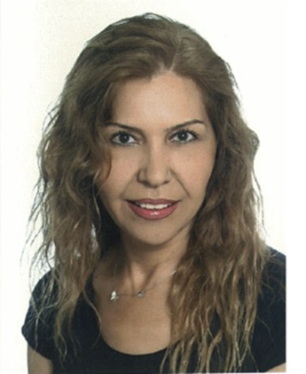
Full Name: Behire Sançar
Email Id: behire.sancar@toros.edu.tr
Contact No: +90 505 252 02 73
Social Network Details (FaceBook/LinkedIn): facebook.com/behire.sancar

