Quantitative investigation on perceived anxiety and pain during the cervical cancer screening path
Alessandra Gobbi¹, Matilde Canepa^{2,3}, Gabriele Tibaldi¹, Massimiliano Grassi^{2,3}

¹ ASLTO5 (Chieri, Turin – Italy)
² IRCCS Ospedale Policlinico San Martino - Genoa
³ University of Genoa

Abstract

Background: Cervical screening path causes the patient a psychological pain due to the cancer fear. Moreover minimize the physical pain experienced is also a remarkable point to consider in order to improve the standard of care provided.
Objectives: To estimate women’s anxiety and pain levels resulting from cervical cancer screening procedures, to understand if the nursing is essential to modify their feelings and improve the standard of quality given.
Methods: Monocentre Prospective study on 119 women from 25 to 64 years old afferent to colposcopy at the Cancer prevention Department of AslTO5 analysing anxiety and pain using the State-Trait Anxiety Inventory Scale Form Y-1 and Y- 2 and the Numerical Rating Scale.
Results: Anxiety increases in patients during the cervical cancer diagnostic iter and exposing women to a consistent risk of developing a severe depression.
The level of pain perceived turned out to be low for the majority of women; however, the 30% refers 5 or more in the NRS evaluation.
Conclusions: This study shows that the quality of care is satisfactory, but there are still some critical issues.
In accordance with our findings, it is essential to specifically train the health care workers to raise the quality of care offered and decrease the costs derived from the medical, pharmacological, psychological and economical support needed for a person with severe major depression.
About 1/3 of the interviewed women refer a “medium to high” pain, so we can reconsider using anesthesia for a selected population.

Keywords— Anxiety, depression, pain, cervical cancer screening

Professional Biography

Dr Massimiliano Grassi has completed his MD in 2016 at the Genoa University School of Medicine. He is involved in clinical and sperimental activities in the Oncology Department of Policlinic Hospital San Martino since 2013 where he is now conducting his residency in Medical Oncology. During his studies he had been in the Antwerpen University Hospital for an internship in the Phase I - Early Clinical Trial Unit of the Oncology Department. In 2017 he worked as a physician for the association “Vela ONLUS”. He has published different scientific papers in reputed journals in the field of oncology.

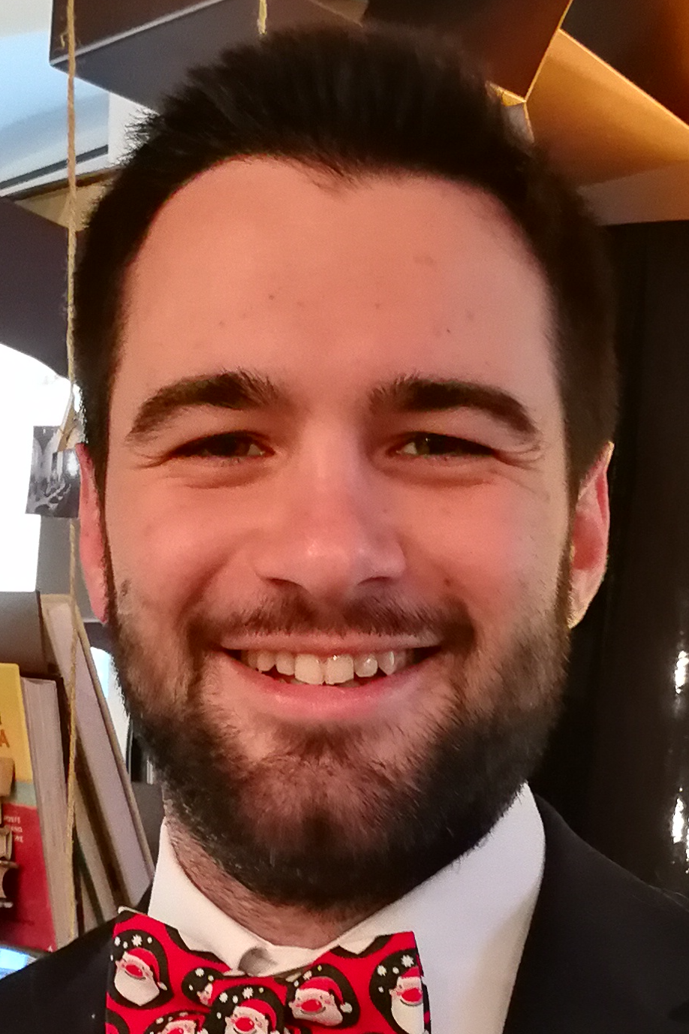

Email Id: massigrassi.mg@gmail.com

