Abstract Template
Abstract Title: Follow-up of suicidal behavior through the diagnosis NANDA 150-Suicide risk
Albuixech-García, R.¹, Escribano, S.², & Juliá-Sanchis, R.²
¹Primary healthcare centre Raval Nord, Institut Català de la Salut, Barcelona, Spain
²Nursing Departament. Health Science Faculty. University of Alicante, Spain

Abstract

Suicidal behavior must be managed from a prevention approach. Therefore, identifying people at high risk, providing follow-up and support could reduce possible recurrences. Aim: to examine the effects of continuity of care procedure using diagnosis NANDA 150-Suicide risk. Method: A total of 213 subjects participated, being 60.8% females (n=129) and 85.9% from Spain (n=183). The age range was between 13 and 91 years (M=41.31; SD=15.17). Of the total sample, 10.8% lived alone, 18.8% with their partner, 12.2% with one or both parents, 35.6% with a family member, 1.9% in a shared flat, not having information of the rest (19.2%). All participants were included in the study after being admitted in the emergency department during 2011 after a suicide attempt and were followed up to January 2015. 110 (51.6%) subjects were diagnosed with NANDA 150-Suicide risk by the triage nurse, in front of 48.4% (n = 103) who followed the usual protocol. The activation of the diagnosis NANDA-150 include an appointment with the Primary Care Nurse and the Outpatient Mental Health Nurse who check if the patient was already known and if he had in follow-up by the unit. Also, they establish phone contact with the patient/family in 24 hours to plan care. Results: More than half of the sample attempted to commit suicide through drug intake (65.7%), and the rest used different methods. There were fewer repetitions of the suicidal behavior "attempt and ideation" among the subjects who were identified with the NANDA-150 diagnosis (n=26; 41.3%), compared to those who were not classify with the nursing diagnosis (n=37; 58.7%) (χ²=7.11; p=0.03). Conclusions: The early detection of suicidal behavior with the diagnosis NANDA-150 has proven to be an effective preventive intervention to improve the continuity of care after discharge from hospitalization in primary care services, and thus decreasing the possibility of new attempts at autolysis.

Keywords— Nursing, diagnosis, risk, Suicide behavior.

Professional Biography (100-150 words)
Dr. Silvia Escribano Cubas received her PhD, with distinction, in Miguel Hernández University (Spain) during the period of 2017. She hold a First-cycle Undergraduate Degree in Nursing (2004). Also hold a Master's Degree in Health Science Research from the University of Alicante, a Second-cycle Undergraduate Degree in Psychology, and a Master's Degree in Psychology Therapy for Children and Adolescents from Miguel Hernández University of Elche. Currently, she is working as a senior lecture at Nursing Department in University of Alicante (Spain) in the Mental Health field. She has published papers and has been serving as a reviewer in several reputed journals. She has authored research about Public Health and VIH/AIDS Preventive Programs articles.

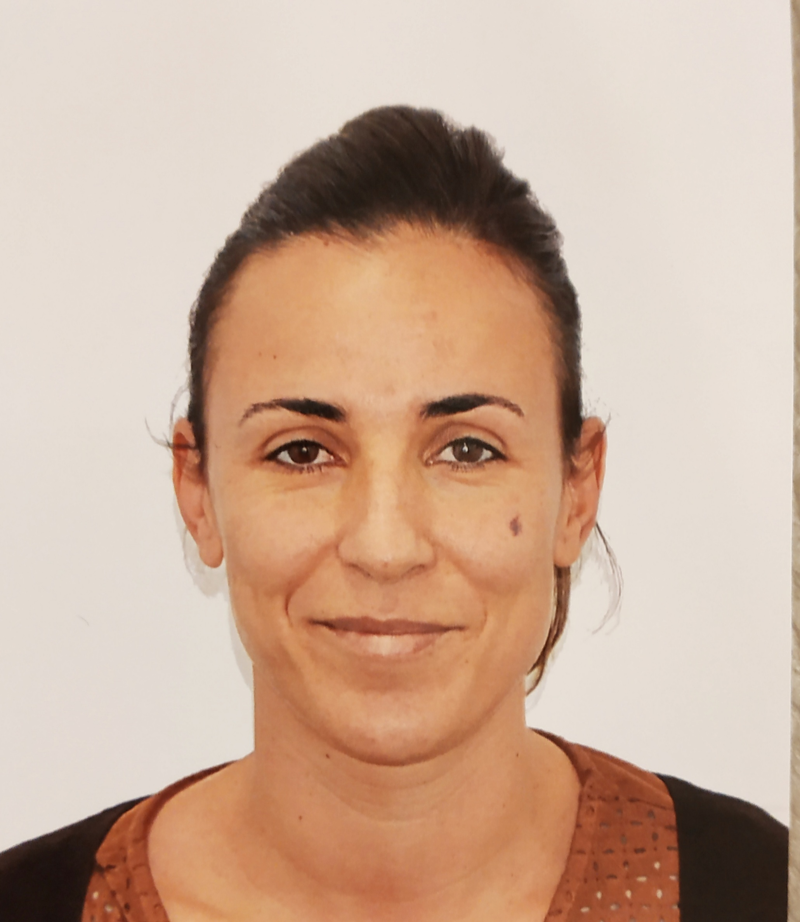

Full Name Silvia Escribano Cubas
Email Id: silvia.escribano@ua.es
Contact No: +34 622028011
Social Network Details (FaceBook/LinkedIn):

Any Comments:

