Abstract Title: Implication of Application Program “PREG-CAL” on Mobile Phone for Promoting Health in Thai Pregnant Women:
Jantakan Kanjanawetang¹

¹ Suranaree University of Technology, Thailand

Background: Pregnancy is accepted as a maturation crisis. Health behavior is very important, because it has a direct effect on health of pregnant mothers and their fetus. PREG-CAL is a mobile application program which operated on smartphones or tablets based on android operating system. This application was developed as an alternate tool for promoting self-care potential of pregnant women and their families sustainably.
Method: A Quasi-experimental research design, one-group with pre-test and post-test, aimed to examine effectiveness of applying the PREG-CAL to promote health of Thai pregnant women. Therefore, knowledge, health behavior and haematocrit between pregnancy were tested. Sample of this study composed of 30 pregnant women who received antenatal care at Chokchai Community Hospital, Nakhon Ratchasima Province. Data was analysed using a paired-t test.
Results: It was found that the score on knowledge (mean = 35.77, SD = 3.07) and health behaviors (mean = 173.00, SD = 9.47) of pregnant women after using the application called PREG-CAL 3.0 was higher than the score on knowledge (mean = 28.93, SD = 5.13) and health behaviors (mean = 162.27, SD = 12.29) before using the application statistically (p< .01). In case of hematocrit, it demonstrated that mean hematocrit level (mean=36.05, SD= 3.28) after using PREG-CAL was statistically higher than level of haematocrit before (mean = 34.60, SD = 3.37) using the application (p <.001).
Conclusion: This study showed that the PREG-CAL could improve knowledge, health behaviors and hematocrit level of Thai pregnant women. Therefore, due to an ease for use and access, the PREG-CAL could be an alternative tool for promoting health behaviors of Thai pregnant mothers. Recently, the PREG-CAL has been downloaded more than 70,000 times and has current users on smartphones or tablets more than 20,000 users. Moreover, satisfaction level which was rated by Google play is approximately 4.8 from 5.0.

Keywords— Pregnancy, mhealth, Mobile application, Thai mother

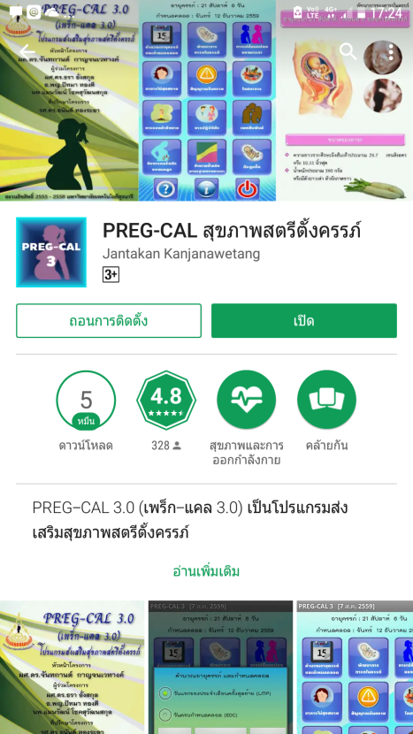

Professional Biography
Jantakan Kanjanawetang had completed her PhD in nursing from Chulalongkorn University, Thailand. She is the deputy director of the Center for Innovation and Educational Technology, and the former associate dean of Nursing Institute, Suranaree University of Thecnology, Thailand. She has long experience on teaching maternal nursing and midwifery for nursing students for more than 20 years.



Email Id: jantakank@sut.ac.th

Any Comments:

