CORRELATION BETWEEN COLLABORATORS 'HAPPINESS INDEX AND CUSTOMER SATISFACTION IN INTENSIVE THERAPY

Leonor Monteiro do Nascimento Carneiro, nurse, Brazil, Dorsal
Lídia Guimarães Morais, nurse, Brazil, Dorsal

The intensive care environment is of great importance for the recovery of customers potentially at risk for life. It requires all employees a lot of concentration, determination and care 24 hours a day. It is a highly complex place, with very strict and costly processes. Inserted in this situation is the customer recovery and, through their moment of weakness, evaluates all this climate in pursuit of greater satisfaction.
The proposal is to determine a happiness index consists of 8 areas: Motivation at work, work environment, recognition and trust, involvement with leadership and organization, Compensation, balance between personal and professional life, happiness in the company where he works and happiness with the function which plays in the company where he works. Making a comparison with customer satisfaction through NPS and determine whether a happier environment provide greater customer satisfaction.
Two private institutions were surveyed named A and B. With happiness index calculated by Likert scale.
Results: happiness index of 0.76 to 0.59 for drive A and drive B. The NPS-unit was 9.17 and B was 9.6. The conclusion is that there is no correlation.

Keywords:Job Satisfaction; Organizational climate; Happiness index; High performance; Leadership; Engagement.

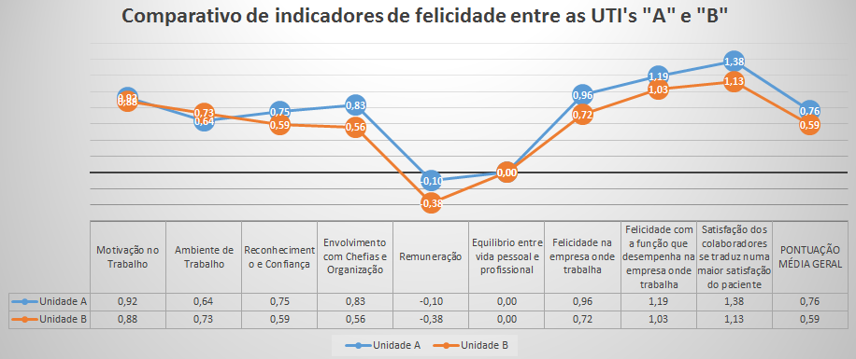

Recent Publications (minimum 5)
1ANDREWS, F. M.; WHITEY, S. B. Social Indicators of well-being: America's perception of quality of life. New York: Plenum Press, 1976.
2ANNUNZIO, S. L. Contagious success: spreading high performance troughout your organizatition. USA: Portifolio-Penguin, 2004.
3BRICKMAN, P.; COATES, D.; JANOFF-BULMAN, R. Lottery winners and accident victims: is happiness relative? J Pers Soc Psychol (não abeviar!), 36 (8): 917-927, 1978.
4CORTELLA, M.S; MUSSAK, E. Liderança em foco/Mario Sergio Cortella, Eugenio Mussak. Campinas ,SP: Papirus 7 Mares, 2009. – (Coleção Papirus Debates)
5CSIKSZENTMIHALYI, M. Flow: the psychology of optimal experience. Harper Collins Publishers, New York, 1990.
Institute of Medicine; 2000


Lídia is a nurse graduated from the Evangelical University of Anápolis, post-graduate in business management by the Dom Cabral Foundation. Working with health sector management, with experience in the general and sectorial management of hospitals in Brasilia and Goiás. Currently involved with projects aimed at developing institutions that seek hospital accreditation and optimization of processes through the application of quality tools. Full associate of the Brazilian College of Health Executives - CBEXs - with a search for the best practices and sustainability for the management. Comprises a group of IQG's leading Evaluators with work on the ONA and QMENTUM hospital certification, disseminating good practices in patient care. She is a partner - owner of the Dorsal company, health management

