Self-assessed competence in provision of care to the severely ill patient among nurses and relatives/carers in Kazakhstan
Alua Sharapieva, RN, MNS, Semey Medical University, Semey, Kazakhstan,
Zhuldyz Zhetmekova RN, MNS, Semey Medical University, Semey, Kazakhstan
Roza Abzalova,Deputy Head of City Polyclinic No.13,
Nur-Sultan, Kazakhstan
Ayan Myssaev, dean of school of nursing, dentistry, farmacy and public health Semey Medical University, Semey, Kazakhstan,

Nurses play a significant role in delivering healthcare services in primary care and community care settings. The past several decades have witnessed the growing demands placed on practicing nurses, which is mostly due to expanding set of required competences among nursing staff employed in public healthcare sector (Bing-Jonsson et al, 2013). To encourage career development of the nursing staff, their competence levels have to be identified and enhanced. In general, competence is defined as a combination of knowledge, skills, experience and attitude. Other factors, such as performance, achievements and self-appraisal can also be applied to describe competence (Benner, 1984; WHO, 2009).
This study aimed to present the level of self-assessed competence of community nurses in three primary health care establishments of Kazakhstan. The study followed cross-sectional design. The sample size included 115 nurses employed in three primary healthcare establishments of Kazakhstan.
The median scores, first and third quartiles for care competences based on nurses’ self-assessment are presented in Table 2. The tool demonstrated satisfactory level of reliability as Cronbach’s α coefficients in all competences ranged between 0.71 and 0.87. This table also displays how the findings could be presented in more details with the help of a color code. Six items (26.1 %) were in the green zone, eight items (34.8 %) in yellow, another eight items (34.8 %) in red and one item (4.3 %) in black.
This study results could be used by healthcare managers in obtaining a clear vision of which educational areas require prioritization and guide public health interventions to overcome the identified problems.
Image
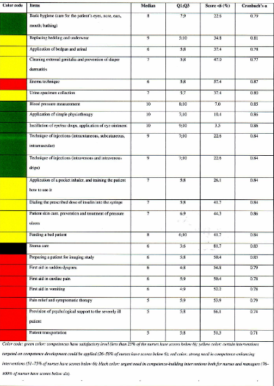

Recent Publications (minimum 5)
- American Nurses Association, 2015. Nursing scope and standards of practice, 3rd edn. ANA, Silver Springs. https://www.nursingworld.org/practice-policy/scope-of-practice/ (accessed 27 January 2019)
- Sharapiyeva, A.,M., Myssaev, A.,O., Abzalova, R.,A., Inoue, K., 2018. Self-assessment of relatives’ knowledge and skills level in caring for a seriously ill patient. Medical Journal of West Kazakhstan. 59 (3), 65-70 [Russian]
3. O’Leary, J., 2012. Comparison on self-assessed competence and experience among critical care nurses. J Nurs Manage. 20(5), 607–14. https://doi.org/10.1111/j.1365-2834.2012.01394.x

Photograph

 Biography
MNS Alua Sharapiyeva has her expertise in improving home care nursing and nurse education in Kazakhstan. She take part in building new education program for masters of nursing science. Her key qualifications are nursing research and home care management. She is studying for a PhD in Public Health. Theme of the thesis is «The improvement of home care in Kazakhstan».
Email:alulya_2790@mail.ru

Notes/Comments:

