The Developmental model of teaching and learning clinical practicum
at postpartum ward for nursing students by using VARK learning styles
Wanwadee Neamsakul, RN PhD, Suranaree University of Technology, Thailand

Abstract (300 word limit)
This study aimed to develop a model of teaching and learning clinical practicum at postpartum ward for nursing students by using VARK learning styles, and evaluate the nursing students’ opinions about the developmental model. Research and development was used as a methodology for this study including 5 steps; 1) reviewed concepts, theory, textbooks, and documents related to clinical practices in postpartum ward and focus group discussion with obstetric nursing instructors who have experiences teaching Maternal Newborn and Midwifery I subject and provided mother and child health care academic services 2) used VARK learning styles; V: Visual, A: Auditory, R: Read/write, and K: Kinesthetic to develop the model of teaching and learning clinical practicum at postpartum ward for nursing students 3) be supervised by experts 4) tried out the model, and 5) evaluated and developed the model. Thirty third year nursing students from one of the northern Nursing Colleges, Academic year 2015 were purposive sampling. Data were collected using a questionnaire which was tested for its validity and reliability. Data were analyzed using descriptive statistics. The findings were as follows: The model composed of 27 activities. Seven activities were developed for visual skill (25.93%), five activities for auditory skill (18.52%), six activities for read and write skills (22.22%), and nine activities for kinesthetic skill (33.33%). VARK learning style was employed as a method for developing the model. Overall opinions about the model were reported at the highest level of average (mean=4.63, S.D=0.45). In the aspects of visual skill (mean=4.80, S.D=0.45) was reported at the highest level of average followed by auditory skill (mean=4.62, S.D=0.43), read and write skill (mean=4.57, S.D=0.46), and kinesthetic skill (mean=4.53, S.D=0.45) which were reported at the highest level of average, respectively. The model could enhance nursing students’ competencies in order to provide quality care for women and their newborn.

Image

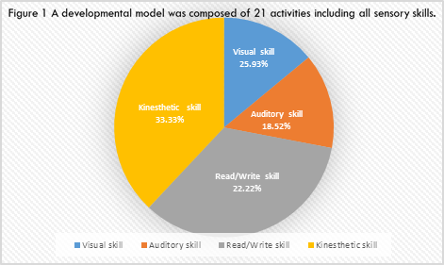
Recent Publications (minimum 5)
1. Neamsakul, W. (2013). “Lived experiences of practicing yoga asana among nursing students”. Journal of Nursing Science 32(1): 71-79 (in Thai).
2. Neamsakul, W. (2016). “Effect of teaching by using didactic strategies on learning achievement of environmental model of nursing: Florence Nightingale of the first year nursing students”.
Boromarajonani College of Nursing Uttaradit Journal 8(1): 94-98 (in Thai).
3.Neamsakul,W.,& Buncherdpongchai, P. (2016). “A developmental model of teaching and learning clinical practicum in antenatal clinic using VARK learning style in Maternal Newborn and
Midwifery Practicum I subject”. Boromarajonani College of Nursing Uttaradit Journal 8(2): 20-36 (in Thai).
4. Sriyasak, A., Almquvist, A-L., Sridawruang, C., Neamsakul, W., & Haggstrom- Nordin, E. (2016). “The new generation of Thai fathers: Breadwinners involved in parenting”. American Journal of Men’s Health. retrieve from jmh.sagepub.com on May 23, 2016 pp1-11.
5. Sriyasak, A., Almquvist, A-L., Sridawruang, C., Neamsakul, W., & Haggstrom- Nordin, E. (2016). “Struggling with Motherhood and Coping with Fatherhood- A Grounded Theory Study among Thai Teenagers”. Midwifery: An International Journal 42: 1-9

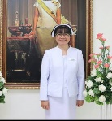 Biography (150 word limit)
Wanwadee Neamsakul has her expertise in teaching and learning of many nursing subjects such as Maternal Newborn and Midwifery, Nursing research, Family health care nursing, and Basic concepts in nursing science subjects, etc. She has conducted research both nursing education and clinical practices in the area of obstetrics. She has established a model of teaching and learning clinical practicum in antenatal clinic, labor room, and postpartum ward and employed these models when supervising the nursing students in the clinic. Her models were built by using research and development methodology. Active learning is always used as a method of her teaching as she believes that it could enhance both knowledge and skills of the nursing students as well as their critical thinking and life-long learning. She also conducted qualitative studies both nursing education and teenage pregnancy. The findings contribute to nursing students and teen parents during her work.

Email: wanwadee@sut.ac.th

Notes/Comments:

