The Power of Interaction
Jenna Forsythe, MSN, RN, AOCNS, OCN, and Margaret Valenti, MSN, RN-BC, AHN-BC

Purpose:
- Determine if Social interactions outside of work, increase employee satisfaction in the work place.
- Determine if celebrating special events such as birthdays, weddings, etc. will increase employee satisfaction and teamwork.

Background:
Evidence has consistently demonstrated a correlation between employee engagement and an employee’s overall job satisfaction. Creating a work environment in which employees feel supported and have trust in their leadership are essential in fostering employee satisfaction and the success of a company (or hospital) (McCabe, 2017).
P. Gowri Kusama and Sukanya Madasu conducted a systematic review examining employee engagement practices of the top five companies from the 2013 “Great Place to Work” India report. Kusman and Madadu defined “employee engagement” as “employees being involved with and enthusiastic about their work and the company” (Kusuma & Madasu, 2015). Amongst these top five “Great Places to Work” common themes to create a culture of employee engagement include fostering relationships and open communication between employees and leadership, practicing employee appreciation and recognition, and offering room for professional and personal growth (Kusuma & Madasu, 2015).
The “Great Place to Work Trust Index Employee Survey” evaluates an employees’ perception of their workplace. Surveys are “launched” for a two-week period of time and take about 15 minutes to complete. Once the survey is completed, responses are analyzed to generate individualized reports for the organization as a whole and for individual areas (such as individual nursing units in the hospital environment) (Great Place to Work, n.d.).
Depending upon the Certification Package an institution subscribes to a variety of different information will be provided. The available packages are: “Assess”, “Analyze”, and “Accelerate”. If an organization chooses to subscribe to the “Assess” package results are analyzed to provide a high-level summary of the organizations results. The “Analyze” package provides insight into results with custom statements and demographics. The “Accelerate” package offers strategic insight and support to change the culture of the organization. Organizations that reach an average Trust Index™ score or greater meet the threshold to be a “Certified Great Place to Work” (Great Place to Work, n.d.).
Hackensack University Medical Center is a 781-bed nonprofit teaching and research hospital located in Bergen County, New Jersey. Hackensack University Medical Center has been named as “One of the 100 Great Hospitals in America”. Hospitals awarded this title have been “recognized nationally for excellence in clinical care, patient outcomes and staff and physician satisfaction”. (Hackensack Meridian Health, 2019). 5 Pavilion West (5PW) is a 26 bed inpatient oncology floor. There are 31 registered nurses (RN), 14 patient care technicians (PCTs), and 3 unit service representatives (USR’s) on staff on 5PW. Hackensack University Medical Center participates in the “Great Place to Work Trust Index Employee Survey” on an annual basis. Once results are analyzed, departmental leadership works with their employees to develop action plans in areas where opportunities for improvement exists.

Method:
In September 2018, a plan was put into place to provide opportunities for the 5PW team member to spend time socializing outside of work. The plan was put into place in hopes of forming friendships and deepening relationships. The outcome of improving our GPTW survey results was the goal, in addition to fostering relationships outside of work in hopes of strengthening teamwork at work. The development of a research project which will compare the 2017 GPTW survey with the 2018 GPTW survey results in hopes that having team members attend these events will foster friendships, deepen existing relationship and have that carry over to the work place.
The first outing was a BBQ on a Friday evening in August 2018, at a team member’s house. Approximately 20 team members attended along with 18 family members. Each person brought a pot luck dish. The evening consisted of team members sitting together talking, eating delicious food and sharing a drink. The children played together. This night provided an opportunity for many people to meet the spouses and children of their teammates in a relaxed, social setting.
Our Second event, in September 2018, was to Brush and Board in Ramsey, New Jersey. Eleven team members including one family member attended. The team members were deliberately assigned certain seats at the table in order to encourage communication and socialization between team members that may not have chosen to sit together due to a lack of familiarity. The night was a huge success, as friendship were formed, relationships were born and a good time was had by all creating a beautiful piece of art. The post event conversations, were filled with excitement and positive comments in regards to the event and the people involved.
Our Third Outing in October 2018, was to Demerest Farms, in Demerest, NJ to participate in Apple picking and pumpkin picking. Five staff members attended along with their thirteen family members. The event included a hay ride, pumpkin picking and apple picking. This experience provided the opportunity for team members to meet their co-workers family members. Everyone had a great time, there was a lot of laughter and friendships were formed.
Our Fourth outing was to Happy Hour in November of 2018. Eighteen team members attended. The Happy Hour was held at the Dog and Cask in Rochelle Park, NJ. The team enjoyed appetizers and cocktails. The night was a big success primarily because of the large turnout but also because of the fun everyone had. Many stories were shared, friendships were formed and relationships birthed.
Our Fifth event was a Christmas Party arranged on a Thursday night in December 2018. Team members along with their spouses were invited to Mangiamos Restaurant in Hackensack, NJ . The event was very well attended. Thirty One team members attended. The evening consisted of dinner, music and drinks. Staff mingled and friendships were formed.

In addition to the outings above, we celebrated two bridal showers, a baby shower along with numerous pizza parties and birthday celebrations. In 2018 we made a concerted effort to celebrate unit successes along with the personal celebrations mentioned above.
The entire Staff on 5PW won the first ever group Daisy award. This also was celebrated with cinnabons and lunch.
The Great place to work survey began on December 3, 2018 and Ended on December 21, 2018. Forty eight out of forty nine team members participated in the survey.
The goal of this study, is to determine if Socialization outside the workplace will increase nursing satisfaction inside the workplace.
Sample Size:
48 Team members, their families and friends

Results:
97% (43/44) of all employees completed the survey in 2017 and 98% (47/48) in 2018.
The following questions were selected to evaluate the progress of the interventions as they reflect employee’s perception of job satisfaction, pride, and camaraderie
Question | 2017 Results | 2018 Results | Percent  Increase/  Decrease
My work has special meaning: this is not “just a job”. | 88 | 98 | 11.36%
People here are willing to give extra to get the job done. | 76 | 87 | 14.47%
People look forward to coming to work here | 56 | 94 | 67.85%
People celebrate special events around here | 65 | 94 | 44.61%
When you join the company, you are made to feel welcome | 76 | 96 | 26.31%
You can count on people to cooperate | 76 | 87 | 14.47%
This is a fun place to work | 70 | 89 | 21.14%
Taking everything into account, I would say this is a great place to work | 76 | 100 | 31.57%
Average of all Great Place to Work ® Model © Statements | 76 | 92 | 21.05%

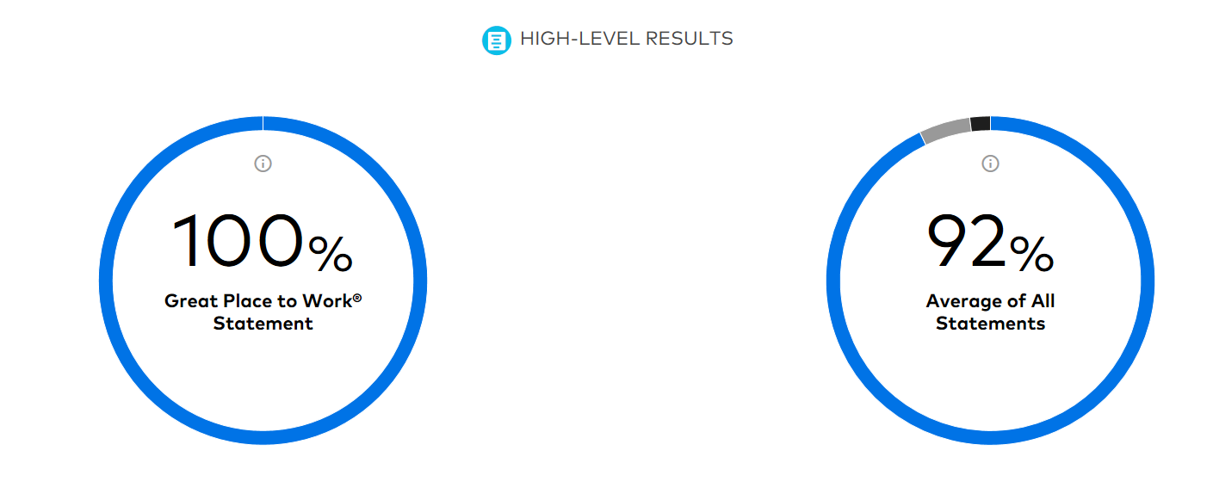

Discussion:
An impressive increase was noted in the percentage of positive responses to all questions, including the Great Place to Work ® Statement “Taking everything into account, I would say this is a great place to work”. In addition to the objective numeric results, many employees that completed the survey chose to leave an optional comment. Of the 15 total comments received, 32 commented on the team-building activities. This subjective data reinforces the success of the interventions.
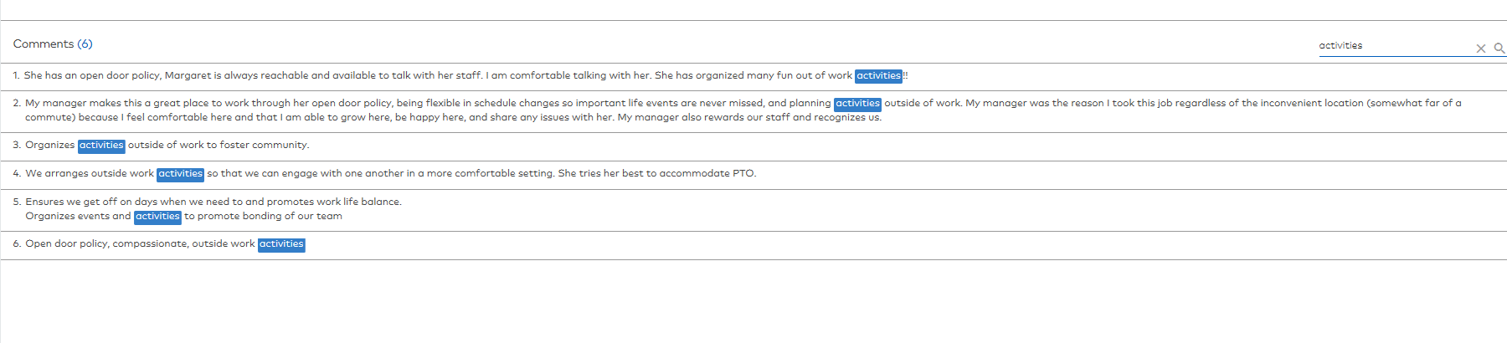

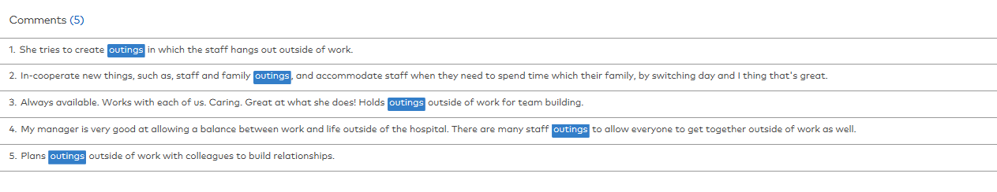

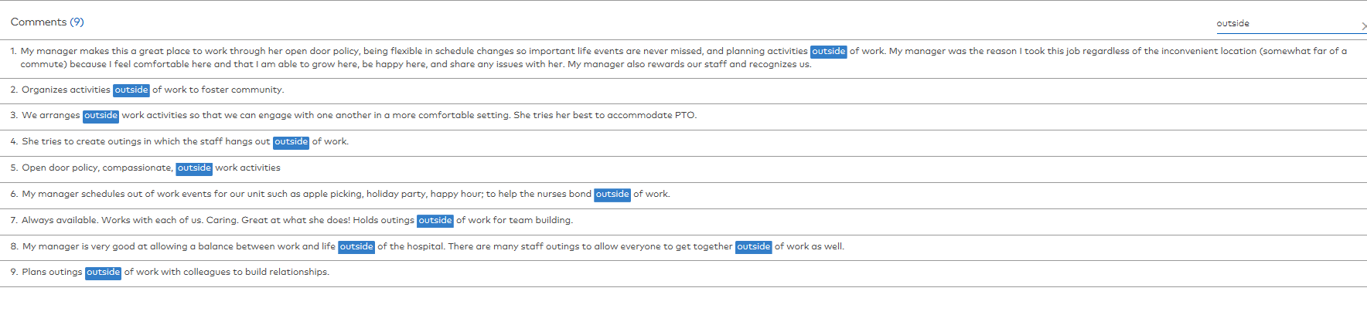

Limitations:
The following limitations were identified:
- Availability to attend –
  - Because a hospital operates 24/7 it was impossible to schedule an activity that all staff members had the opportunity to attend at the same time
  - Some staff members have other child care responsibilities, per diem jobs, or school obligations that do not allow them the “free time” to attend

- Cost – Interventions were carefully selected and varied in price-point from free/low cost (barbeque, apple picking; estimated cost = $5.00 - $15.00) to more expensive activities (board n’ brush; estimated cost = $60.00). Interventions were intentionally chosen in an effort to accommodate potential budgetary restrictions of all employees however some employees may still have had financial restrictions that prohibited them from participating.
Conclusion & Future Direction:
Providing opportunities for employees to interact outside of work, and encouraging the celebration of “special events” in the workplace helped to form new relationships and strengthen existing bonds. This led to a dramatic impact in positive responses on the Great Place to Work Survey.
In 2019 5PW Leadership will continue to schedule team activities outside of work on a minimum of a quarterly basis. Leadership will also continue to plan and encourage celebrates during work hours for special events. Once this behavior is embedded into the culture of the unit this task may be handed off to 5PW’s Unit Based Council (UBC).
Moving forward these interventions will be implemented on 3 Conklin, a 15 bed medical/oncology floor that shares the same manager and nurse specialist as 5PW. Additionally this Evidence Based Project will be shared at the Nurse Manager Council meeting. Nurse Managers within the organization may then choose to implement similar interventions with their staff to enhance employee satisfaction and camaraderie.

References:

McCabe, T. (2017). Employee Engagement A great place to work. Human Resources Magazine, 34-37.
Great Place to Work. (n.d.). Great Place to Work. Retrieved from https://www.greatplacetowork.com/
Kusuma, P. G., & Madasu, S. (2015). 'A Great Place to Work': A comparison of Employee Engagement PRactice of select companies with David Zinger Engagement Pyramid. Aweshkar Research Journal, XIX(1),
55-66. Retrieved January 22, 2019.

Hackensack Meridian Health. (2019). Hackensack University Medical Center Once Again Named as One of the 100 Great Hospitals in America - Press Releases - Hackensack Meridian Health. [online] Available at: https://www.hackensackmeridianhealth.org/press-releases/2018/05/07/hackensack-university-medical-center-named-one-100-great-hospitals-america/ [Accessed 22 Jan. 2019].

