The effect of perioperative body temperature management on unplanned hypothermia
Xiao-Wen Tsai, RN, HN, Nursing Dept, Kaohsiung Municipal Hsiao-Kang Hospital, Kaohsiung, Taiwan
Hsiu-Yueh Chen, RN, HN, Nursing Dept, Kaohsiung Municipal Hsiao-Kang Hospital, Kaohsiung, Taiwan
Shu-Ting Lin, NP, Nursing Dept, Kaohsiung Municipal Hsiao-Kang Hospital, Kaohsiung, Taiwan
Yu-Ping Chou, NP, Nursing Dept, Kaohsiung Municipal Hsiao-Kang Hospital, Kaohsiung, Taiwan
Ya-Chi Hsu, NA, Anesthesia Dept, Kaohsiung Municipal Hsiao-Kang Hospital, Kaohsiung, Taiwan
Po-Jung Chen,VS, Surgery Dept, Kaohsiung Municipal Hsiao-Kang Hospital, Kaohsiung, Taiwan

Abstract
Statement of the Problem: Surgical site infections (SSI) are significantly associated with longer inpatient length of stay, higher medical expense and poor life quality. It is estimated that 40~60% of SSI is preventable. Unplanned hypothermia could predispose to SSI and might occur in 50% of patients undergoing anesthesia in the operation room. World Health Organization (WHO) have suggested that maintaining peri-operative normothermia above 36℃ is effective in reducing SSI. The purpose of this study is to describe the experience of team work from surgical ward, operation room and anesthesia department to improve body temperature management for inpatients undergoing surgery. Methodology & Theoretical Orientation: An inter-departmental improvement program was initiated to use warming equipment, establish hypothermia guideline and hand-over system. The guideline kept perioperative body temperatures with various warming equipment according to body temperature. Findings: Peri-operative body temperature monitoring and complete hand-over reached 100%. Unplanned hypothermia decreased from 38.2% (335/884) to 29.2% (121/418) during transfer from ward to operation room and decreased from 27% to 1.5% during transfer from operation room to the post-anesthesia care unit. Conclusion & Significance: An inter-departmental body temperature management protocol reduced perioperative hypothermia. A team work between surgery ward, operation room and anesthesia department provided continuous body temperature monitoring and suitable warming guideline thus ensured the perioperative care quality.

Image

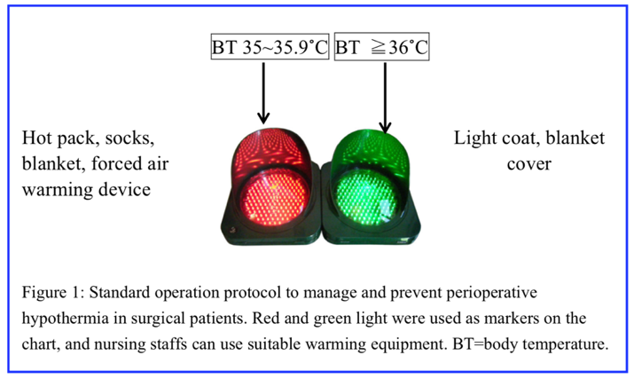
Recent Publications
- Huang Shuru, Lu Minji.Reducing (2017) Surgical Site Infection Via The Practice of Perioperative Glycemic and Normothermic Control. Medical quality magazine 11:84-89
- Owens P, McHugh S, Clarke-Moloney M, et al. (2015) Improving surgical site infection prevention practices through a multifaceted educational intervention. Ir Med J 108:78-81.
- Murdoch H (2012) What are the key infection prevention and control recommendations to inform a surgical site infection (SSI) prevention quality improvement tool? Health Protection Scotland; version 2.0: 1-46
- Whitney JD, Dellinger EP, Weber J, et al. (2015) The effects of local warming on surgical site infection. Surg Infect 16:595-603.
- Campbell G, Alderson P, Smith AF, Warttig S.(2015) Warming of intravenous and irrigation fluids for preventing inadvertent perioperative hypothermia. Cochrane Database Syst Rev 4:CD009891.

Photograph

 Biography
Head nurse Hsiao-Wen Tasi has her expertise in adult nursing and passion in improving the surgical care quality. She has clinical experience in emergency department, intensive care unit and surgical ward. She has 16 years of experience in nursing care, patient safety, teaching and administration in Kaohsiung Municipal Hsiao-Kang Hospital.
Email: 910139@kmuh.org.tw

Notes/Comments:

