Reducing Standardized Utilization Ratio for Central Line and Urinary Catheters: A Multi-Faceted Approach
Opal Dy MSN RN CCRN CMC CSC

Abstract (300 word limit)

Purpose: This initiative aimed to decrease the Standardized Utilization Ratio (SUR) for central lines and foley catheters below the benchmark of 1.0, thereby enhancing patient safety and mitigating the risk of catheter/line-related complications, such as central line-associated bloodstream infections (CLABSI) and Catheter Associated Urinary Tract Infections (CAUTI). These complications contribute to increased morbidity, mortality, and healthcare costs. Description: To reduce catheter/line-related risks and improve patient outcomes and healthcare efficiency, we employed a three-pronged approach: Revised Charge Nurse Report Sheet: Central lines/Foleys were emphasized in red for easy identification and prioritization, and a drop-down menu was added to indicate the appropriate indication for the central line. Standardized Charge RN/Manager Rounding System: This system streamlined the assessment and management of central lines and foley catheters. Morning rounds identified candidates for de-lining/Cath D/C, and afternoon follow-ups evaluated success or documented rationale for retention. This structured approach facilitated staff collaboration and communication. Monthly Data Presentation: Data visualization was posted around the unit and discussed during staff meetings, improving staff awareness. Evaluation and Implications for Nursing Practice or Patient Outcomes: A marked reduction in central line and foley catheter usage was observed within the ICU service line following the standardized project's implementation. This demonstrates the effectiveness of increasing staff awareness, incorporating leadership supervision, and using a data-driven approach to minimize device usage in the ICU service line. This initiative highlights the importance of proactive device management, interdisciplinary collaboration, and data-driven decision-making in enhancing patient safety and outcomes. Implementing similar strategies in other healthcare settings may lead to improved efficiency and better patient care.
Image

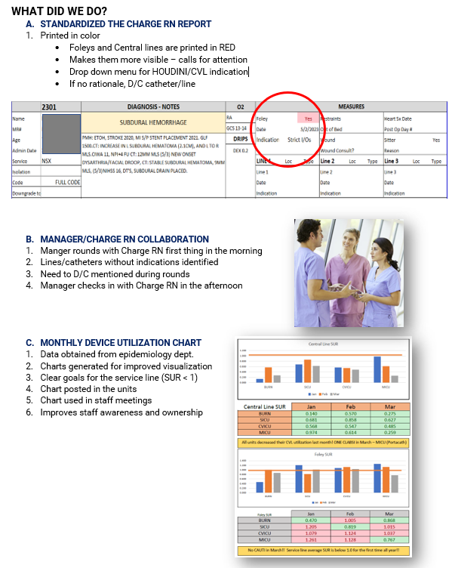
Recent Publications (minimum 5)
- Centers for Disease Control and Prevention. (2019). "National and State Healthcare-Associated Infections (HAI) Progress Report". Atlanta, GA: U.S. Department of Health and Human Services, CDC.
- Conway, L. J., Riley, L., Saiman, L., Cohen, B., Alper, P., & Larson, E. L. (2016). "Implementation and impact of an automated group monitoring and feedback system to promote hand hygiene among health care personnel". Journal of Quality and Patient Safety, 42(9), 394-400
Opal Dy is a Clinical Nurse Specialist at Arrowhead Regional Medical Center (ARMC) in Colton, CA, with over two decades of experience in nursing and staff education. Opal played a pivotal role in setting up the Cardiothoracic Surgery Program at ARMC, where he now serves as a clinical resource and leader in quality assurance, staff engagement, and evidence-based practice implementation. Prior to her current role, he worked as an ICU Nurse Educator and Charge Nurse at ARMC, where he excelled in staff development, patient care, and coordination.
Opal holds a Master of Science in Nursing from Grand Canyon University and a BSN from Metropolitan Hospital College of Nursing in Manila. Her certifications include Critical Care (CCRN), Cardiac Medicine (CMC), and Cardiac Surgery (CSC), showcasing her commitment to excellence in patient care and safety. Opal's strong communication skills and compassionate approach make her an essential asset to the ARMC team.

- Saint, S., Greene, M. T., Krein, S. L., Rogers, M. A. M., Ratz, D., Fowler, K. E., ... & Chopra, V. (2016). "A program to prevent catheter-associated urinary tract infection in acute care". New England Journal of Medicine, 374(22), 2111-2119.
4. Stevens, M. P., Doll, M., Pryor, R., Godbout, E., Cooper, K., Bearman, G., & Stevens, L. (2018). "Impact of COVID-19 on traditional healthcare-associated infection prevention efforts". Infection Control & Hospital Epidemiology, 39(8), 956-957.
5. Zimlichman, E., Henderson, D., Tamir, O., Franz, C., Song, P., Yamin, C. K., ... & Bates, D. W. (2013). "Health care–associated infections: A meta-analysis of costs and financial impact on the US health care system". JAMA Internal Medicine, 173(22), 2039-2046

Email: Dyo@armc.sbcounty.gov

