THE EXPERIENCE OF WOMEN WITH OBSTETRIC FISTULA FOLLOWING CORRECTIVE SURGERY: A QUALITATIVE STUDY IN BENADIR AND MUDUG REGIONS, SOMALIA
Dr Adam A. Mohamed, PhD, Baskent Uni, Turkey
Prof, Dr Abiodun O. Ilesanmi, UI, Nigeria
Dr M. David Dairo, PhD, UI, Nigeria

Abstract

Obstetric fistula is a severe maternal morbidity which can have devastating consequences for a woman’s life and is generally associated with poor obstetric services leading to prolonged obstructed labour. The predisposing factors and consequences of obstetric fistula differ from country to country and from community to community. The World Health Organization estimated that more than 2 million women in sub-Saharan Africa, Asia, the Arab region, Latin America, and the Caribbean are living with the fistula, and some 50,000 to 100,000 new cases develop annually with 30,000–90,000 new cases developing each year in Africa alone. This study aimed at describing and exploring the experiences of women living with obstetric fistulas following corrective surgery in Benadir and Mudug regions, Somalia. Women living with obstetric fistula who had surgical repairs at Daynile and GMC fistula centers and key informants were identified purposively. Twenty-one individual in-depth interviews among women with obstetric fistula and eight key informant interviews were conducted. Thematic analyses were used. Codes were identified, and those codes with similar connections were organized together as to form themes. Detailed reading and rereading of the transcribed interviews were employed in order to achieve and identify themes and categories. Themes, categories, and subcategories illustrating the experiences of women living with obstetric fistula emerged from the thematic analysis of individual in-depth and key informant interviews. These were challenges of living with OBF which include “wounds around genitalia, bad odour, incontinences of urine and feces, stigma, isolation, divorce, powerlessness, dependency, financial constraints, and loss of healthy years” and coping mechanisms which include “withdrawal from the community and improved personal hygiene.” Women with obstetric fistula experience serious health and social consequences which prevents them fulfill social, family, and personal responsibilities. We recommend expansion of BEmONC services to underserved areas, capacity building for local OBF surgeons, and improved media campaign and birth preparedness at community levels.
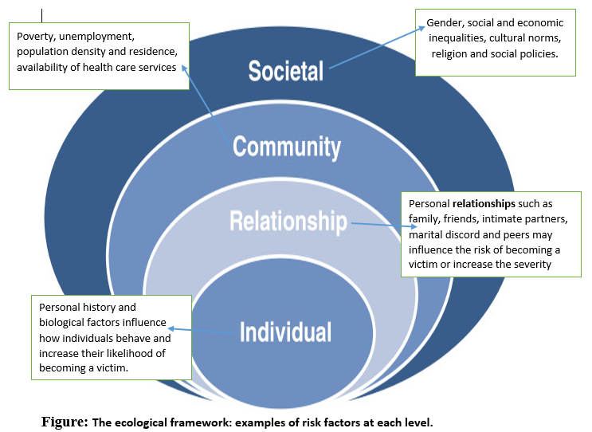
Recent Publications
- Adam A. Mohamed, Abiodun O. Ilesanmi, and M. David Dairo, “The Experience of Women with Obstetric Fistula following Corrective Surgery: A Qualitative Study in Benadir and Mudug Regions, Somalia,” Obstetrics and Gynecology International, vol. 2018, Article ID 5250843, 10 pages, 2018
- Development of Interventions to Help Women during Emergencies to Resume or Increase Breastfeeding to Protect and Nourish Their Infant in Somalia, with Save the Children International Somalia
- Obstetric fistula victim’s understanding on causal and predisposing factors of obstetric fistula: a qualitative study in Somalia Obstetrics and Gynecology International, vol. 2018, Article ID 5250306.v1, 10 pages, 2018
- Review of Infant and Young Child Feeding Interventions to Help Women to Resume or Increase Breastfeeding in Puntland, Somalia, with Save the Children UK
- Prevalence and Associated Factors of Exclusive Breastfeeding Practices among Mothers of Infants in Galkayo, Somalia: A Community Based Cross-Sectional Study, Science Journal of Public Health, Volume 6, Issue 5, September 2018, Pages: 133-139

Photograph

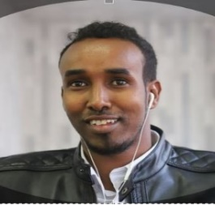 Biography
Dr has his expertise in maternal health care, health promotion and operational researches related to maternal and child health. He has worked with a number of International NGOs in Health care and research related programs in the developing countries. Dr Adam has conducted the first Obstetric Fistula research in Somali women who has one of the worst health care indicators across the world. He has recently implemented two operational researches related to breastfeeding and re-lactation with Save the Children International. Dr Adam is known to his multicultural expertise across Africa continent. He did his MD in Addis Ababa, Master of Reproductive Health in Nigeria with Pan-African University scholarship and is currently doing PhD in Public Health in Baskent University, Ankara, Turkey with the sponsorship of Turkey Government under Turkish Burslari Government Scholarship.
Email: adamafrican@gmail.com

