Quality of Work Life and Job Satisfaction among Registered Nurses Working at Ministry of Health and Prevention Hospitals in the United Arab Emirates
Dr Sarah Sanad, RN, PhD, American University in the Emirates, UAE

Abstract (300 word limit)
Introduction: Quality of work life (QWL) and job satisfaction are important factors in supporting the nursing workforce and improving retention. This study aimed to assess the association between QWL and job satisfaction among registered nurses (RNs) working at Ministry of Health and Prevention (MOHaP) hospitals in the United Arab Emirates (UAE) and evaluate the psychometric properties of the Work-Related Quality of Life (WRQoL) and Minnesota Satisfaction Questionnaire (MSQ).
Methodology: A cross-sectional design was used. RNs from MOHaP hospitals (n = 919) were recruited using total population sampling. Self-reported measures included the WRQoL and MSQ. Data were analyzed using IBM SPSS and AMOS. Independent t-test, one-way analysis of variance, correlation, and Generalized Linear Model analyses were performed. Cronbach's alpha and factor analyses evaluated reliability and construct validity.
Findings: A significant, strong and positive relationship was found between QWL and job satisfaction (r = 0.662, p < 0.001). Better QWL was associated with higher job satisfaction after controlling for age, gender, nationality, education status, and employment status. Nurses in managerial positions had significantly higher QWL (p = 0.001) and job satisfaction (p = 0.03) than nurses in non-managerial positions. Married nurses reported significantly higher job satisfaction than single nurses (p < 0.001). The WRQoL and MSQ demonstrated satisfactory internal consistency reliability (alpha = 0.936 and alpha = 0.954, respectively).
Conclusion and Recommendations: QWL was significantly and positively associated with job satisfaction among RNs working at MOHaP hospitals in the UAE. Strategic initiatives should be considered to improve nurses' QWL and job satisfaction. Future research should include RNs from private and other governmental healthcare sectors across the UAE.

Image
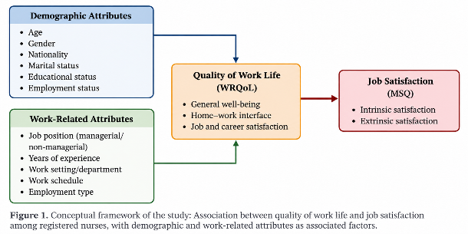
Recent Publications (minimum 5)
- Sanad, S. et al. (2026). Differential Associations of Occupational and Total Physical Activity with Sleep Quality Among Adults in the United Arab Emirates: A Cross-Sectional Study. International Journal of Environmental Research and Public Health, 23(7), 935. DOI: 10.3390/ijerph23070935.
- Sanad, S. et al. (2025). The Holy Month of Ramadan: A Blessed Union (Etihad) of Societal Collective Effervescence, Belonging and Positive Mental Health for All. F1000Research, 14, 327. DOI: 10.12688/f1000research.162960.1.
- Sanad, S. et al. (2024). Exploring Risk Perception, Mental Health, Mental Fatigue, Stigma, and the Quality of Life among UAE Healthcare Workers during the COVID-19 Pandemic: A National Multicentric Cross-Sectional Study. International Journal of Environmental Research and Public Health, 21, 1124. DOI: 10.3390/ijerph21091124.
- Sanad, S. et al. (2021). Assessment of the Awareness, Perception, Attitudes, and Preparedness of Health-care Professionals Potentially Exposed to COVID-19 in the United Arab Emirates. Journal of Multidisciplinary Healthcare, 14, 91–102. DOI: 10.2147/JMDH.S278479. Dr Sarah Sanad 2026 CV
5. Sanad, S. et al. (2017). Survey of Energy Drinks Consumption and Adverse Health Effects: A Sample of University Students in the United Arab Emirates. Journal of Scientific Research and Reports, 15(4), 1–13. Dr Sarah Sanad 2026 CV


Biography (150 word limit)
Dr. Sarah Sanad is a nursing academic and leader with over 15 years of experience in nursing and health professions education in the UAE. She holds a PhD in Healthcare Management, a Master of Science in Nursing in Clinical Nursing–Critical Care, and a Bachelor of Science in Nursing. She is a Registered Nurse, Clinical Nurse Specialist, and Fellow of the Higher Education Academy. Her experience spans critical care nursing, nursing education, academic leadership, curriculum and assessment, accreditation, and quality assurance. Her research interests include nursing workforce wellbeing, quality of work life, job satisfaction, nursing education, and healthcare management. She is currently Acting Dean of the College of Health Sciences and Assistant Professor at the American University in the Emirates. Email: sarah.sanad@aue.ae and Sarah.sanad@aue.ae

