Association between sarcopenia and mortality risk in older adults

Yu-Chen Su , PhD Department of Nursing, College of Nursing, National Taipei University of Nursing and Health Sciences, Taiwan
Shu-Fang Chang , Professor Department of Nursing, College of Nursing, National Taipei University of Nursing and Health Sciences, Taiwan

Abstract (300 word limit)

Purposes:

The study aim of is to investigate whether sarcopenia is associated with for the occurrence associations of mortality risks.

Methods:

A previous study was conducted in reviewed and extracted the searched literature. The keywords searched included “sarcopenia”, “Mortality”, and “older people”, “elderly”, “geriatric”, and “senior.” The researcher searched the keywords Between January 2012 to July 2022 for articles relating to sarcopenia and mortality. The literature search steps followed conducted according to the PRISMA guideline. This study systematic literature search was conducted in CINAHL Embase, MEDLINE PubMed, and Cochrane Library and then we selected them with outcomes such as analyzed the collected the literature. Data Synthesis and Statistical Analysis using the Review Manager 5.4 was used to pool Hazard ratio (HR) for the association between sarcopenia and mortality.

Results:

Sarcopenia was significantly correlated with mortality. this study collected a total of 22 prospective studies and performed a systematic literature review and meta-analysis of the data. The main results showed that when comparing to robust individuals, the risk of negative health effects for elderly individuals with sarcopenia was significantly higher risk of all causes compared with non-sarcopenic subjects for mortality (HR: 8.33〔95% CI: 3.28 - 21. 17〕) in comparison with people without sarcopenia.

Conclusions.:

Our results obtained Sarcopenia is associated with a significantly higher risk of mortality. from a Sarcopenia is a prevalent syndrome that is associated with premature mortality among older adults. such as physical performance physical frailty disability of negative health events, in the elderly population with sarcopenia are higher than those of the population which highlights the need for which could Early detection of these sarcopenia group, and early intervention with nutrition or exercise is important in preventive medicine in all populations.


Image
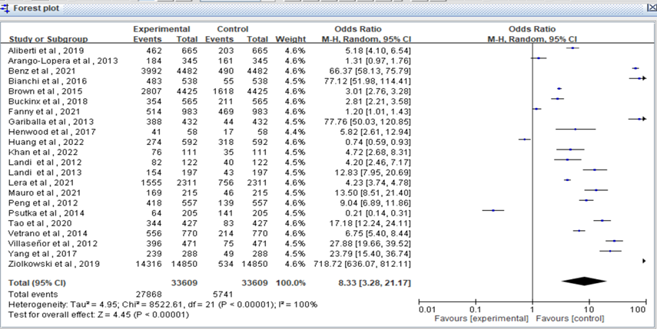
Recent Publications (minimum 5)
- Yu-Chen Su., Shu-Fang Chang. (2023). The Relationship Between Sarcopenia and Fracture Risk In Older Adults: A Systematic Review and Meta-Analysis. The 29th International Council of Nurses (ICN), in Montreal, Canada(post)
- Yu-Chen Su., Shu-Fang Chang. (2023). The Relationship Between S Diabetes and Depression Risk In Adults: A Systematic Review and Meta-Analysis. The 29th International Council of Nurses (ICN), in Montreal, Canada(post)
- Yu-Chen Su., Shu-Fang Chang., and Hsiao-Chi Tsai. (2022). The Relationship between Sarcopenia and Injury Events: A Systematic Review and Meta-Analysis of 98,754 Older Adults. J. Clin. Med. 11, 6474, 1–16.
- Yu-Chen Su (2021) Exploring the Relationship between Falls in Older Adults and Sarcopenia: A Systematic Literature Review. Healthcare Technology and Management.Taipei, Taiwan (post).
5. Yu-Chen Su.,(2020). Relationship Between Resillence and Depression in Patients With Stroke in Taiwan. The 26th International Council of Nurses (ICN), Taipei, Taiwan (post).
National Taipei University of Nursing and Health sciences Sciences.

Biography (150 word limit)
Yu-Chen Su, a nurse with years of experience in clinical care, has a deep understanding of the impact of aging on physical health. Her focus is on the health and quality of life of older adults, and she hopes to improve their physical health and quality of life through research results. Research on aging may include studying the reasons for changes in the physical function of older adults, researching methods to prevent and treat age-related diseases, and studying how to improve the quality of life of older adults. These research results will have a positive impact on the health and well- being of older adults, and provide more scientific basis for nursing practice and clinical decision-making.

Email: 13448.s.hr@gmail.com

Notes/Comments:

Presenting author details
Full name:
Yu-Chen Su
Contact number:
+886-2-89663584
Twitter account:
NO
Linked In account:
Email: 13448.s.hr@gmail.com
Session name/ number:
Category: (Oral presentation/ Poster presentation)
Oral presentation

