User Research and Co Design underpinning Service Creation
Karen Cleale, Delivery Director, Difrent Group

Abstract (300 word limit)
Statement of the Problem: To develop services that meet organizational aspirations, it is crucial that they are driven by User Research and Co-design. User research helps us learn about users and create services that meet their needs.
To ensure we get it right, we design digital services with user research at our core. We map customer journeys and build a blueprint of a user-centered service. We use user research to ensure that we know what problems we’re trying to solve and if the service we create will work well for users.
We’ve led the development of services including Revalidation for the Nursing and Midwifery Council, the development of patient facing services for NHS Digital such as transforming NHS.uk and we are building the replacement to NHS Jobs.
Revalidation, is an online service for 800,000 Nurses and Midwives, launching in 2017. Development involved multi-disciplinary teams (including nurses/midwives) and close collaboration with wide-ranging influencers (GMC, RCN, UNISON) and users. Starting with stakeholder workshops, we defined the product vision and maintained stakeholder participation throughout development.
Wireframes and prototypes were created, feeding regular/iterative testing with end users. Using a variety of tools (inVision, Marvel, Sketch, Axure), observation of users within labs environments and analysing participant feedback; we delivered an MVP which delighted users and stakeholders.
In all of these services, we put users first undertaking extensive user research – using a number of means including face-to-face interviews, gorilla pop-up sessions, focus groups and surveys, include co-design such as having nurses as a pert of our design team on Revalidation.
Through these programmes, we encountered gaps in stakeholder understanding or appetite and inertia, a barrier to change we used the insight from our UR and the voice of users to land service that have made a real difference.

Image

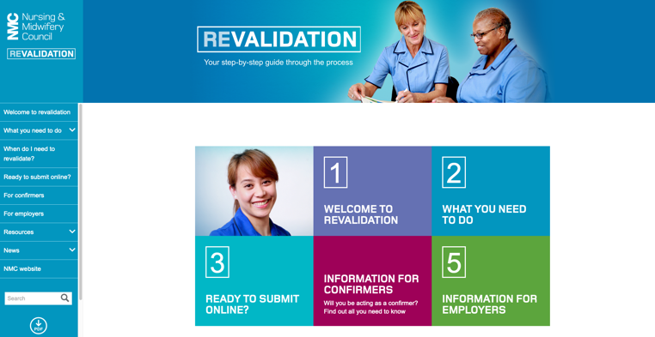
Recent Publications (minimum 5)
- Revalidation:
  - https://www.youtube.com/watch?time_continue=3&v=bY8gWlOhh0Y
  - http://revalidation.nmc.org.uk/news/blog
- NHS Jobs:
  - Case study https://difrent.co.uk/how-we-do-it/
  - https://blog.nhsbsa.net/?p=149
  - Managing user research findings https://blog.nhsbsa.net/?p=94
- NHS Digital:
  - https://digital.nhs.uk/blog/transformation-blog/2018
  - https://digital.nhs.uk/blog/transformation-blog
- About Difrent:
  - https://www.youtube.com/watch?v=YXpyKJoO-Xw
  - https://difrent.co.uk

Photograph

Biography (150 word limit)
Karen Cleale her expertise in developing digital services and creating change for the public good. Taking a user centered approach to service design isn’t new, it’s aligned to the Government Digital Service standard – but executing on that approach, pulling tangible user insight and building the services to meet user needs, that’s something that Karen, as Delivery Director for Difrent executes on, every time. We deliver, come what may, a positive impact for the public good.
Email: karen.cleale@bedifrent.com

Notes/Comments:

