Revascularization of Temporomandibular Joint After Surgical Intervention Using CT Volume Rendering Technique (Clinical Study)
Heba Abdul wahed Sleem ¹ , Mona Gamalludin Alkaphoury ²

- Associate professor, department of oral and maxillofacial surgery, faculty of dentistry Ain Shams University, Cairo , Egypt
- Lecturer, department of Diagnostic radiology, faculty of medicine, Ain shams university, , Cairo , Egypt .

Abstract (not more than 300 words):

The present study aimed to trace the arterial blood supply of Tempromandibular joint after open joint procedures using CT volume rendering technique. To achieve this goal six operated joints with residual symptoms radiographed one year post-operatively. Computed tomographic scanning with intravenous contrast, were examined. The direct volume rendering technique of CT images was used, and a data set of images to demonstrate the vasculature of the human Tempromandibular joint in three dimensions. After elaboration of the data through post-processing, the arterial supply of the Tempromandibular joint was compared to reference anatomy. The most commonly injured arteries are anterior tympanic, masseteric, superficial temporal arteries (detection rate 33%, 33%, 50% respectively). Furthermore, osteoarthritic changes, synovial and articular cartilage calcifications with detached bony fragments were noticed that could be attributed to vascular injury. Open joint procedures are associated with significant decrease in arterial supply to TMJ, which could be correlated with osteoarthritic changes noticed later on. The three-dimensional volume rendering technique of computed tomography angiography is an effective non-invasive diagnostic tool; it allows simultaneous evaluation of boney changes and residual vascularity in previously operated joints.

KEY WORDS:
Revascularization, temporomandibular joint, joint surgery, CT volume rendering technique.

Professional Biography (100-150 words)

Dr. Mona Alkaphoury has completed her M.D at the age of 32 years from Ain Shams University. She is lecturer at Ain Shams University Hospitals, Cairo, Egypt and works as diagnostic radiology consultant in Ain Misr Radiology Centre (MRC) in Cairo, and published this paper International Journal of Clinical Oral and Maxillofacial Surgery.

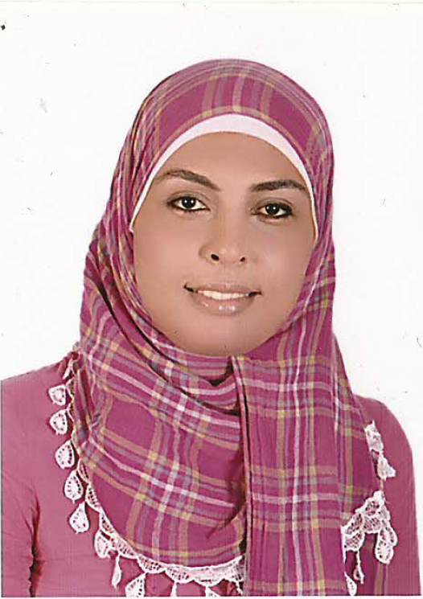

Full Name: Mona Gamalludin Alsayed Alkaphoury
Email Id: Dr.monakaphoury@hotmail.com
Contact No: 00201118374630 - 00966560014968
Social Network Details (LinkedIn): https://www.linkedin.com/in/mona-kaphoury-130a1034/

