SKULLDUGGERY: Beating a high grade infantile glioma
Dr Vishal Aggarwal, Queen’s Medical Centre, Nottingham, UK
Mr Ashwin Kumaria, Queen’s Medical Centre, Nottingham, UK

Abstract (300 word limit)

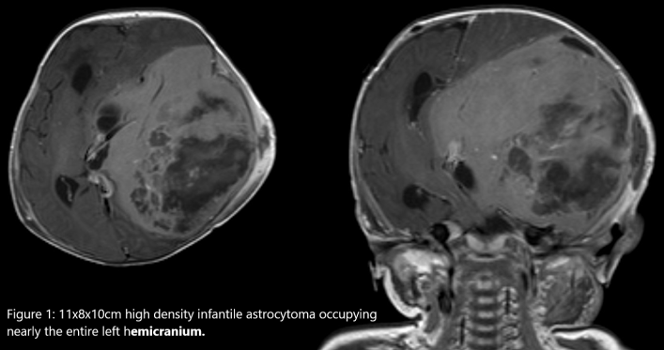
A 5 month old boy presented with parental concerns of abnormal head shape. He was otherwise well and was developing normally. On examination there was a large boggy swelling to the left side of his scalp and fullness of the anterior fontanelle, although he was neurologically intact. CT head scan demonstrated a large 11x8x10cm high density intracranial mass occupying nearly the entire left hemicranium, with a typical “beaten copper pot” appearance of the skull. MRI with contrast and spectroscopy suggested high grade glioma (Image 3).

We carried out subtotal tumour resection in two operations, limited by bleeding and tumour swelling where it had outgrown its blood supply. Deep portions of the tumour involving midline structures were unresectable. He developed seizures for which he was given phenobarbitone and lacosamide, but had no complications. Histology confirmed a diagnosis of high grade infantile astrocytoma. The BEBE BRAIN chemotherapy regime (Carboplatin/Procarbazine, Cisplatin/Etoposide,Vincristine/Cyclophosphamide) was chosen.

Excepting mild side effects, he remained well. Effective tumour control was achieved, demonstrated on interval MRI scans. He has not required further surgery. Now aged 20 months, he is alert, interactive and speaking some words.

Brain tumours are the commonest solid tumour in children. With modern treatment nearly 70% of children are cured. In this case, survival at 1¼ year post-diagnosis, let alone good neurological function, with a large, aggressive, vascular tumour occupying most of the left brain hemisphere was not anticipated a year ago.

This case report seeks to provide hope where it may be lacking.
Image

Recent Publications (minimum 5)
- Samkari A, Alzahrani F, Almehdar A, Algahtani H. Desmoplastic infantile astrocytoma and ganglioglioma: case report and review of the literature. Clin Neuropathol. 2017;36 (2017)(1):31-40. doi:10.5414/NP300945
- Tiwari B, Sinha VD, Singhvi S, Bhandari A. Infantile desmoplastic astrocytoma: Magnetic resonance imaging suggestive of pathology. J Neurosci Rural Pract. 2016;7(3):458-459. doi:10.4103/0976-3147.182773
- Bianchi F, Tamburrini G, Massimi L, Caldarelli M. Supratentorial tumors typical of the infantile age: desmoplastic infantile ganglioglioma (DIG) and astrocytoma (DIA). A review. Childs Nerv Syst. 2016;32(10):1833-1838. doi:10.1007/s00381-016-3149-4
- Tanık C, Devecioğlu EG, Hasçiçek S, Meltem Can S, Halefoğlu AM, Kabukçuoğlu F. A Rare Tumor in Childhood Desmoplastic Infantile Astrocytoma: Two Case Reports. Sisli Etfal Hastan Tip Bul. 2018;52(3):224-228. Published 2018 Sep 28. doi:10.14744/SEMB.2018.29292
- Gupta A, Karthigeyan M, Gupta K, Salunke P. Atypical imaging in a desmoplastic non-infantile astrocytoma. Childs Nerv Syst. 2017;33(3):517-520. doi:10.1007/s00381-016-3274-0



Biography (150 word limit)
Dr Aggarwal is a second year foundation doctor, training in the Neurosurgical department at Queen’s Medical Centre, Nottingham.
Email: vishal.aggarwal@nuh.nhs.uk
Notes/Comments:

