Atrial fibrillation with hemodynamic instability after the use of the third dose of adenosine during surgery for 7 intracranial aneurysms: case report
Eduardo Quiroz Murga, MD, Mg
Grassy Simon Scamarone, MD

Víctor Lazarte Echegaray Hospital, Trujillo, Perú

Abstract

Adenosine-induced asystole is a technique that prevents and controls the intraoperative rupture of cerebral aneurysm, facilitating temporary, and/or definitive clipping of the aneurysm. This is the case of a 58-year-old woman who underwent clipping of 7 intracranial aneurysms, who was induced asystole with adenosine 3 times and developed atrial fibrillation with hemodynamic instability after the last dose. Adenosine has been shown to be useful and safe, however, its use should be planned and possible cardiological complications should be considered.

Image
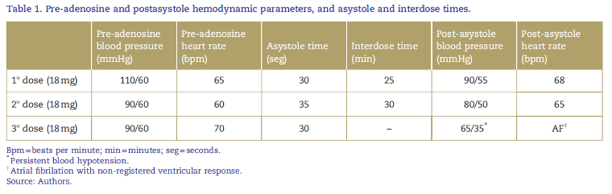

Recent Publications
- Schuette AJ, Barrow DL, Cohen-Gadol AA. Strategies to minimize complications during intraoperative aneurysmal hemorrhage: a personal experience. World Neurosurg 2015;83: 620–626
- Lee SH, Kwun BD, Kim JU, et al. Adenosine-induced transient asystole during intracranial aneurysm surgery: indications, dosing, efficacy, and risks. Acta Neurochir 2015;157:1879-1886
- Chowdhury T, Petropolis A, Wilkinson M, et al. Controversies in the anesthetic management of intraoperative rupture of intracranial aneurysm. Anesth Res Pract 2014;2014:595837.
- Layland J, Carrick D, Lee M, et al. Adenosine: physiology, pharmacology, and clinical applications. JACC Cardiovasc Interv 2014;7:581–591.
5. Deb K, Ghosh J, Jain H, et al. Adenosine in difficult aneurysm surgeries: report of two cases. J Neuroanaesthesiol Crit Care 2014;1:66–68.

Photograph

 Biography
Dr. Eduardo Quiroz Murga is a specialist in anesthesiology, master in medicine, graduated from the National University of Trujillo in Peru. He has developed his professional experience with greater inclination to neuroanesthesia. His work in vascular microneurosurgery is focused on the complications of intraoperative rupture of aneurysms, using the strategy of deep hypotension and adenosine-induced asystole. In his report he tells us about one of the few complications seen in its use and alternatives to prevent and solve it.
Email: eduardo048@gmail.com

