Pharmacological treatment of psychosis after cerebellar hemorrhage : a case report

Ah-Ra Cho, M,D. Department of Rehabiliation Medicine, Eunpyeong St, Mary’s Hospital, College of Medicine, The Catholic University of Korea Seoul, Republic of Korea

Abstract (300 word limit)
Post-stroke psychosis is a predictor of poor outcome but is often underdiagnosed and undertreated. Although there have been few reports of psychosis after cerebellar hemorrhage, the mechanism of the cerebellum in hallucinations in neuropsychiatric disease such as schizophrenia or Parkinson’s disease has recently been demonstrated.
A 61-year old woman who had acute hemorrhage at the right cerebellum about 3.5×4.2 cm sized with intraventricular hemorrhage and dilatation at 4th and 3rd ventricles on brain CT got emergent surgery. She showed neurological symptoms such as motor dysmetria, dysarthria, dysphagia and neglect to left side. The disorientation for time, person and place was sustained and sleepless murmuring at night was been reported. Quetiapine 25mg was started. On 2 months later after cerebellar hemorrhage, she complained of visual hallucination and exhibited abusive language and violent behavior. Psychiatrist diagnosed it with mixed delirium and risperidone 0.5mg was started. While taking risperidone 0.5mg and quetiapine 50mg, the sleep disturbance improved, but daytime visual hallucination and aggression continued and she suffered persecutory delusions. Risperidone was gradually increased to 2.5mg, but the psychotic symptoms persisted despite improved orientation for time, person and place. The perfusion defect in the right cerebellum was detected on brain magnetic resonance image (Fig 1). On the 76th day after cerebellar hemorrhage carbamazepine 200mg started and increase to 400mg. Aggression and visual hallucinations gradually partial resolved and improved attention and cooperation during the rehabilitation therapy was reported.

Conclusion
The deficits of cognition and emotional function reduced the patient’s functional recovery and quality of life. Therefore, early recognition and treatment of hallucinations or delusions that occurred after stroke will be important. There are still insufficient guidelines for drug treatment for post-stroke psychotic symptoms. Therefore, it is necessary to understand the mechanism for each affected brain lesion and to study the appropriate treatment.

Image

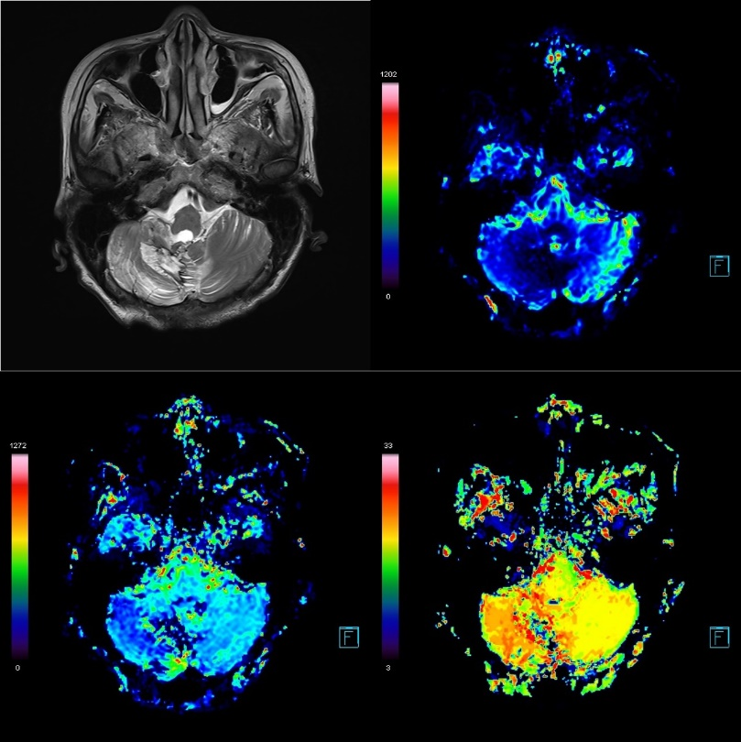
Fig 1. Perfusion MRI : perfusion defect in the right cerebellum

Recent Publications (minimum 5)
- McMurtray, A., Tseng, B., Diaz, N., Chung, J., Mehta, B., & Saito, E. (2014). Acute psychosis associated with subcortical stroke: comparison between basal ganglia and mid-brain lesions. Case Reports in Neurological Medicine, 2014. Heilig M, Egli M (2006) Pharmacological treatment of alcohol dependence: Target symptoms and target mechanisms. Pharmacology and therapeutics 111:855-876.
- Bielawski, M., & Bondurant, H. (2015). Psychosis following a stroke to the cerebellum and midbrain: a case report. Cerebellum & ataxias, 2, 1-4.
- Lawn, T. (2021). Cerebellar correlates of visual hallucinations in Parkinson's disease and Charles Bonnet Syndrome. Cortex, 135, 311-325.
- Greve, K. W., Stanford, M. S., Sutton, C., & Foundas, A. L. (1999). Cognitive and emotional sequelae of cerebellar infarct: a case report. Archives of clinical neuropsychology, 14(5), 455-469.
5. Almeida, J., Serrão, E. M., Almeida, A. T., & Afonso, J. G. (2011). Effective treatment with clozapine and valproate for refractory schizophrenia-like psychosis after cerebellar hemorrhage. Clinical Neuropharmacology, 34(3), 131-132.

Photograph

Biography (150 word limit)
Dr Cho conducts clinical care and research on neurodegenerative disorder and neurodevelopemental disorder in adults and children. As a clinical professor at a university hospital, she is also participating in policy research on the rehabilitation medical system for children. Her specialty is public rehabilitation.
Email: soulinsky@naver.com

Notes/Comments:

